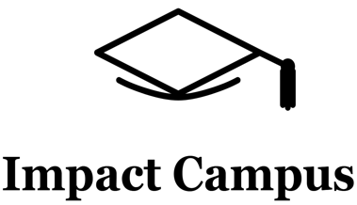
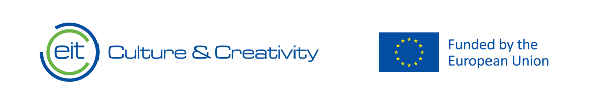

Knowledge Valorisation Centre Institutional Brief
UNINETTUNO Knowledge Valorisation Centre

Prepared by Prof. Alessandro Pollini, PhD, Associate Professor of Design
EIT HEI Initiative – IMPACT-Campus: Knowledge Valorization Centres for Sustainable Entrepreneurship and Digital Transformation
Fourth Call for Proposals (October 2024), Strand A
This Knowledge Valorisation Center profile is based on the conceptual framework “IMPACT-Campus: Knowledge Valorization Centres for Sustainable Entrepreneurship and Digital Transformation”.

1. Introduction and Regional Context
The International Telematic University UNINETTUNO, established by the decree of 15th April 2005 of the Italian Ministry of Education, University and Research, delivers academic titles having a legal value in Italy, Europe and in the Mediterranean Countries, for first-cycle (bachelor) degrees, specialization degrees, specialization degrees , doctor’s degrees and master's degrees.
In the International Telematic University UNINETTUNO distinguished lecturers of important universities worldwide deliver their courses in the Internet-based real and virtual spaces in Italian, Arabic, English and French.
The Knowledge Valorization Center UNINETTUNO Knowledge Valorisation Centre is based at the International Telematic Uninettuno University in Rome, Italy, and as a web portal accessible from remote. It operates in a digital/global scenario, further than in a physical regional one. The Uninettuno KVC is presented as a Hub without Walls, leveraging the Didactic Cyberspace to democratize access to innovation.

The establishment of the Uninettuno Knowledge Valorisation Centre (KVC) represents a strategic evolution in the university’s "Third Mission" mandate. Unlike traditional Higher Education Institutions (HEIs) where innovation hubs are geographically bound to a physical campus, the Uninettuno KVC is designed as a Phygital (Physical + Digital) Ecosystem. Based at the headquarters in Rome, the Centre operates within the complex socio-economic framework of the Lazio Region, while simultaneously serving a Pan-European community through its digital infrastructure.

  - Regional Context Analysis.
The Centre is physically located in Rome, within the Lazio region, which acts as a major hub for aerospace, cultural heritage, and life sciences. However, the region is characterised by a moderate innovator status (Regional Innovation Scoreboard 2023), facing specific structural challenges:
- The Digital Skills Gap: A misalignment between the high demand for ICT professionals in the Roman industrial park and the output of traditional educational paths.
- Fragmentation of the Innovation Ecosystem: a paradoxical disconnection between many research centers (CNR, Universities) and the SME fabric, often resulting in the difficulty of innovation, where patents fail to reach the market.

  - The Uninettuno KVC as a strategic interface.
It leverages Uninettuno’s technological platform, the Didactic Cyberspace, to bridge these regional gaps and aligns its roadmap with the European Commission's Digital Education Action Plan (2021-2027). The Centre has the mandate to democratize access to Deep Tech knowledge, ensuring that innovation is not confined to elite metropolitan hubs but is accessible to students and entrepreneurs in underserved or remote areas (a core tenet of the EIT Regional Innovation Scheme).

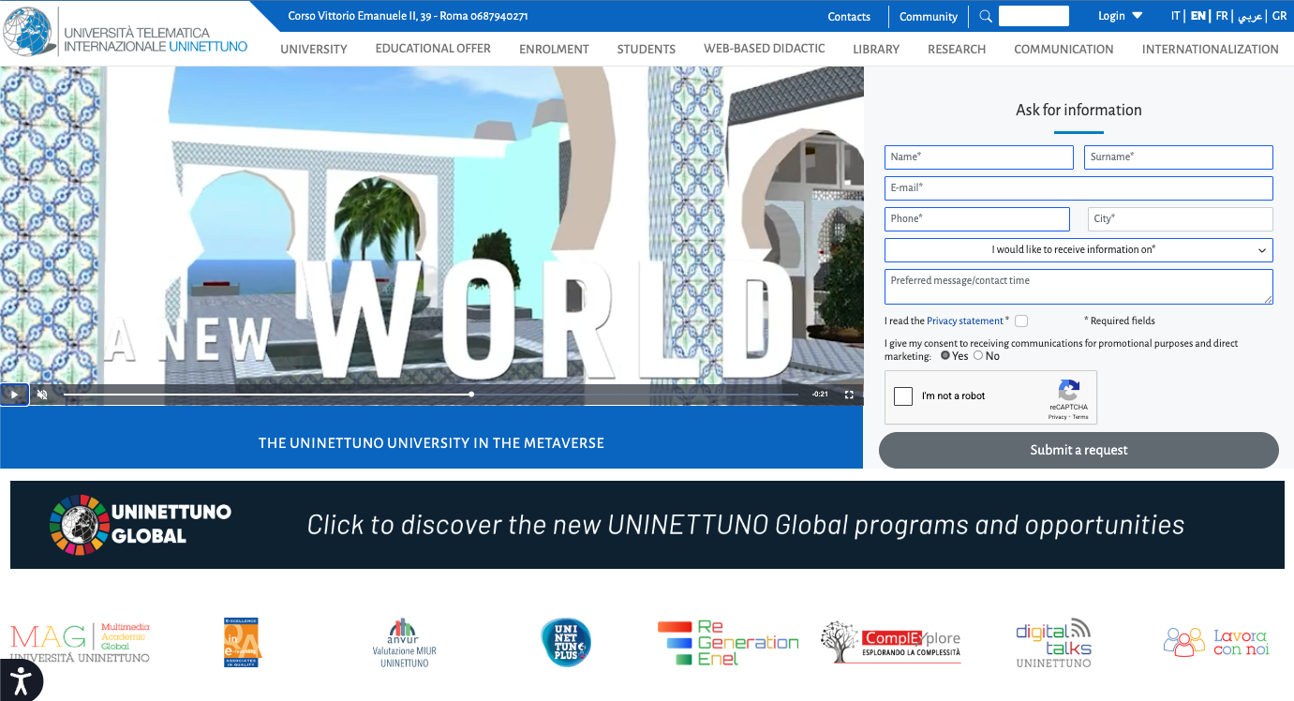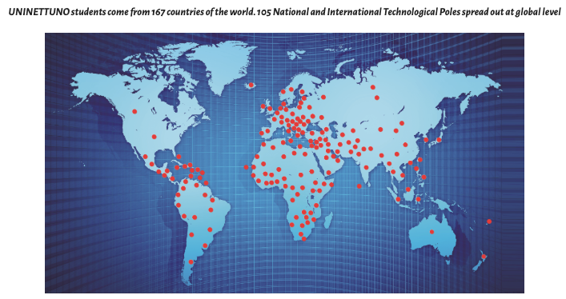

Figure 1. Virtual Campus - Main Website (top) and Map of Technological Poles (down)
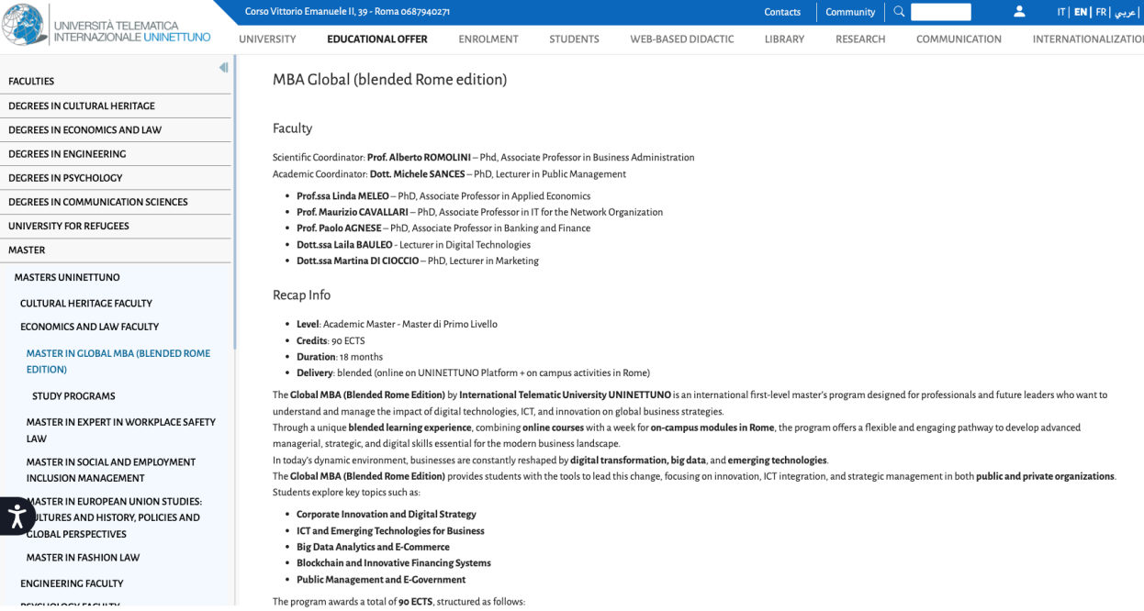
Figure 2. Virtual Campus - Didactic Cyberspace

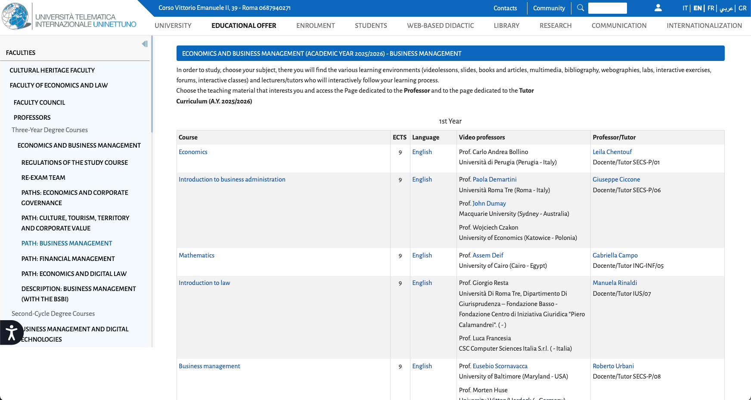
Figure 3. Virtual Campus - Uninettuno Cyberspace - Study Programs

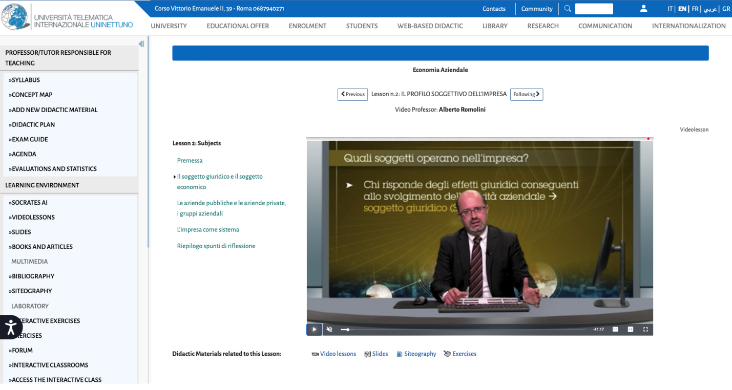
Figure 4. Virtual Campus - Uninettuno Cyberspace - Videolessons

The KVC is currently piloting its operations since 1 June, 2025, with the first pilot courses on
- Organizational Dynamics and Behaviour (June - July 2025),
- Private Law (September - October 2025),
and the IMPACT Campus training (November-December 2025).

The Center is to be officially presented to the Academic Senate and University Board of Directors on the December 2025 with the proposal to be opened on February 2026 within the framework of the project IMPACT-Campus: Knowledge Valorization Centres for Sustainable Entrepreneurship and Digital Transformation, funded under the EIT HEI Initiative, Fourth Call 2024, Strand A.

Designed from the outset as a bridge between higher education, industry, public authorities, and civil society, the Center carries a mandate to translate knowledge into tangible impact for the region.
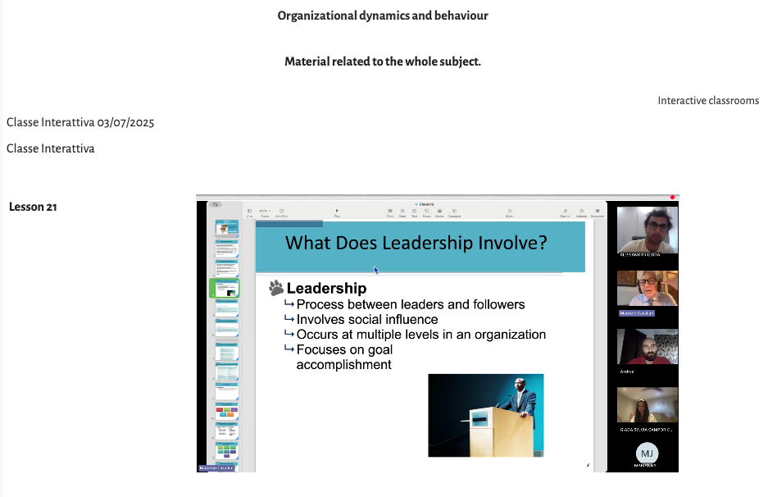
Figure 5. Online Training on Organizational Dynamics and Behaviour - Pilot Course - July 2025
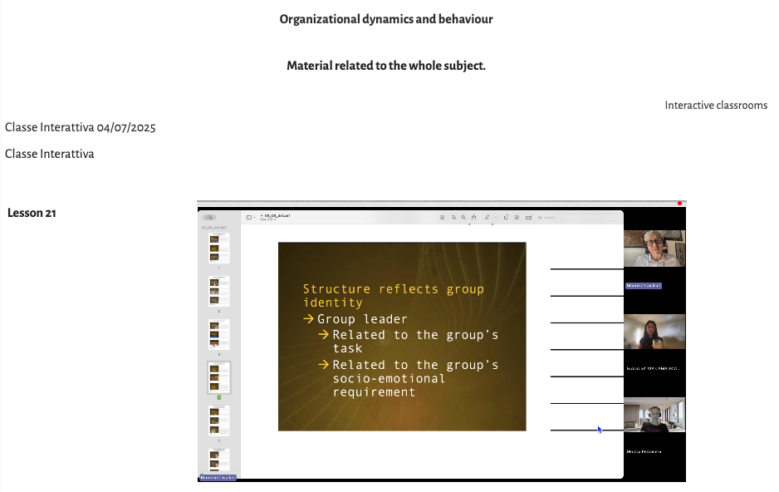
Figure 6. Online Training on Organizational Dynamics and Behaviour - Pilot Course - July 2025
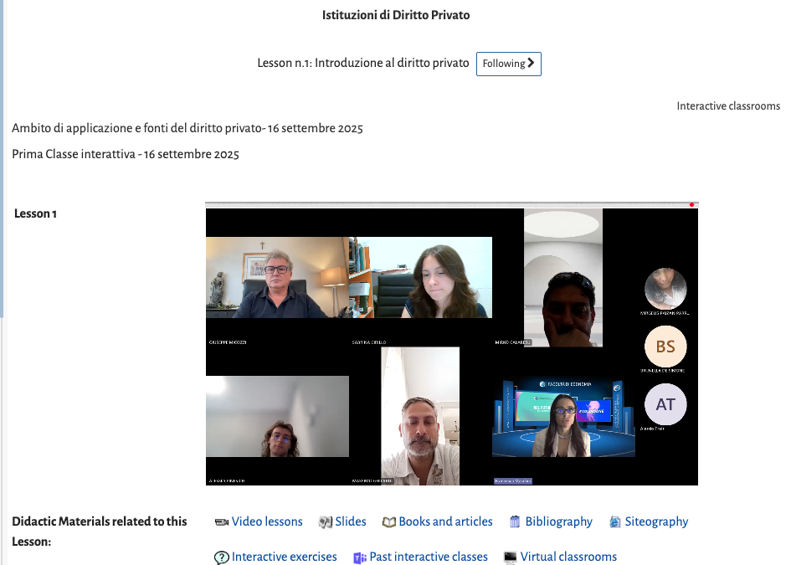
Figure 7. Online Training on Private Law - Pilot Course - September 2025

2. Institutional Home, Leadership and Team

2.1 Governance Structure
The KVC is institutionally embedded within the Research and Development Department (R&D) of Uninettuno. It does not operate as a silo but functions as a transversal unit connecting the five Faculties (Engineering, Economics and Law, Psychology, Communication, Cultural Heritage) with external stakeholders.

The governance model follows a Dual-Layer Administration:
- The Steering Committee: Composed of the Rector and Industry Representatives. This body defines the long-term scientific strategy and ensures alignment with the Smart Specialisation Strategy (RIS3) of the Lazio Region.
- The Operational Task Force: Led by the Research Manager, this team executes daily valorisation activities, including IP management, startup scouting, and curriculum design. The core team is currently planned to have 5 members, 3 academics and 2 non-academic staff, including administrative and technical personnel people whose expertise includes entrepreneurship, digital technologies, green transition, social innovation, and industrial design.

Together, the team will coordinate activities such as training, mentoring, matchmaking, living labs, and policy dialogue.
The internal governance structure ensures shared leadership, facilitation of the participation of students, and links to the University Strategic Plan, allowing valorisation activities to be integrated into the long-term strategy of the International Telematic University Uninettuno.
The KVC is not a temporary project structure but is designed for permanence. Its activities are integrated into the university’s Quality Assurance (QA) processes, ensuring that the entrepreneurial training provided creates recognised ECTS credits for students.
3. Stakeholder Ecosystem and Partnerships

3.1 The Digital Quadruple Helix
Uninettuno adopts the Quadruple Helix Model of Innovation, integrating four key spheres into the KVC’s workflow. Uniquely, this model is implemented through a digital feedback loop:
- Academia: Uninettuno’s global network of professors and researchers provides the raw "intellectual assets" (technologies, methodologies).
- Industry: A network of associated partners, ranging from multinational tech corporations to local SMEs. These partners do not just receive interns; they actively co-design the curricula to ensure market relevance (e.g., specific modules on Green Energy Management or AI Ethics).
- Government: Collaboration with regional bodies (e.g., Lazio Innova) to ensure the KVC’s startups can access public funding and regional venture capital.
- Civil Society: Through partnerships with NGOs and social enterprises, the KVC places a strong emphasis on Social Innovation, addressing challenges such as migration and gender inclusion in tech.

3.2 Proposed Partnerships
As of Phase 1, the Centre has proposed to formalise cooperation agreements with 4 key entities. Notable partners include:
MEDIAVOICE (Italy): Collaborating on AI and Deep Tech mentorship.
MATTERS (Italy): Providing AI agent tech facilities for student startups.
CIDAS (Italy) Focusing on migrants and refugees’ inclusion and social impact projects.

For Phase 2 the following are proposed:
DEMOCRACY X (Denmark): Emphasising policy making and ecosystem engagement in participatory design.

3.3 The Virtual "Open Innovation" Platform
A key differentiator of the Uninettuno KVC is the establishment of a Virtual Common Room. This digital environment allows stakeholders from different countries to interact synchronously. It functions as a permanent Virtual Living Lab where industry partners can post Innovation Challenges, and students can form cross-border teams to solve them.

4. Contribution to IMPACT-Campus KPIs (Phase 1)

The KVC has implemented and piloted a Monitoring and Evaluation (M&E) method to track its contribution to the IMPACT-Campus objectives. The current roadmap focuses on four critical dimensions:

4.1 Dimension 1: Building Entrepreneurial Training
Objective of the Pilot: To equip students and staff with transversal skills in sustainable entrepreneurship.
Methodology: Planning of the development of a MOOC (Massive Open Online Course) titled
"From Research to Business: The Sustainable Path."
This course utilizes Uninettuno’s video-lesson model, enriched with interactive exercises.
Target: Train 50 students and 10 academic staff.
Current status of the pilot: Curriculum defined, and didactic materials’ finalization.

4.2 Dimension 2: Business Acceleration
Objective: To transform academic research into viable business models.
Methodology: Planning of the development of the "Uninettuno Start-up Lab." This is an incubation program that guides selected teams through the Business Model Canvas, IP protection, and investor pitching.
Target: Support 2 start-ups or scale-ups.
Current status of the pilot: 2 teams coached.

4.3 Dimension 3: Ecosystem Integration
Objective: To reduce fragmentation in the innovation ecosystem.
Phase 1 Target: Establish 5 new strategic partnerships.
Activity: Planning the organization of 3 "University-Industry Matchmaking Events" as webinars/seminars during 2026.
Current status of the pilot: scheduling and management of events in progress.

Since the starting of the IMPACT Campus project activities, the UNINETTUNO has contributed directly to the key metrics defined in the IMPACT-Campus project. To date, Uninettuno has carried out:
- trained 9 students
- trained 5 academic staff
- trained 4 non-academic staff
- mentored 3 students
- supported 1 early-stage team

These achievements align with the KPI Framework of IMPACT-Campus: competence development, entrepreneurial capacity building, startup activation, and ecosystem connectivity.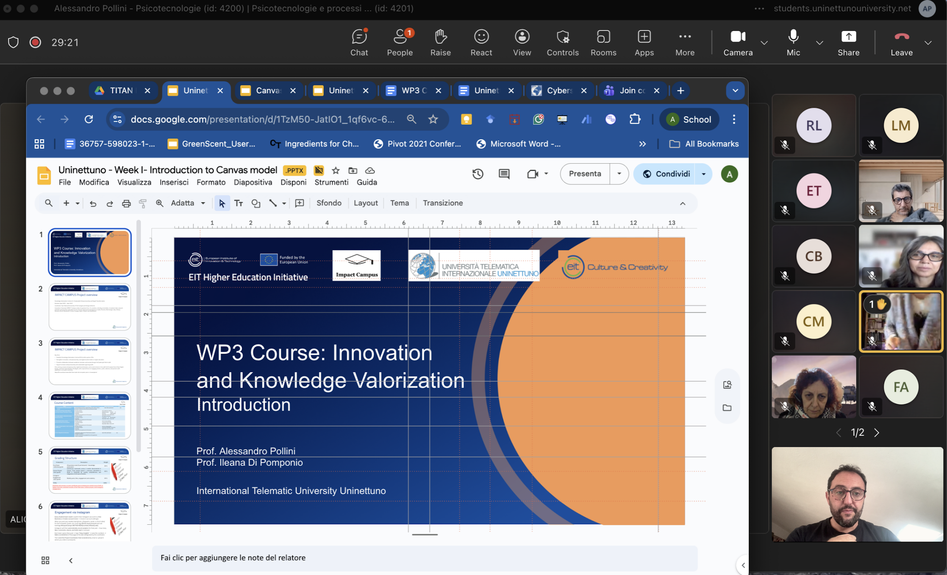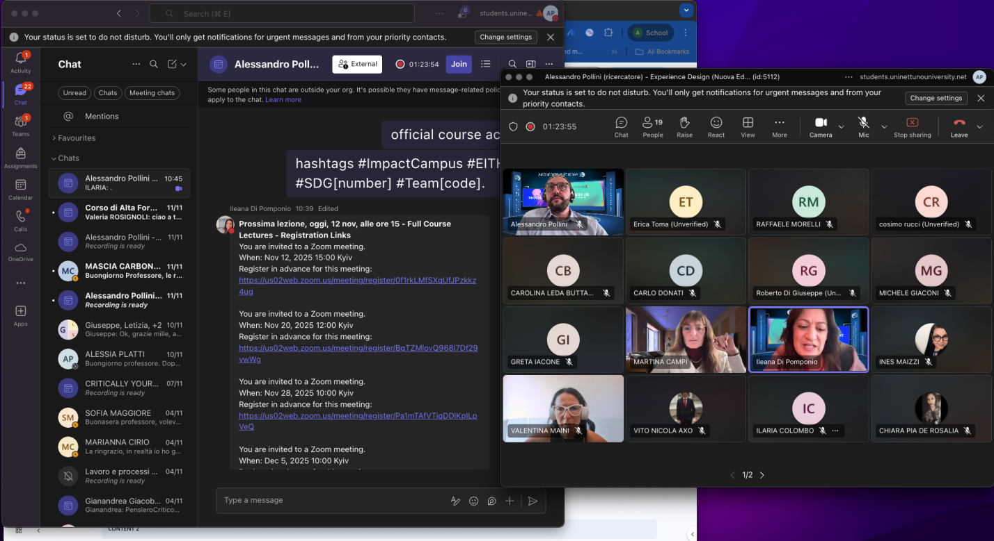
Figure 8. Online Training Sessions on WP3 Course Introduction - Week 1

5. Institutional and Regional Changes Enabled by the KVC
The establishment of the Uninettuno Knowledge Valorisation Centre (KVC) is not merely an additive project; it is a catalyst for structural transformation. This section details the systemic changes envisioned and currently being implemented at both the institutional and regional levels.

5.1 Internal Institutional Transformation
The Third Mission Integration Historically, Uninettuno has excelled in the first two missions of the university: Education and Research. The KVC formalizes the Third Mission (Innovation and Societal Impact) as a core pillar of the university's governance.

Curricular Innovation
The KVC acts as a feedback mechanism for the Academic Senate. Insights gained from industry partners in the KVC are channeled back into the faculties to update degree programs. E.g. the introduction of Micro-credentials in Sustainable Entrepreneurship (aligned with the European Council Recommendation 2022/C 243/02) can be stacked towards traditional degrees.

New Operational Units
The creation of the KVC may necessitate the formation of a specialized Technology Transfer desk within the administration, permanently enhancing the university’s capacity to manage complex innovation projects beyond the life of the IMPACT-Campus funding.

5.2 Regional and Systemic Impact
The "Phygital" Bridge at the regional level, the Uninettuno KVC addresses the fragmentation of the Lazio innovation ecosystem by functioning as a "Phygital Bridge".

Democratizing Innovation Access
Traditional incubators require physical presence, often excluding talented individuals in remote areas or those with mobility constraints. Uninettuno’s KVC leverages its telematic infrastructure to offer Distributed Incubation. This allows a student in a rural area of Lazio (or an international student in a developing region) to access the same high-quality mentorship and investor networks as a student in central Rome.

Sectoral Acceleration (Digital & Green)
The Center specifically targets the Twin Transition. By focusing on startups that apply digital technologies (AI, IoT, Blockchain) to sustainability challenges (Circular Economy, Smart Grids), the KVC supports the region's Smart Specialisation Strategy (RIS3) priorities.

Social Inclusion
In line with Uninettuno’s history (e.g., the University for Refugees initiative), the KVC prioritizes support for underrepresented groups. The roadmap includes specific quotas to ensure that at least 10% of supported entrepreneurs come from marginalized backgrounds (migrants, women in deep tech), thereby actively reducing the socio-economic innovation gap.

6. Strategic Importance of the KVC
The strategic relevance of the Uninettuno KVC extends beyond immediate KPIs, positioning the university as a pivotal actor in the European Higher Education Area (EHEA).

6.1 Alignment with EU Policy Frameworks
The KVC’s roadmap is rigorously aligned with high-level European Commission priorities:
- The New European Innovation Agenda: by fostering Deep Tech talents, the KVC directly responds to the flagship initiative on improving access to finance and talent for deep tech scale-ups.
- The Digital Education Action Plan (2021-2027): The KVC serves as a best-practice model for "Priority 2: Enhancing digital skills and competences for the digital transformation," proving that entrepreneurship education can be effectively delivered online.
- The European Green Deal: Through its thematic focus on sustainable ventures, the Center acts as a pipeline for "Green" innovations that contribute to the EU’s 2050 climate neutrality goal.

6.2 Uninettuno’s Competitive Positioning
For Uninettuno, the KVC is a differentiator that cements its leadership in EdTech Innovation. As a gateway to the Mediterranean, the KVC might leverage Uninettuno’s strong network in the Euro-Mediterranean region (partnerships in Tunisia, Egypt, Morocco, etc.),and serve as a soft-power tool, exporting European innovation standards and facilitating cross-border collaborations.

7. Plans for Phase 2 and Beyond
The roadmap for the KVC is designed for long-term sustainability. Phase 2 (Months 13-24) and the post-project period focus on scaling impact and securing financial independence.

7.1 Expansion of Services (Scaling Up)
Through the implementation of Open Innovation Challenges, the KVC will move in Phase 2 from pilot projects to large-scale impact. Corporate partners will sponsor specific problem statements and the KVC will crowd-source solutions from its global student body.
By scaling up its services the KVC will implement Advanced Mentoring Tracks. The introduction of specialized tracks for high-potential startups, including Legal Clinics (for IP defense) and Investment Readiness sprints will make KVC impacts tangible.

7.2 Financial Sustainability Strategy
To ensure the KVC operates permanently without sole reliance on grant funding, a diversified revenue model will be implemented including corporate membership model, with Industry partners paying an annual fee to access the Talent Pool and post challenges in the Virtual Living Lab, and a Freemium Education Model, that implement basic entrepreneurial training as free for students, and advanced "Executive Education" modules for external professionals will generate tuition revenue.

7.3 Knowledge Transfer to the Network
Uninettuno commits to acting as a mentor node within the IMPACT-Campus consortium. We will codify our Digital KVC methodology into a White Paper on Digital Innovation Hubs, sharing our best practices on remote mentoring and virtual ecosystem building with other European universities.

Future priorities include:
- Policy Makers dealing with Regional Sectoral Specialization
- Transfer and pilot KVC experience to other Uninettuno partners in Italian or European regions in IMPACT-Campus network.
- Establishment of KVC in the Metaverse initiative

EIT Higher Education Initiative
IMPACT-Campus: Knowledge Valorization Centres for Sustainable Entrepreneurship and Digital Transformation - Fourth Call for Proposals (October 2024) – Strand A
Knowledge Valorisation Centre
Uninettuno Knowledge Valorisation Centre



Prepared by: Prof. Alessandro Pollini, PhD, Associate Professor of Design
Date: December 2025

