
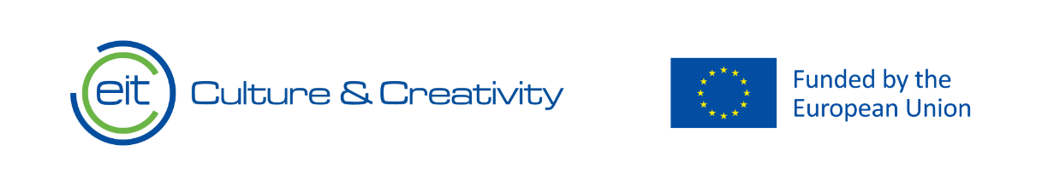

Knowledge Valorisation Centre Institutional Brief
Mediterranean School of Business

Prepared by MADIHA FERJANI, Dr. Associate Dean on Strategic Initiatives and AMIRA BOUZIRI, DR. Associate Professor
EIT HEI Initiative – IMPACT-Campus: Knowledge Valorization Centres for Sustainable Entrepreneurship and Digital Transformation
Fourth Call for Proposals (October 2024), Strand A
This Knowledge Valorization Center profile is based on the conceptual framework “IMPACT-Campus: Knowledge Valorization Centers for Sustainable Entrepreneurship and Digital Transformation”.

1. Introduction and Regional Context
The Knowledge Valorization Center KVC is based at Mediterranean School of Business in Tunis, Tunisia. Strategically located in the Maghreb region of North Africa, Tunisia is a Mediterranean country neighboring Algeria from the West and Libya from the South. It operates in a regional environment characterized by economic, environmental, and social challenges. Tunisia youth sparked the Jasmine Revolution in 2011. Due to the unstable economic environment and currency depreciation, the country was reclassified in 2020. Despite these challenges, Tunisia provides an attractive ecosystem for startups to grow with active incubators, accelerators, co-working spaces, and growing access to venture capital, the Tunisia ecosystem thrives. Founders benefit from a high quality of life, affordable living costs, and a well-educated, multilingual talent pool Tunisia’s innovation profile, as measured scientifically by the GII, remains relatively robust within its regional and income peer groups, pointing to a potential foundation for future development. Human capital (e.g., graduates in science/engineering) , research and knowledge & technology outputs (e.g., patent filings, ICT service exports) are considered a major strength. This indicates a solid foundation of skills and some capacity to generate innovative outputs, though often constrained by the broader economic environment. Human capital is not sufficiently being leveraged as talent leaves the country to grasp better opportunities.
Tunisia remains in a democratic transition following the 2011 revolution. Its sectoral strengths are anchored in a diversified light manufacturing base (automotive components, aerospace, and textiles), a robust tourism sector, and a strong agricultural export industry focusing on olive oil and dates. Key challenges include high youth unemployment, weak public finances, health management services need improvement, water scarcity, an inefficient state-owned enterprise sector, and the need for deeper structural reforms to unlock sustainable growth.

The Center was officially opened on [OPENING_DATE_IN_2025] within the framework of the project IMPACT-Campus: Knowledge Valorization Centres for Sustainable Entrepreneurship and Digital Transformation, funded under the EIT HEI Initiative, Fourth Call 2024, Strand A.
Designed from the outset as a bridge between higher education, industry, public authorities, and civil society, the Center carries a mandate to translate knowledge into tangible impact for the region.

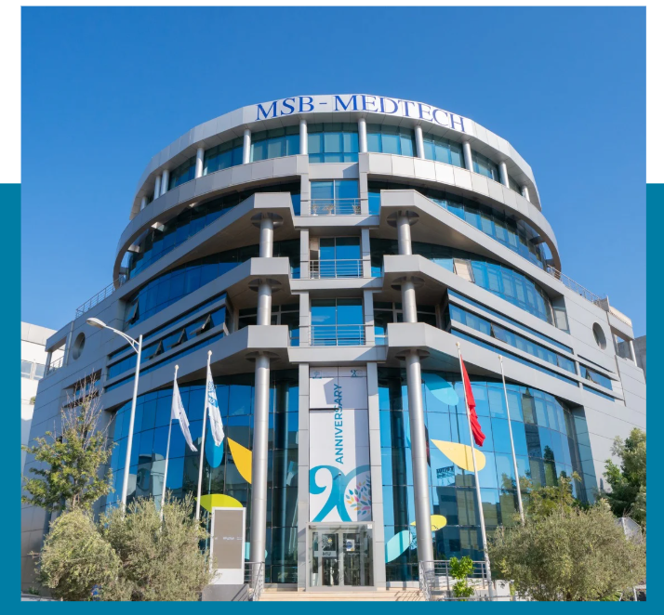
MSB Main Building

2. Institutional Home, Leadership and Team
The Center is hosted by MEDITERRANEAN SCHOOL OF BUSINESS WITHIN SOUTH MEDITERRANEAN UNIVERSITY and led by [KVC_LEADER_NAME AND POSITION]. The core team currently consists of 7 TEAM_MEMBERS members whose expertise includes ENTREPRENEURSHIP, BUSINESS INCUBATION, GREEN TRANSITION, SOCIAL INNOVATION, FINANCIAL VALUATION, CRITICAL THINKING AND COMMUNICATION and MARKETING, DESIGN THINKING and INNOVATION.
Together, the team coordinates activities such as TRAINING/WORKSHOPS, BOOTCAMPS, CAPACITY BUILDING, MENTORING, COACHING, MATCHMAKING, LIVING LABS, POLICY DIALOGUE.
The internal governance structure ensures:
- SHARED LEADERSHIP WITH OUR ENGINEERING SCHOOL, MEDTECH, OUR HEALTH MANAGEMENT SCHOOL, MSH AND OUR CULTURAL AND LANGUAGE CENTER LCI,
- Collaboration with the Research Center, Alumni and Career Center, and SMU Foundation
- PARTICIPATION OF STUDENTS students are involved in the SMU incubator as contributors
- MANAGEMENT provides support and talent
allowing valorisation activities to be integrated into the long-term strategy of MEDITERRANEAN SCHOOL OF BUSINESS AND SOUTH MEDITERRANEAN UNIVERSITY.
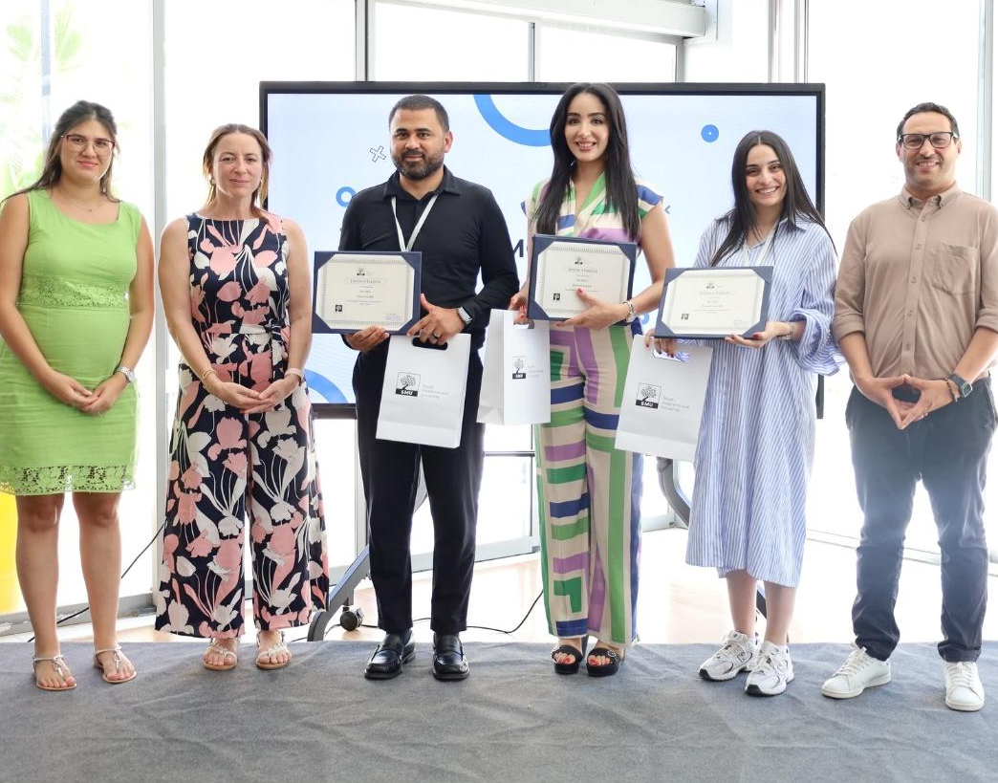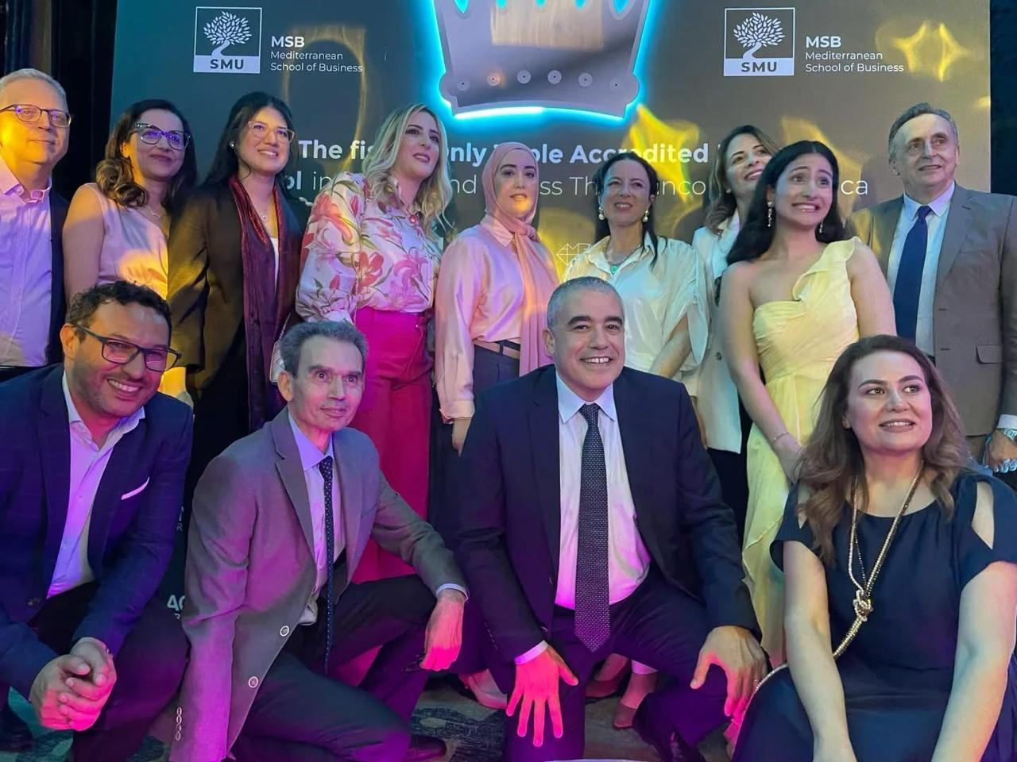

3. Stakeholder Ecosystem and Partnerships
The ecosystem around [MSB KVC] includes stakeholders such as: SMU ALUMNI, INVESTORS, FOUNDATIONS, SMEs, LARGE COMPANIES, TUNISIAN DIASPORA, BUSINESS LEADERS, NGOS, ORGANIZATIONS, INCUBATORS, CHAMBERS OF COMMERCE etc.
The Center has formalised cooperation with more than 100 AGREEMENTS; Partners, Key PARTNERS include: Banks, international companies, retailing companies, Consulting companies, such EY & Delitt,Tunisian Enterprise Fund, Technology integration companies, CHAMBERS OF COMMERCE]. These agreements underpin collaboration in domains such as: INTERNSHIPS, STARTUP SUPPORT, CASE STUDIES, STUDENT PROJECTS, PARTICIPATION IN EVENTS.
Alongside this, informal cooperation with [OTHER RELEVANT ACTORS] contributes to the creation of a functional regional innovation and knowledge valorisation ecosystem.
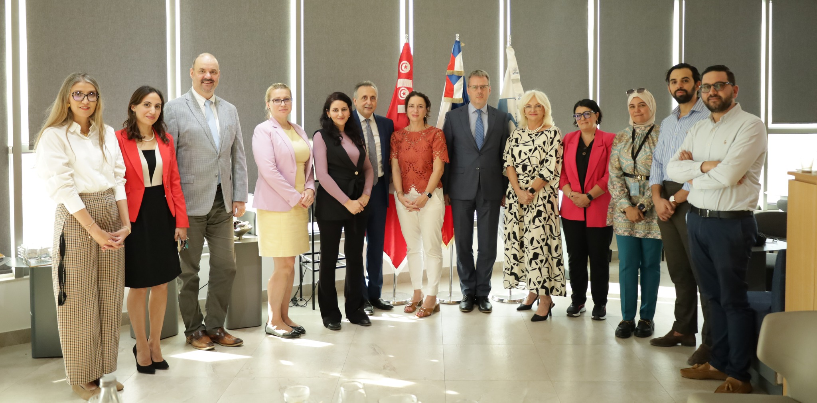
Agreement Signature with Tunisian Sweden Chamber of Commerce
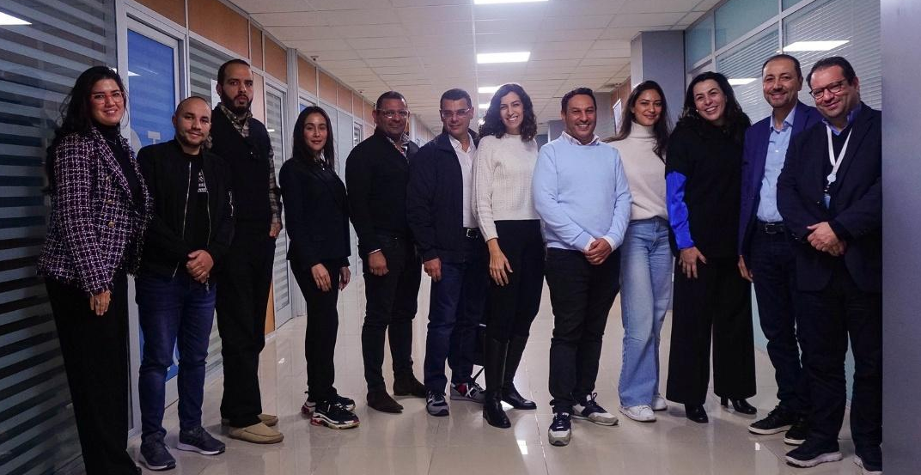

4. Contribution to IMPACT-Campus KPIs (Phase 1)
Since its establishment, MSB KVC has contributed directly to the key metrics defined in the IMPACT-Campus project. To date, the Center has:
- trained [32] students
- trained [10] academic and non-academic staff
- mentored [11] students, academic and non-academic staff
- supported [3] startups or early-stage teams
- contributed to [0] new ventures
- established or strengthened [2] regional partnerships
These achievements align with the KPI Framework of IMPACT-Campus: competence development, entrepreneurial capacity building, startup activation, and ecosystem connectivity.
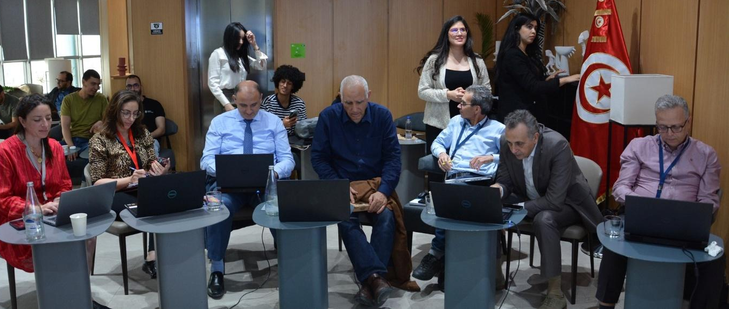
Jury members evaluate Startup pitching and workshops
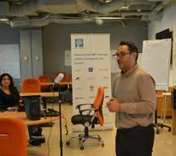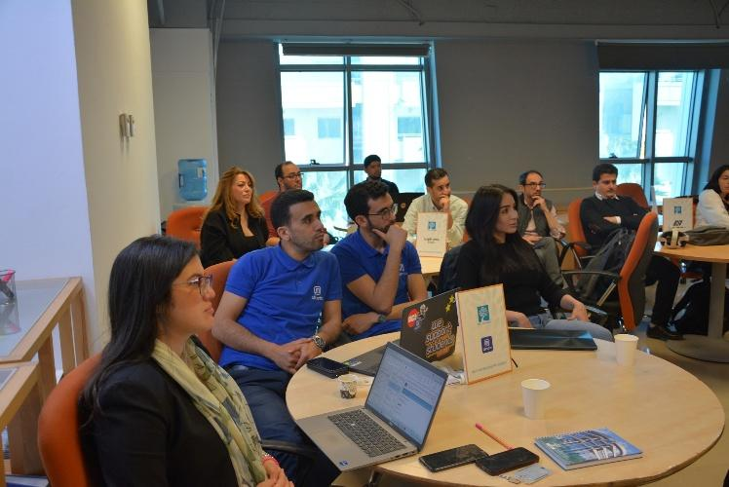
Trainings, workshops, Mentoring sessions
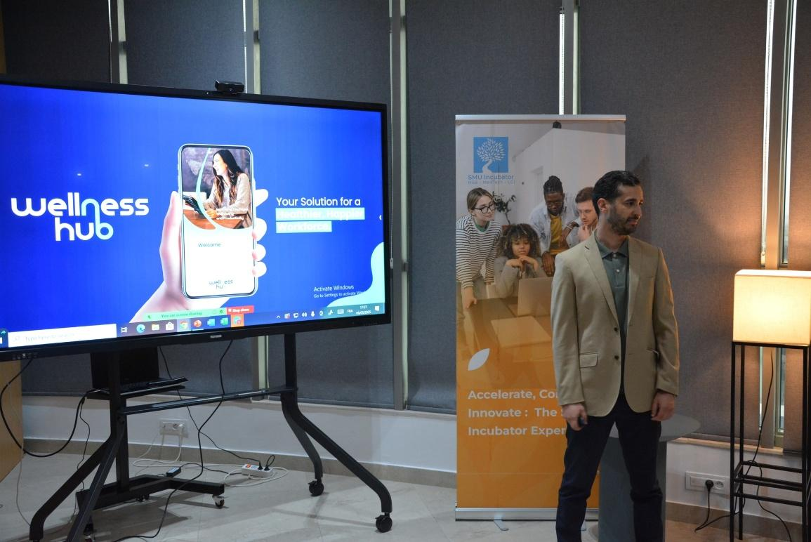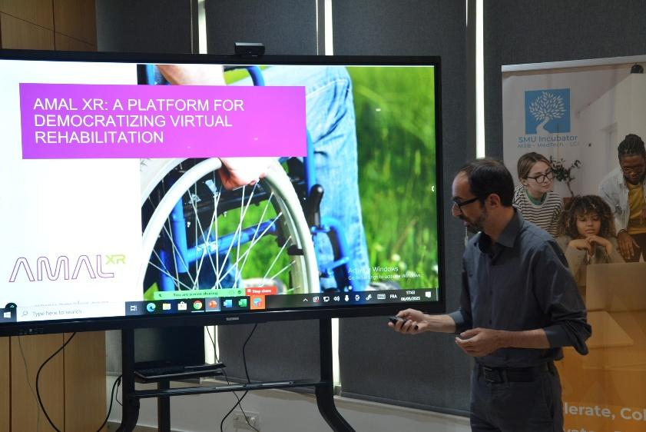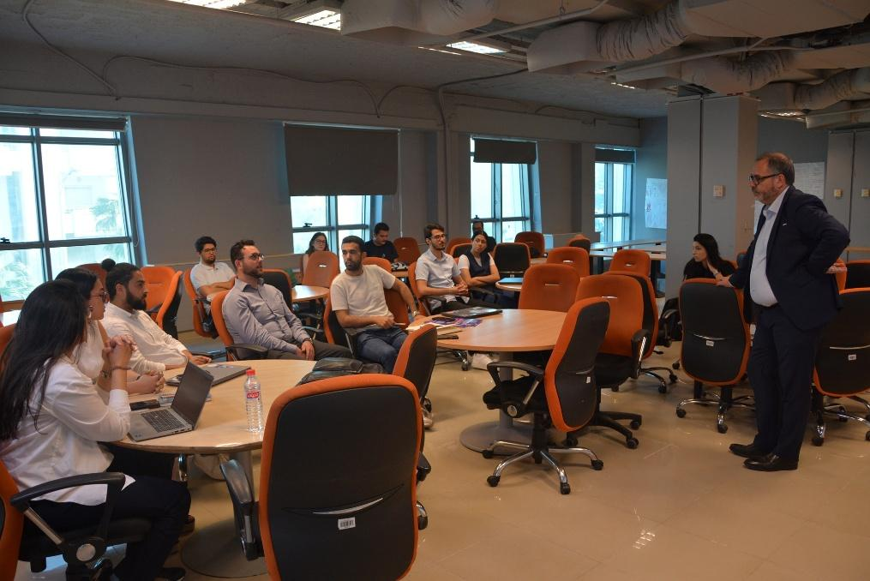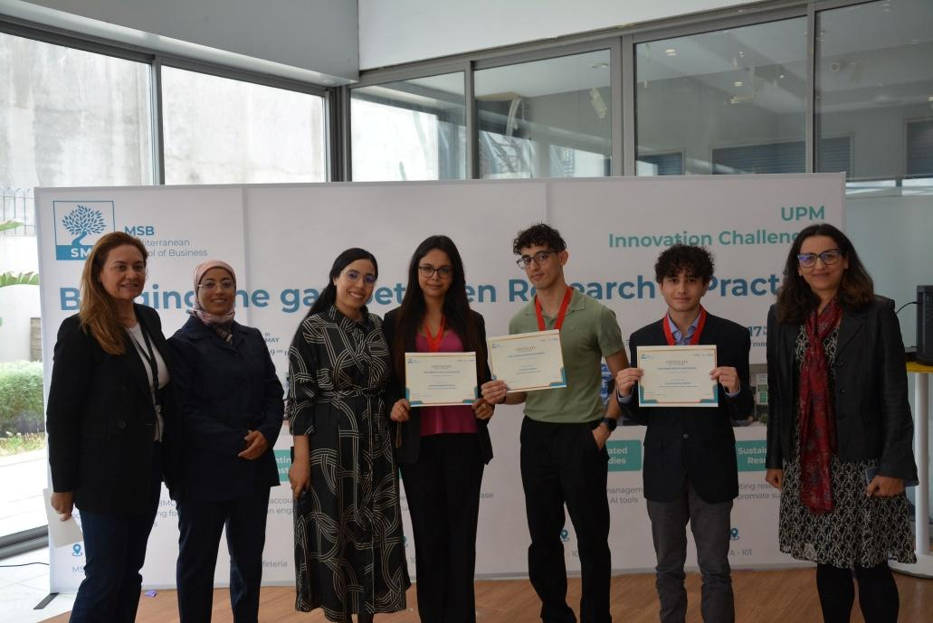
Students receive certificates for the Innovation Challenge competition about sustainability

5. Institutional and Regional Changes Enabled by the KVC
The establishment of The KVC has already influenced the development of the Mediterranean School of Business. Key transformations include:
courses improvements, new programs under development, updated curricula, new internal policies, stronger links between faculties and external partners.
At the regional level, the center has contributed to giving visibility of local startups, recognition as SSO by smart capital, connecting universities and the entrepreneur ecosystem, increasing participation of women and marginalized groups, accelerating digital and green transformation in many sectors.
Another initiative is a Researchers–Startups Speed-Dating Event designed to foster collaboration between academic researchers and innovative startups. The event took place on December 9th and featured startup presentations, researcher introductions, and an interactive networking session. Startups shared their applied research needs in areas such as AI-driven solutions, EdTech scalability, Lean Management, AgriTech adoption, and corporate wellness analytics. Researchers are invited to contribute their expertise to co-develop impactful solutions addressing these challenges. By joining, participants gain a unique opportunity to explore partnerships that bridge research and industry for real-world impact.
These examples show how IMPACT-Campus KPIs correspond not only to numerical achievements but also to structural change in the production, dissemination, and valorisation of knowledge.

First Edition of Startup Fest
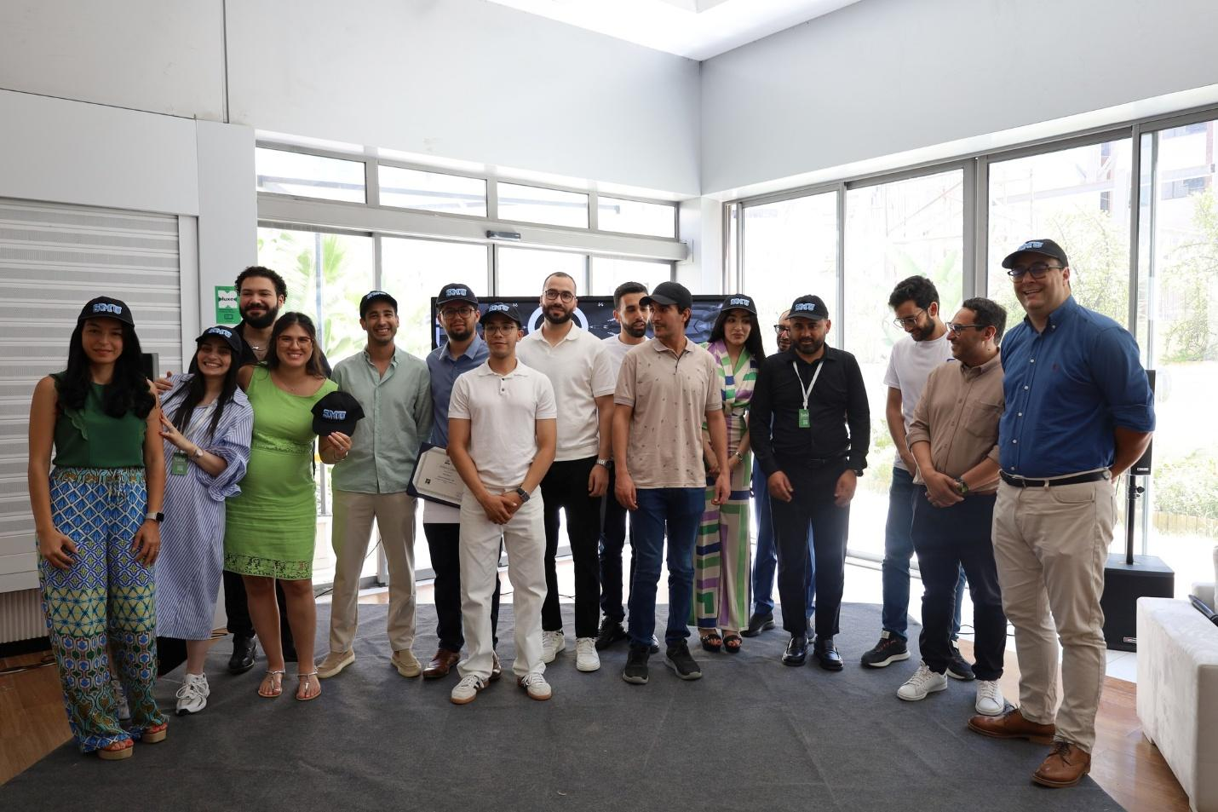

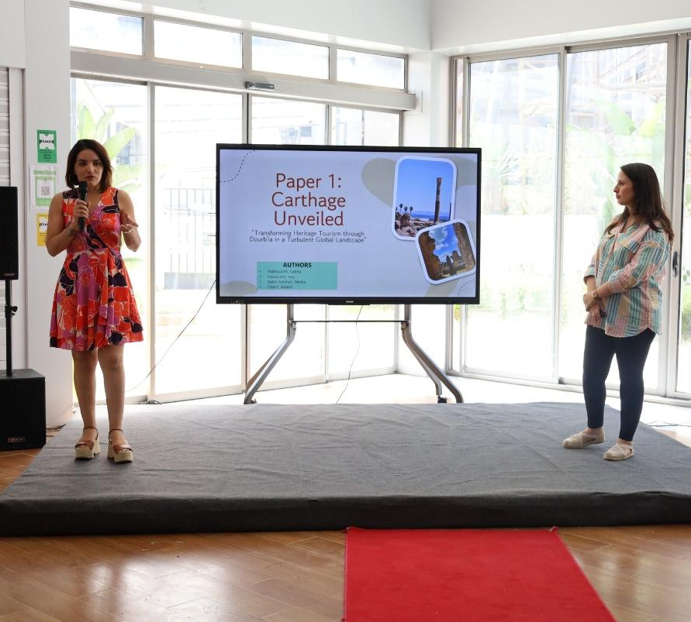
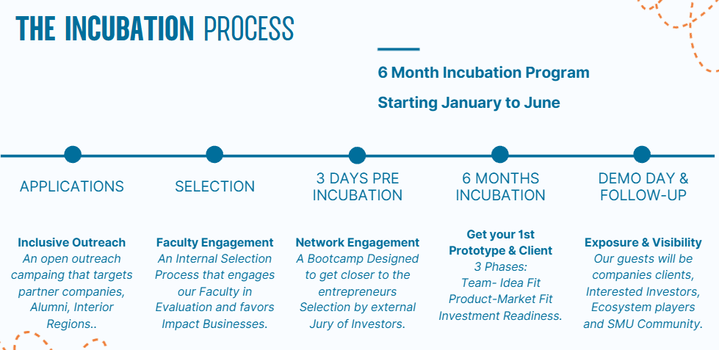
Improvement of our incubation process
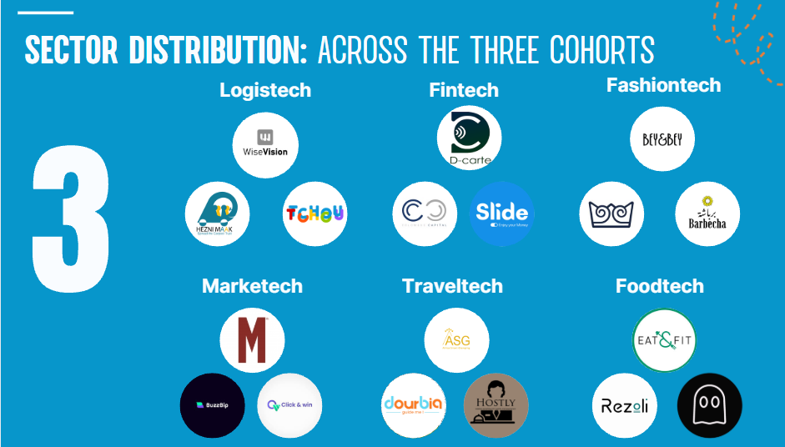
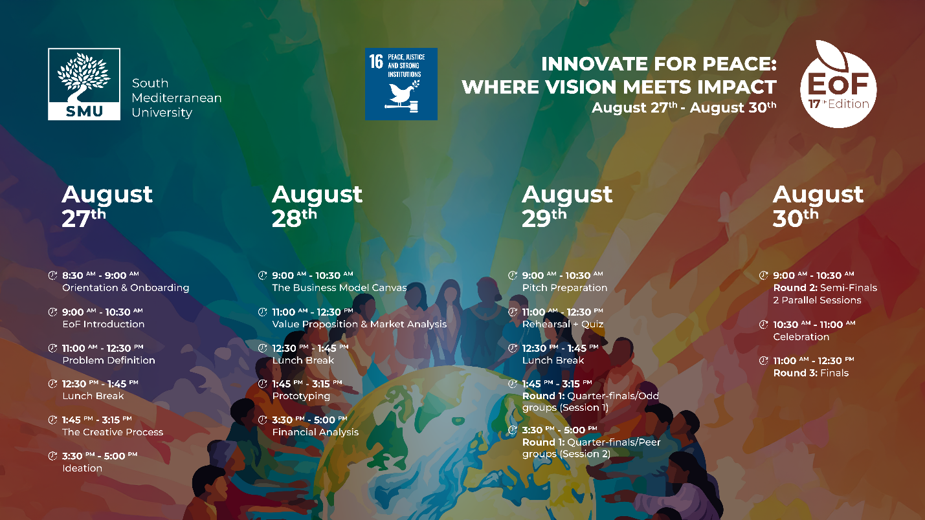
Launch of Innovation Challenges and Revamping of EoF (Entrepreneurs of the Future course)

6. Strategic Importance of the KVC
Participation in Impact-campus and the establishment of MSB KVC are significant for Mediterranean School of Business], as they enable the institution to [align with its strategy to strengthen its entrepreneurial, sustainability and innovation focus, increase international visibility, engage students in real-world projects, strengthen its strategy for producing impactful quality applied research relevant to our region and knowledge dissemination].
For the region of Tunisia, Mediterranean Sea and North Africa, the center serves as
- a hub to empower entrepreneurs and spinoffs to drive innovation, sustainable growth, & create impactful ventures through strategic investment and sustainable market development.
- a springboard for innovation projects, access to training and mentoring, a platform for cross-border and interdisciplinary cooperation.
For the wider Impact-campus network, MSB KVC provides : a multidisciplinary knowledge, a combination of health, & engineering expertise to empower youth through interdisciplinary open innovation, a strong network of alumni, commitment to responsible leadership and sustainability specialisation, and a gateway to Africa. It provides a co-creation platform, transforming data and knowledge into sustainable products, business, experiences, ideas, and solutions for Tunisia and beyond.

7. Plans for Phase 2 and Beyond
Looking ahead, KVC plans to build on the achievements of Phase 1 by:
- Post Incubation program: SCALING TRAINING PROGRAMMES and EXTENDING MENTORING,
- Launching Research Startup Speed Dating
- Financial Support and incentives
- Develop our Makerspace: Coworking Space, 3D printer, Labs, Access Library, Boxes, Meeting Rooms
- Launching a new cohort of Startups.
Future priorities include:
- Actors are still missing from the ecosystem: Edtech companies, simulations, International investors, business angels, testbeds, Financial institutions, Digital and AI, experts, coaches and mentors.
- Which KPIs should be prioritised next: Number of Collaborations of Startups with Faculty, Growth and acceleration of current and future startups, Revenue generation, Number of Sustainable solutions, and startups.
- How the Center’s experience can be transferred to other regions in IMPACT-Campus: Collaboration in events such as pitching, mentoring, workshops, Sharing expertise and knowledge platforms, technology transfer programs, exchange opportunities; collaborations with other researchers involved in incubation programs.

8. Title Page Template (for each KVC)
EIT Higher Education Initiative
IMPACT-Campus: Knowledge Valorization Centres for Sustainable Entrepreneurship and Digital Transformation
Fourth Call for Proposals (October 2024) – Strand A
Knowledge Valorisation Centre
MEDITERRANEAN SCHOOL OF BUSINESS
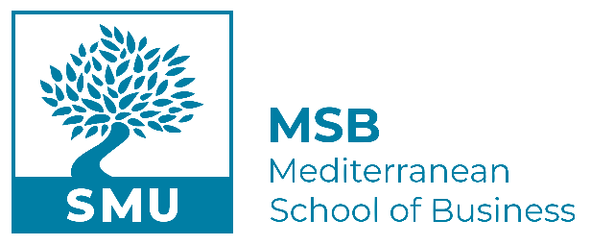
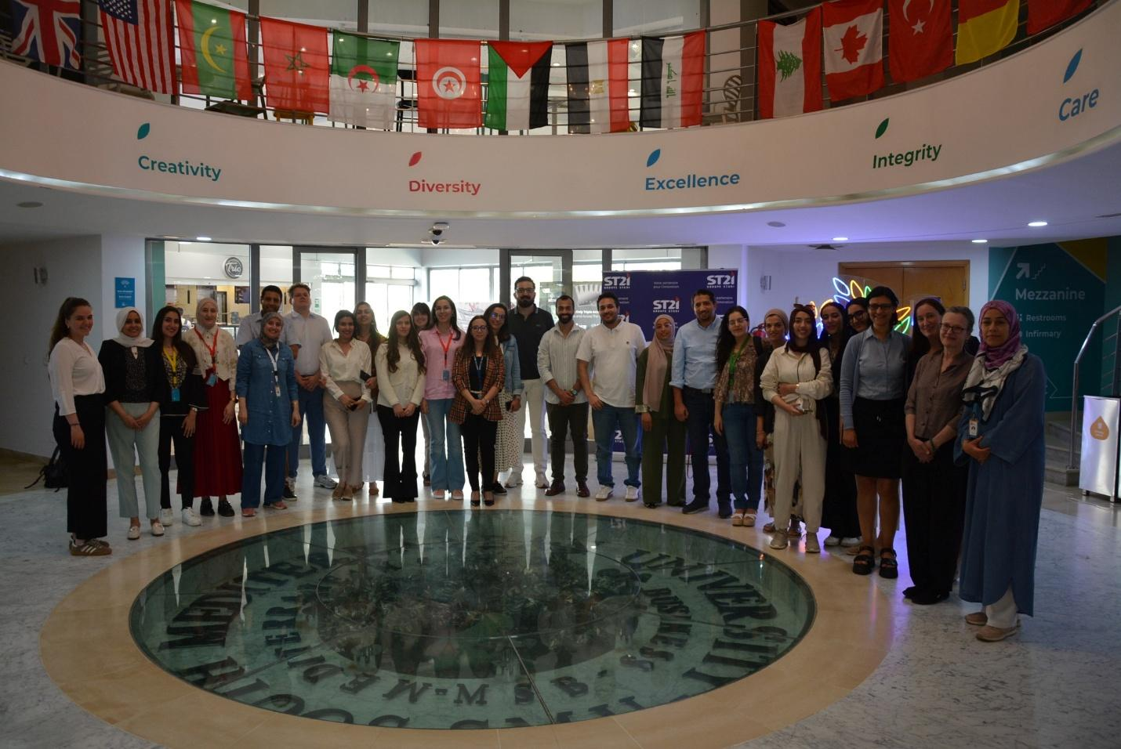
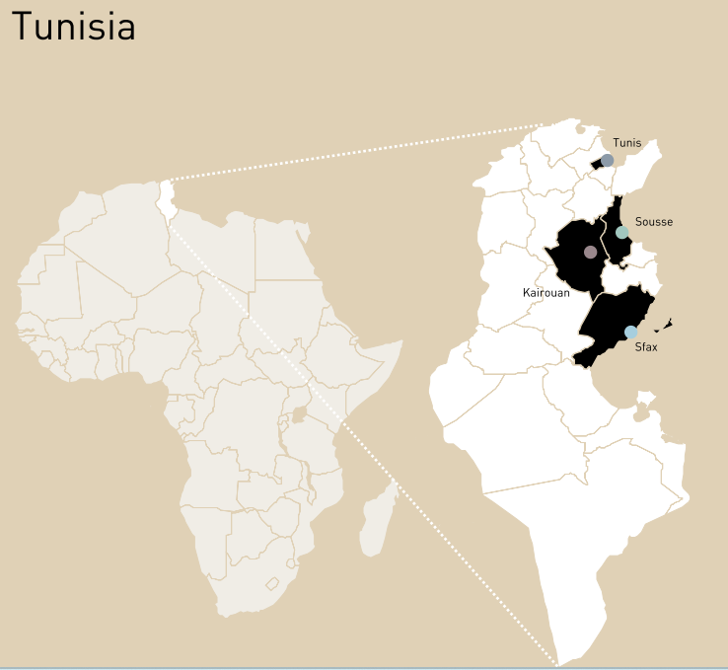

Prepared by:

Dr. MADIHA FERJANI, ASSOCIATE DEAN ON STRATEGIC INITIATIVES
DR. AMIRA BOUZIRI, ASSOCIATE PROFESSOR
Dr. NOOMEN LAHIMER, SMU INCUBATOR DIRECTOR
Date: DECEMBER 2025

