

Knowledge Valorisation Centre Institutional Brief
University FINRA Tuzla

Prepared by Aldijana Omerović, MA of IT, University FINRA Tuzla
EIT HEI Initiative – IMPACT-Campus: Knowledge Valorization Centres for Sustainable Entrepreneurship and Digital Transformation
Fourth Call for Proposals (October 2024), Strand A
This Knowledge Valorisation Center profile is based on the conceptual framework “IMPACT-Campus: Knowledge Valorization Centres for Sustainable Entrepreneurship and Digital Transformation”.

1. Introduction and Regional Context

The Knowledge Valorisation Centre of the University FINRA Tuzla (FINRA KVC) was formally established through a Senate Decision dated 18 July 2025, with the aim of fulfilling the institutional responsibilities defined under the IMPACT-Campus project: Knowledge Valorization Centres for Sustainable Entrepreneurship and Digital Transformation, funded under the EIT HEI Initiative, Fourth Call 2024, Strand A.
The Decision explicitly mandates the Centre to support:
- training of students and academic staff in digital skills and entrepreneurship,
- mentoring and development of start-up ideas,
- establishment of new partnerships,
- strengthening innovation capacity in the underserved regions of the Western Balkans.
Situated in the Tuzla Canton—a region characterized by rapid digitalisation, rising demand for fintech solutions, and a strong need for structured innovation support—FINRA KVC responds to key societal and economic challenges by:

• Enhancing knowledge valorisation
Transforming academic knowledge into socially and economically relevant innovations.

• Building digital and entrepreneurial competencies
Through structured training programs, workshops and mentoring, the Centre contributes directly to the empowerment of youth, professionals, and underrepresented groups.

• Supporting start-ups and innovation
FINRA has a longstanding tradition in IT education, digital marketing, data literacy and fintech training, positioning the Centre as a natural driver of an innovation pipeline for the region.
Designed from the outset as a bridge between higher education, industry, public authorities, and civil society, the Center carries a mandate to translate knowledge into tangible impact for the region.
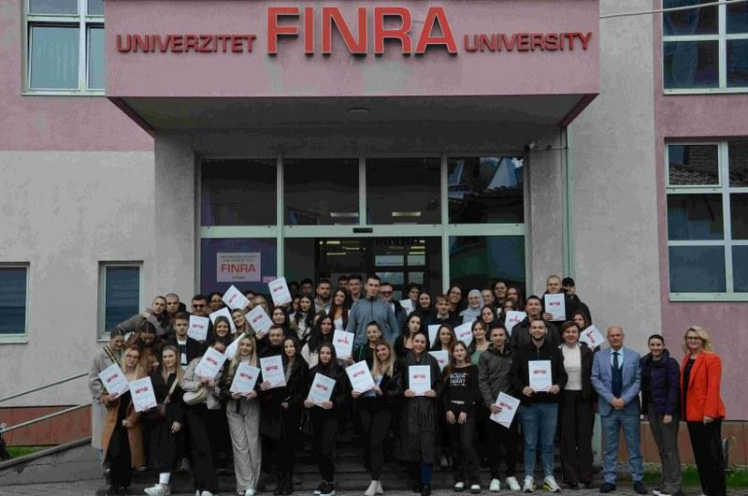
Figure 1 FINRA University

The Knowledge Valorisation Centre (KVC) of the University FINRA Tuzla is housed within the institution’s Multimedia Centre, as defined in the official Senate Decision on the establishment of the Centre .
This provides a modern, technologically equipped environment that enables the implementation of innovation, digital skills training, entrepreneurship development and community engagement activities.
The facilities and equipment available to the KVC include:
- Multimedia Centre
The Multimedia Centre serves as the primary operational hub of the KVC and includes:
- Smart classrooms equipped with projectors, interactive boards and digital presentation systems
- Recording and streaming equipment for hybrid teaching, webinars and online events
- High-performance computers for data analysis, design and software training
- Video conferencing facilities supporting collaboration with partner institutions across the IMPACT-Campus network
- Flexible learning space for workshops, hackathons, mentoring sessions and peer-to-peer learning
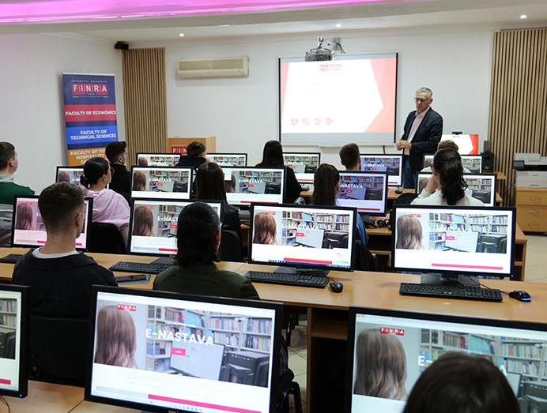
Figure 2 Multimedia Center
The Centre is designed to accommodate both group trainings and individualized mentoring formats required for knowledge valorisation activities.

IT and Computer Laboratories
FINRA maintains several IT laboratories used for digital skills training and startup development programmes:
- Computers with modern specifications suitable for programming, data analysis, fintech simulations and multimedia work
- Software for education in IT, finance, economics, digital marketing and business analytics (SPSS, SPIN)
- Secure Wi-Fi and network infrastructure enabling cloud-based work and remote collaboration
- Access to e-learning platforms for blended and asynchronous training delivery
- Information System-UISBAX


.

Figure Modern equpiment

Dedicated Training Rooms

To support continuous education and lifelong learning, FINRA provides:
- Training classrooms equipped with projection systems and modular furniture adaptable for teamwork
- Seminar rooms for mentoring, brainstorming sessions and advisory meetings
- Rooms for group project work with whiteboards, flipcharts and collaborative tools
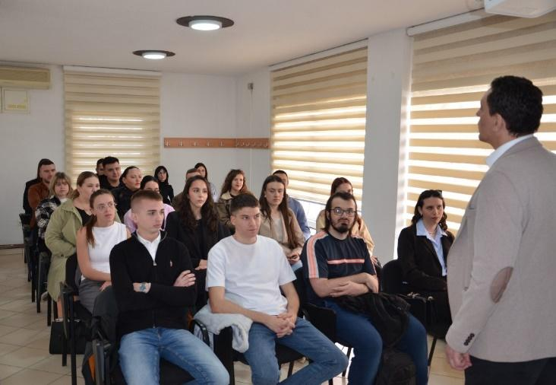
Figure 4 Training classroom
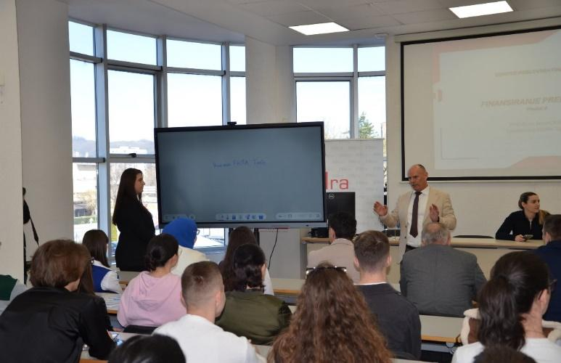
Figure 5 Seminar room
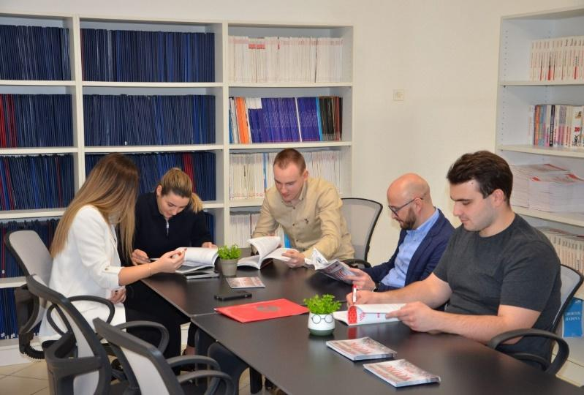
Figure 6 Rooms for group project work
These spaces are essential for the KVC’s mission to train students, staff, and community members in innovation and entrepreneurship.

Administrative and Coordination Offices
The KVC leadership and operational teams have access to:
- offices for the KVC Manager and Coordinators
- meeting rooms for planning and coordination
- administrative support spaces for project management, reporting and documentation
This ensures smooth organizational functioning and alignment with IMPACT-Campus management requirements.

Digital Infrastructure and Learning Platforms
The University FINRA provides modern digital infrastructure supporting the KVC’s educational and innovation activities:
- Internal LMS/e-learning system
- Cloud-based collaboration platforms (used for team projects and mentoring)
- Tools for digital literacy, financial simulations, and business modelling
- Secure servers for storing teaching materials, reports and project documentation
This infrastructure enables efficient delivery of both synchronous and asynchronous learning formats, consistent with the IMPACT-Campus training model.
- Community and Event Spaces
For public events, conferences, competitions and outreach activities, the University provides:
- Large lecture halls suitable for regional events and innovation programs
- Spaces for student exhibitions and demo days
- Public access areas for hosting innovation challenges, startup showcases and community workshops
These facilities make it possible for FINRA KVC to function as a regional innovation hub, accessible not only to university members but also to external stakeholders and vulnerable groups.
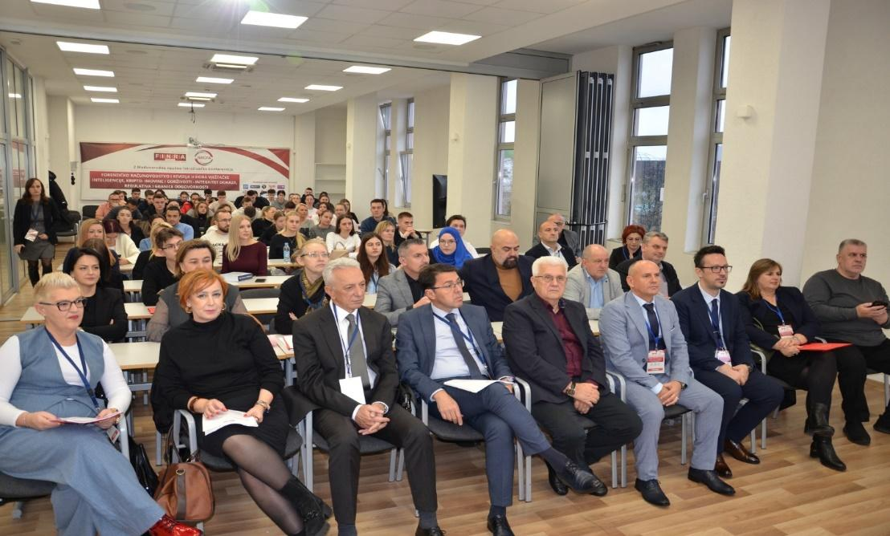
Figure 7 Large lecture hall

2. Institutional Home, Leadership and Team
According to the official Decision, the FINRA KVC is located within the Multimedia Centre of the University FINRA Tuzla, which provides the infrastructure and resources for the Centre’s activities.

Leadership Structure
- Head of the Centre: Prof. Dr. Saša Čekrlija
- Coordinator of Centre Operations: MSc Aldijana Omerović
- Coordinator for Start-up Development: MSc Adem Azapagić
- Coordinator for Digital Literacy: MSc Šejla Mandić

Operational Teams
Digital Skills & Entrepreneurship Training Team:
Ahmedin Hasanović, Nermin Kalić, Belma Mešić, Amra Hasanbašić, Amela Hajdarević, Adin Glogić
Digital Literacy Capacity-Building Team:
Edvin Murgać, Azra Gogić, Anisa Redžić, Dženita Mujić, Adin Ćosićkić
The structure is unique within the consortium because it includes not only academic staff but also a significant group of trained student-assistants, enabling peer-to-peer learning models and rapid skill dissemination.
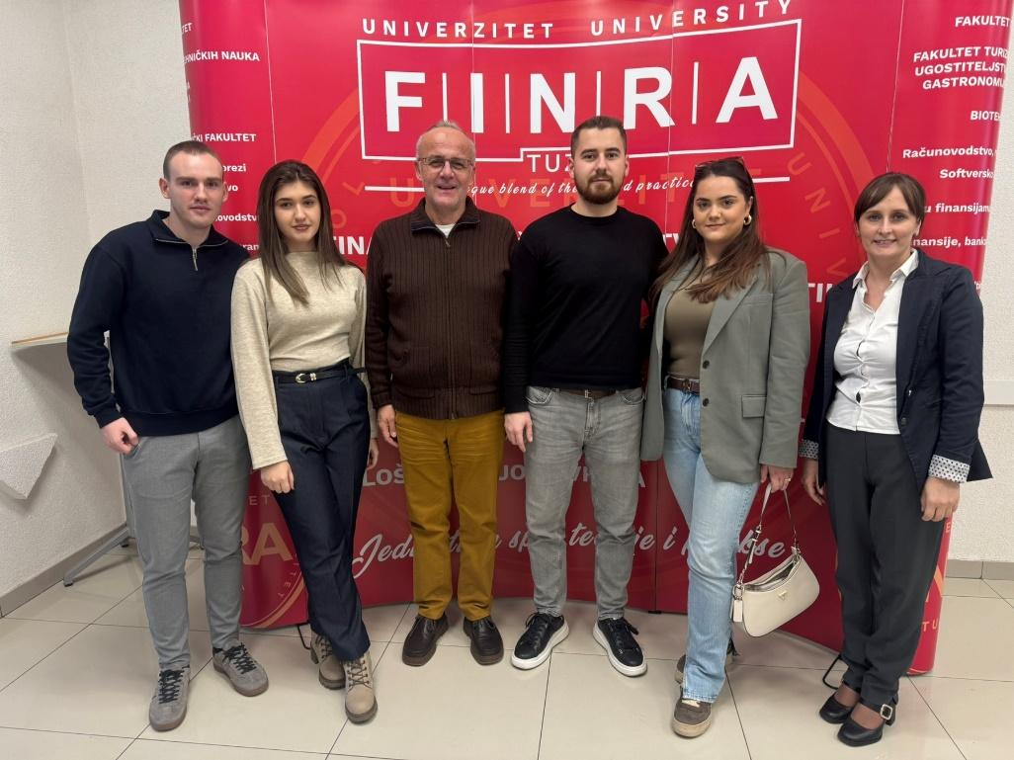
Figure 8 Group photo of KVC FINRA team

3. Stakeholder Ecosystem and Partnerships

In the period following July 2025, the University FINRA Tuzla significantly expanded its network of institutional partnerships, strengthening its capacity for knowledge valorisation, professional training, innovation development, and international cooperation. These newly established agreements directly support the mission of the FINRA Knowledge Valorisation Centre (KVC) and enhance collaboration between higher education, industry, public institutions, and international academic partners.
The following cooperation agreements have been formally signed or initiated after July 2025:

1. FinTech doo
Date: December 2025
Type of cooperation: This Agreement establishes the principles, commitments, and cooperation mechanisms between the Knowledge Valorization Centre and representing local authorities, community organisations, civil society actors, or regional development bodies. Its purpose is to create a structured, long-term collaboration framework enabling both parties to jointly support innovation, entrepreneurship, skills development, and societal engagement within the region.

2. ERAZMO Centar za promociju cjeloživotnog učenja
Date: December 2025
Type of cooperation: This Agreement establishes the principles, commitments, and cooperation mechanisms between the Knowledge Valorization Centre and representing local authorities, community organisations, civil society actors, or regional development bodies. Its purpose is to create a structured, long-term collaboration framework enabling both parties to jointly support innovation, entrepreneurship, skills development, and societal engagement within the region.

3. ICC Konsultantska kuća
Date: December 2025
Type of cooperation: This Agreement establishes the principles, commitments, and cooperation mechanisms between the Knowledge Valorization Centre and representing local authorities, community organisations, civil society actors, or regional development bodies. Its purpose is to create a structured, long-term collaboration framework enabling both parties to jointly support innovation, entrepreneurship, skills development, and societal engagement within the region.

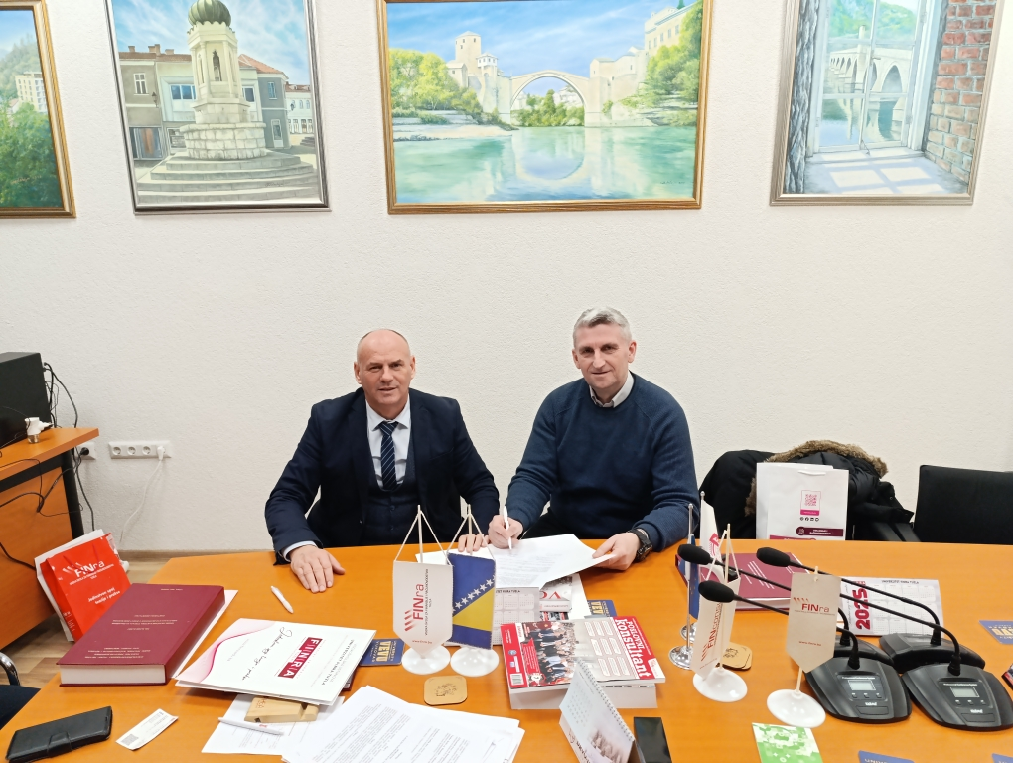
Figure 9 Partnership with ICC

4. Contribution to IMPACT-Campus KPIs (Phase 1)
During Phase 1, the University FINRA Tuzla contributed to the IMPACT-Campus KPIs primarily through its active participation in consortium-wide training activities and through internal institutional strengthening under WP2. While FINRA did not organise its own standalone training sessions during this period, it made measurable contributions to the KPIs by engaging staff and students in training delivered by partner universities, and by delivering one expert lecture within a joint WP3 learning module.
These activities, combined with the formal establishment of the FINRA Knowledge Valorisation Centre (KVC), represent FINRA’s validated KPI outputs for Phase 1.
FINRA staff and students participated in the consortium’s Phase 1 training programme on sustainable entrepreneurship, innovation methods, and digital skills delivered under WP3 by partner HEIs.
A FINRA professor delivered one lecture within the WP3 training cycle, contributing expert knowledge to the consortium.
A major KPI achievement for FINRA in Phase 1 is the formal creation and operationalisation of its Knowledge Valorisation Centre, including:
- designation of leadership and operational teams,
- allocation of Multimedia Centre and IT facilities,
- definition of KVC mandate and strategic functions.
FINRA contributed strongly to the partnership KPI through new agreements Over 350 existing cooperation agreements with companies and institutions continue to support student internships, joint projects, and community activities.
Since its establishment KVC University FINRA Tuzla has contributed diectly to the key metrics defined in the Impact Campus Project. To date, the Center has:
- 35 trained students,
- 5 trained academic and 5 trained non-academic saff,
- 5 mentored students, 2 mentored academic and 2 mentored non-academic staff,
- Established or strengthened 5 partnerships
These achievements align with the KPI Framework of IMPACT-Campus: competence development, entrepreneurial capacity building, startup activation, and ecosystem connectivity.

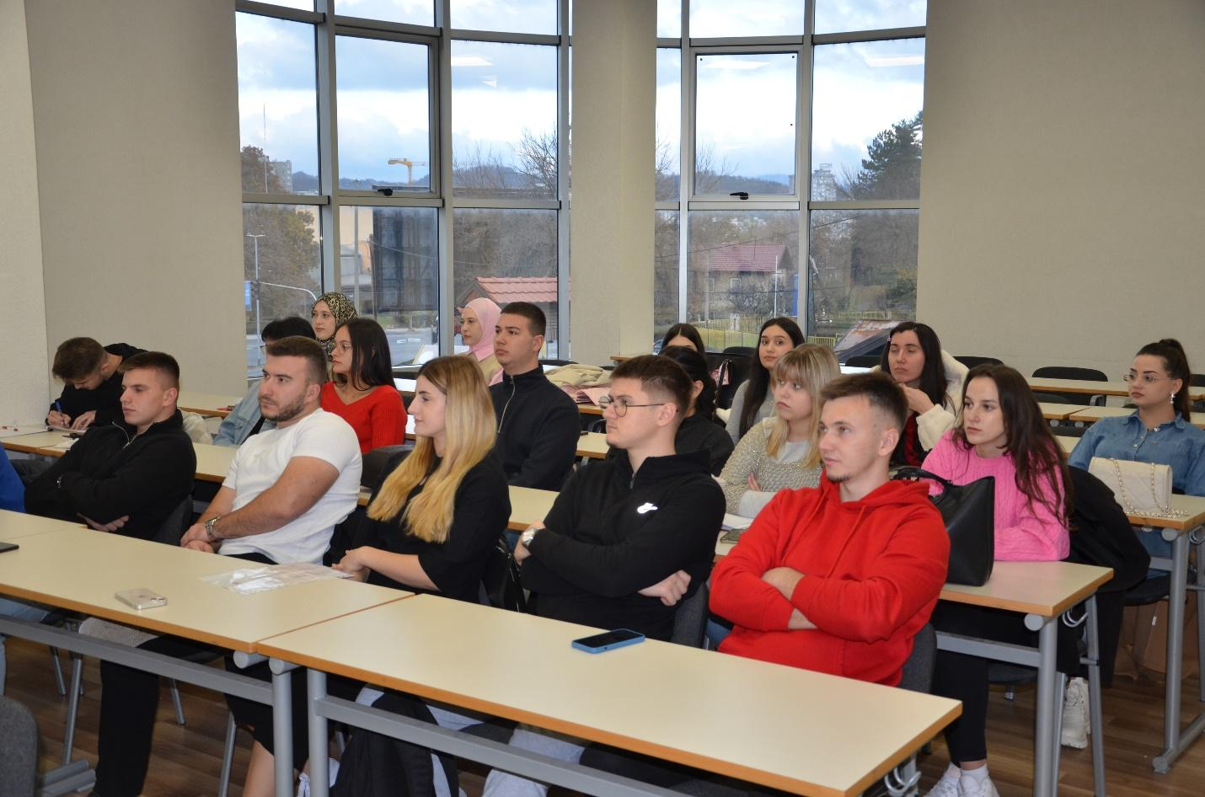
Figure 10 Students training

5. Institutional and Regional Changes Enabled by the KVC

The establishment of the Knowledge Valorisation Centre (KVC) at the University FINRA Tuzla has already generated significant institutional and regional impact, even within the first months of its operation. These changes reflect a shift toward a more innovation-oriented culture, stronger engagement with the local environment, and a more structured approach to digital skills development, entrepreneurship, and knowledge transfer.

Creation of a Formal Innovation Structure
With the establishment of the FINRA KVC, the University now has a formally recognised institutional unit dedicated to innovation, entrepreneurship development and digital transformation. This represents a major structural improvement, as previously these activities were dispersed across departments without unified coordination.
The KVC now provides:
- a central hub for innovation activities,
- leadership structures (KVC Manager, Coordinators, teams),
- formalised project responsibilities and workflows,
- dedicated facilities within the Multimedia Centre.
This internal transformation aligns FINRA with European practices in knowledge valorisation and innovation management.

Strengthening Teaching and Learning Practices
Through participation in WP3 training activities and the delivery of an expert lecture by a FINRA professor, the University has:
- introduced new teaching methods (Canvas-based learning, digital reflection assignments, teamwork methodologies),
- increased staff readiness to integrate innovation-focused content into teaching,
- enhanced openness toward digital tools, hybrid delivery, and experiential learning,
- initiated cross-departmental cooperation in skill development.
Students demonstrated improved critical thinking, creativity, and problem-solving skills, as shown in the Phase 1 training outputs highlighted in your presentation (e.g., Business Model Canvas tasks, Instagram reflections).
This marks a shift toward more modern, entrepreneurial learning culture within FINRA.
The KVC has supported and enhanced FINRA’s role in community-oriented initiatives, including:
- digital literacy programmes,
- youth-focused educational workshops (Winter Academy),
- participation in IT Days and other school-level innovation events,
- cooperation with museums, foundations, and municipal institutions,
- support for the Digital Innovation Hub Tuzla.
Through these activities, FINRA contributes to building a more digitally capable and innovation-driven regional environment.
Because of FINRA’s extensive cooperation network and structured internship pathways, the KVC strengthens:
- practical learning opportunities,
- industry–academia collaboration,
- employability outcomes for students,
- pathways for graduates to start their own businesses.
The project “Internship – Scholarship – Employment” continues to be a cornerstone of FINRA’s employability strategy, now further enhanced by the KVC’s capacity-building role.
The establishment of the Knowledge Valorisation Centre has enabled FINRA to achieve measurable institutional and regional changes, including:
- institutionalisation of innovation and entrepreneurship activities,
- adoption of modern teaching and mentoring practices,
- strengthened partnerships and regional integration,
- enhanced community engagement,
- increased student and staff readiness for digital and entrepreneurial challenges,
- development of a more innovation-driven culture,
- reinforcement of employability and practical skills pathways.
These outcomes demonstrate that the FINRA KVC is not merely an administrative unit, but a transformational mechanism driving long-term institutional change and regional development.

6. Strategic Importance of the KVC

The establishment of the Knowledge Valorisation Centre (KVC) at the University FINRA Tuzla represents a strategically significant institutional development that strengthens the University’s role within the regional innovation ecosystem and enhances its contribution to the broader objectives of the IMPACT-Campus project. The KVC serves not only as an operational hub for project implementation but also as a long-term mechanism for transforming FINRA into a more innovative, entrepreneurial, and community-oriented higher education institution.
The KVC enhances FINRA’s institutional capacity by:
- creating a formal structure dedicated to innovation, digital transformation, and entrepreneurship,
- integrating teaching, research, and community engagement under a unified innovation agenda,
- improving coordination of training activities, internships, and cooperation with industry partners,
- enabling the adoption of modern pedagogical approaches, including hybrid learning and practice-based education.
Through the KVC, FINRA can more effectively respond to emerging labour-market demands, technological changes, and the need for digital and entrepreneurial competencies among students and staff.
FINRA plays an increasingly important role in the development of the regional innovation ecosystem of Tuzla Canton and northeastern Bosnia and Herzegovina. The KVC strengthens this role by:
- mobilising FINRA’s extensive network of 350+ cooperation agreements with companies and institutions,
- generating opportunities for applied research, internships, and student projects,
- supporting digital transformation initiatives, including cooperation with IT companies, municipalities, NGOs, and development agencies,
- acting as a knowledge-transfer bridge between academia and industry in fields such as IT, finance, tourism, agriculture, and entrepreneurship.
The KVC thus becomes a catalyst for skills development, employability, and sustainable regional growth.
Partnerships increase FINRA’s ability to:
- participate in European research and innovation projects,
- attract international mobility and exchange opportunities,
- integrate European best practices into teaching and innovation activities,
- contribute to cross-regional knowledge valorisation under the IMPACT-Campus network.
The KVC therefore plays a strategic role in positioning FINRA as a competitive regional higher-education institution aligned with European standards and frameworks.
The KVC is designed to remain operational beyond the lifecycle of the IMPACT-Campus project. Its long-term strategic importance lies in:
- embedding innovation and entrepreneurship as core components of FINRA’s mission,
- creating sustainable partnerships with industry, public institutions, NGOs, and international organisations,
- supporting continuous professional development for staff and students,
- generating long-lasting social and economic value through improved employability and support for new business creation.
By formalising its innovation activities, FINRA strengthens its identity as a university that produces not only graduates but also entrepreneurs, innovators, and community-impact leaders.
The KVC positions FINRA as:
- a regional hub for digital skills and entrepreneurship,
- a connector between students, employers, policymakers, and civil society,
- a platform for sharing best practices and scaling successful educational models across the Western Balkans,
- an active contributor to the IMPACT-Campus macro-regional network of Knowledge Valorisation Centres.
This strategic positioning ensures that FINRA’s impact extends beyond its campus — influencing local economic development, supporting community transformation, and contributing to broader societal progress.
The KVC’s strategic importance lies in its ability to:
✔ reinforce FINRA’s institutional development,
✔ enhance regional innovation capacity,
✔ support international cooperation,
✔ ensure long-term sustainability,
✔ strengthen the University’s role as a dynamic and impactful knowledge hub.
Through the KVC, FINRA is not only participating in the IMPACT-Campus project — it is establishing the foundations for a stronger, more innovative, and more competitive future.

7. Plans for Phase 2 and Beyond

Building on the foundations established during Phase 1, the University FINRA Tuzla plans to significantly expand the scope, quality, and impact of its Knowledge Valorisation Centre (KVC) in Phase 2 of the IMPACT-Campus project (January 2026 – April 2027) and beyond the project lifecycle. The strategic direction focuses on scaling activities, deepening partnerships, and ensuring long-term institutional sustainability.
During Phase 2, the University FINRA Tuzla will continue contributing to the IMPACT-Campus project through a set of realistic, capacity-aligned and fully compliant activities. As a smaller institution and a non-leading partner in WP3 and WP4, FINRA will focus on participation, targeted expertise contributions, and strengthening the Knowledge Valorisation Centre (KVC), rather than implementing large-scale training programmes.
FINRA will continue to:
- send students and staff to consortium training sessions organised by leading WP3 partners;
- ensure regular participation in online and hybrid workshops;
- integrate selected WP3 modules into existing FINRA coursework where applicable.
FINRA can contribute through:
- one expert lecture delivered by FINRA staff in Phase 2
FINRA will contribute by:
- participating in mentoring sessions organised by other partners;
- offering light-touch mentoring or consultations to students with business ideas;
- supporting consortium-wide events (e.g., online clinics, feedback sessions).
FINRA will attend:
- Phase 2 sensemaking sessions,
- KIC discovery events,
- macro-regional coordination meetings,
- Phase 2 co-creation workshops.
FINRA will:
- maintain the KVC as an institutional unit,
- integrate it into university workflows,
- continue building cooperation with companies and schools,
- contribute to the consortium’s support structure KPI through its newly established KVC.
FINRA will provide dissemination content, social media posts, website updates, local promotion of IMPACT-Campus activities.

8. Title Page Template (for each KVC)

EIT Higher Education Initiative
IMPACT-Campus: Knowledge Valorization Centres for Sustainable Entrepreneurship and Digital Transformation
Fourth Call for Proposals (October 2024) – Strand A

The Knowledge Valorisation Centre of the University FINRA Tuzla (FINRA KVC)
Prepared by: Aldijana Omerović, MA of IT; University FINRA Tuzla
Date: December, 2025

