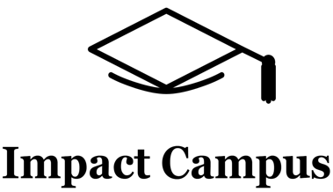


Knowledge Valorisation Centre Institutional Brief
University of Life Sciences “King Mihai” I from Timișoara

Prepared by the University of Life Sciences "King Mihai I” from Timișoara, Romania
EIT HEI Initiative – IMPACT-Campus: Knowledge Valorisation Centres for Sustainable Entrepreneurship and Digital Transformation
Fourth Call for Proposals (October 2024), Strand A
This Knowledge Valorisation Centre profile is based on the conceptual framework “IMPACT-Campus: Knowledge Valorisation Centres for Sustainable Entrepreneurship and Digital Transformation”.

1. Introduction and Regional Context
The Knowledge Valorisation Centre (KVC ULST) is hosted at the University of Life Sciences “King Mihai I” from Timișoara (ULST), in the dynamic Banat region, an EU RIS (Regional Innovation Scheme) area, with strong potential in agri-tech, sustainability, green transition, and circular bioeconomy. It was formally opened during our International Cooperation Erasmus+ Staff Week, July 2025, and officially will be stated by the Administration Council’ decision, next year, in the first meeting.
The region is closely aligned with Romania's Smart Specialisation Strategy (S3), especially in:
- Sustainable agriculture and food systems
- Digitalisation of rural landscapes
- Green transition and climate resilience
- Circular economy and eco-innovation
The KVC ULST was created as a strategic bridge between academic expertise, the agricultural sector, technology providers, local authorities, entrepreneurs, and civil society, ensuring that university knowledge translates directly into regional socio-economic impact.
Dual KVC Infrastructure: The KVC ULST operates across two complementary innovation spaces:
A. Campus Hub ULST
A multifunctional, student-centred space for:
- Innovation workshops
- Entrepreneurship and leadership sessions
- Cross-disciplinary events
- Community engagement
- Certificate-based training
B. LearnX AI & XR Lab (AI LAB X)
A state-of-the-art facility “Transforming Learning for the Digital Age”, equipped with:
- AI-powered educational tools
- VR/AR & XR immersion systems
- Large interactive smart screens
- Advanced digital teaching platforms
- Experimentation spaces for AI-driven creativity and learning
Together, these two infrastructures form the physical and digital backbone of KVC ULST’s activities.

2. Institutional Home, Leadership and team
Institutional Home
The KVC is anchored within:
The Campus Hub ULST – for community building, trainings, workshops
The LearnX AI & XR Lab – for digital innovation, immersive learning, AI literacy
Leadership
Core Team: 5 experts in agriculture, sustainability, environmental engineering, AI & digital tools, entrepreneurship, GIS/UAV, and green transition.
Team Responsibilities:
- AI and digital transformation workshops
- Entrepreneurial and leadership trainings
- Mentorship sessions
- Sustainability and green transition events
- Living Labs (urban greening, planting, circular ecosystem building)
- Student innovation showcases and certificate ceremonies
The KVC enables ULST to cover an unique spectrum, from agri-tech and sustainability to AI, enabled innovation and immersive education.

3. Stakeholder Ecosystem and Partnerships
Based on visible engagements and collaborations, KVC ULST fosters partnerships with:
- Local & Regional stakeholders
- Farmer associations and agricultural cooperatives
- Regional SMEs and agri-tech companies
- NGOs focusing on sustainability and green transition
- Youth leadership organisations (e.g., CLEF, AUF partners)
- Innovation-driven companies connected to AI, XR, and digital tools
- KVC-ULST Ecosystem contributions
- Hosting multi-stakeholder workshops in Campus Hub
- Demonstrating AI and VR applications (AI LAB)
- Engaging community volunteers and students in green transition projects (tree planting activities)
- Strengthening cross-sector dialogue between academia, businesses, and public authorities
During organised events, one may notice a vibrant open innovation environment, where students, external speakers, entrepreneurs, and community actors interact regularly.

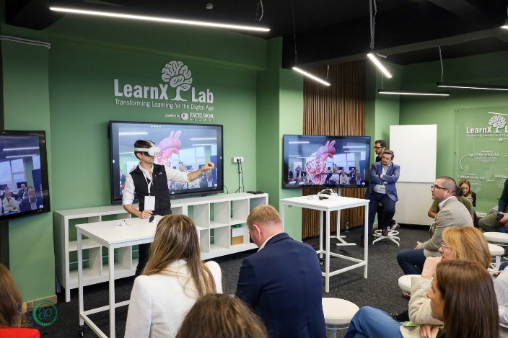 | 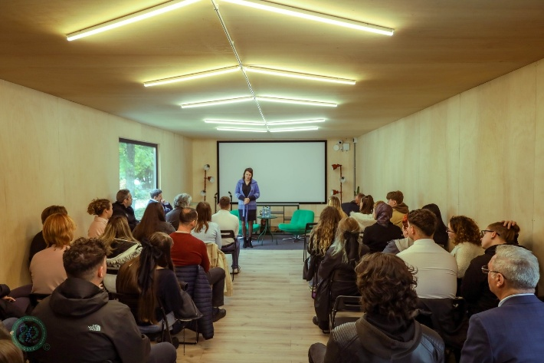
Figure 1. AI LAB | Figure 2. Hosting multi-stakeholder workshops in Campus Hub
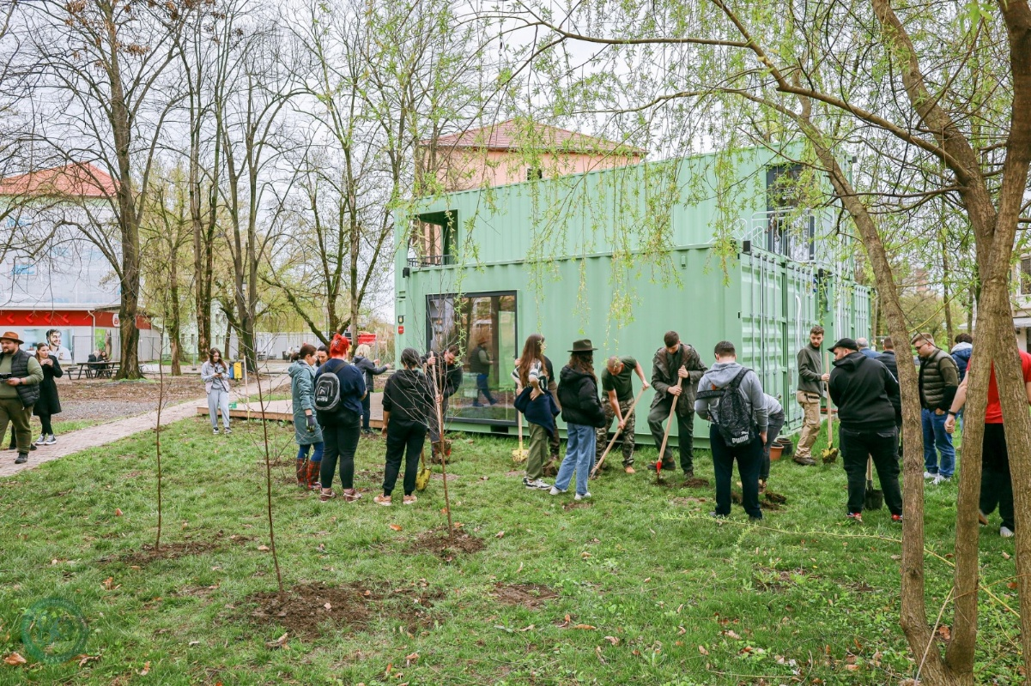
Figure 3. Engaging community volunteers and students in tree planting

4. Contribution to IMPACT-Campus KPIs (Phase 1)
(Based on all Campus Hub + AI Lab activities)
A. Training & Competence Development
Across both spaces (Campus Hub + AI LAB X), the KVC ULST has:
- Trained 17 students in:
- Innovation & entrepreneurship
- Creativity and leadership
- AI tools in education and research
- VR/AR applications in sciences
- Sustainability and green transition
- Trained 15 academic and non-academic staff in AI-based teaching, digital methods, and collaborative innovation approaches.
B. Mentoring & Innovation support
Within the KVC, 17 students and young entrepreneurs have been already mentored in innovation and sustainability.
The KVC has supported early-phase student ideas in green transition, creative industries, AI literacy, enabling hands-on AI & XR exploration for problem-solving.
C. Ecosystem connectivity
Through events and collective activities:
The KVC has led to 6 new partnerships, facilitating at the same time a very good and strong collaboration with regional innovators, community organisations, youth clubs, and digital education stakeholders, showing at the same time an engagement in multi-stakeholder workshops, AI demonstrations, and living lab activities.
D. Startup & Innovation activation
The AI Lab enabled:
- Immersion into startup-relevant digital tools
- Familiarity with VR design workflows
- AI-based decision-support thinking
- The Hub encouraged:
- Brainstorming sessions
- Business modelling exercises
- Creative ideation
E. Living Labs & Green Transition Engagement
From the outdoor planting events:
Students and staff participated in environmental restoration and urban greening activities, demonstrating applied sustainability practice.
These activities align strongly with EU Green Deal, climate adaptation, and circular bioeconomy themes
Overall quantified contribution for Phase 1:
- 17 trained students
- 15 trained staff
- 12+ mentored participants
- 6 partnerships
Multiple innovation, AI, XR, sustainability and entrepreneurship events across 2 infrastructures
KVC ULST exceeded typical RIS-region expectations for its first operational phase.

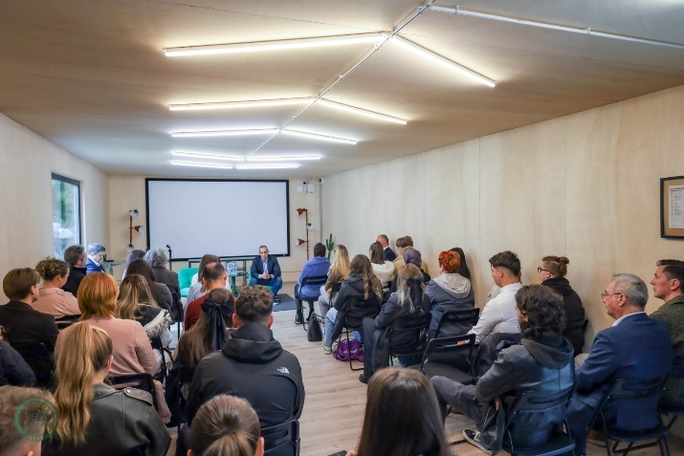 | 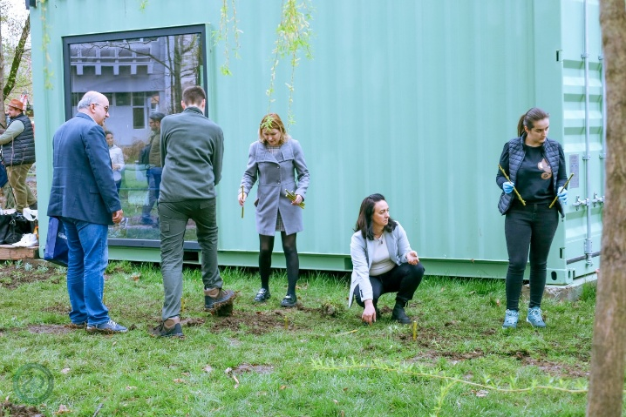
Figure 4. Collaboration with regional innovators, community organisations, youth clubs, and digital education stakeholders | Figure 5. Students and staff participated in environmental restoration and urban greening activities

5. Institutional and regional changes enabled by the KVC:
- Internal transformations
- Integration of AI and immersive technologies into university teaching practices
- Adoption of modern entrepreneurship-oriented pedagogy
- Activation of student innovation culture through the Hub
- Development of hybrid and experiential learning models
- Reinforcement of ULST’s strategic commitment to green and digital transformation
- Regional Impact
- Strengthened regional AI and agri-tech literacy
- Community engagement in ecological restoration
- Enhanced dialogue between agriculture, technology, and civic actors
- Increased visibility of ULST as a leader in sustainable innovation and digital education

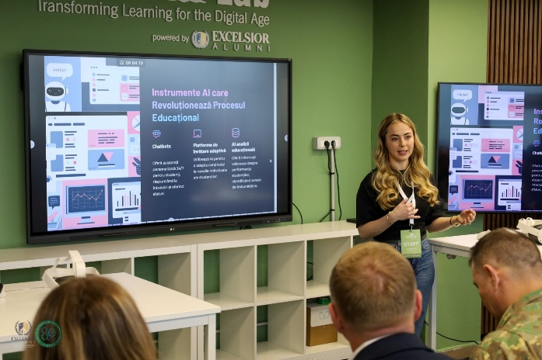 | 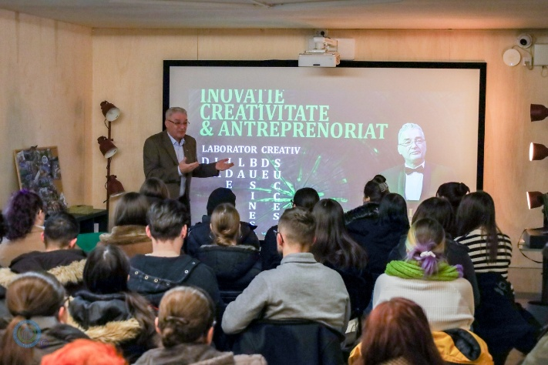
Figure 6. Integration of AI and immersive technologies into university teaching practices | Figure 7. Enhanced dialogue between agriculture, technology, and civic actors
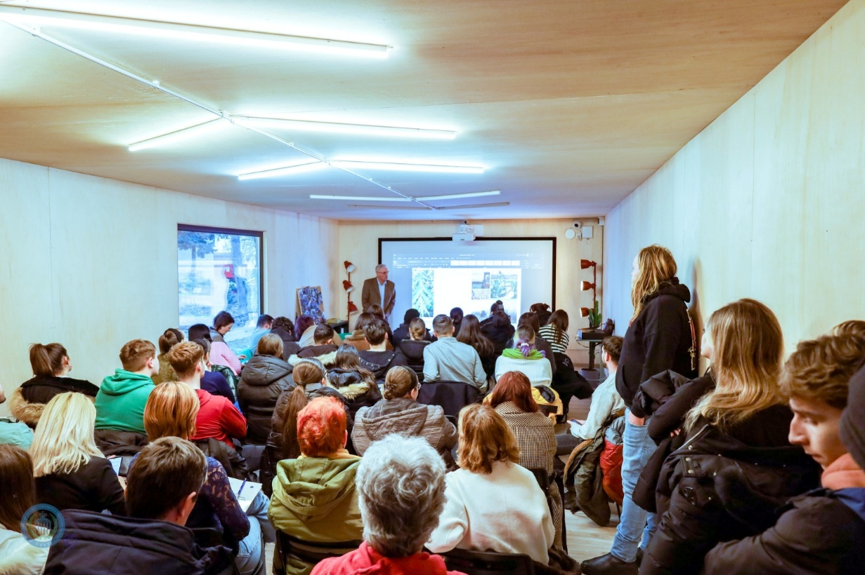
Figure 8. Adoption of modern entrepreneurship-oriented pedagogy

6. Strategic Importance of the KVC
The dual KVC infrastructure (Hub + AI LAB X) positions ULST as:
- A regional accelerator of green transition
- A centre of excellence in AI literacy and immersive learning
- A facilitator of agricultural digitalisation
- A youth innovation empowerment hub
- A crossroads for interdisciplinary collaboration
This aligns strategically with:
- EU Green Deal
- Farm to Fork Strategy
- Climate Adaptation Mission
- Digital Education Action Plan
- Romania’s S3 priorities
ULST becomes a macro-regional innovation node in the Western Balkans–Romania corridor.

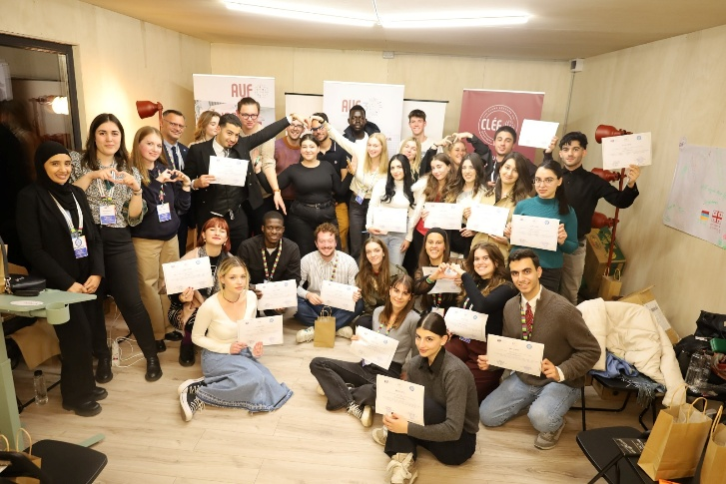 | 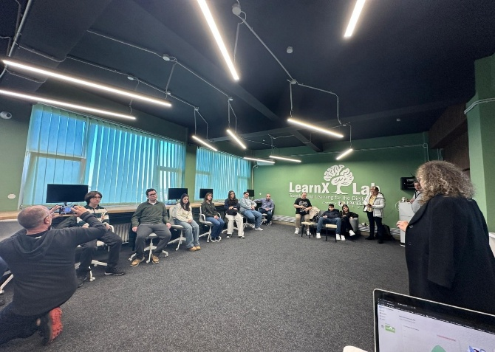
Figure 9. A youth innovation empowerment hub | Figure 10. A centre of excellence in AI literacy and immersive learning
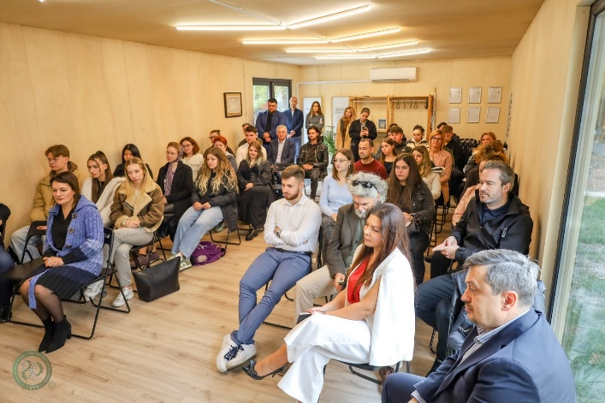 | 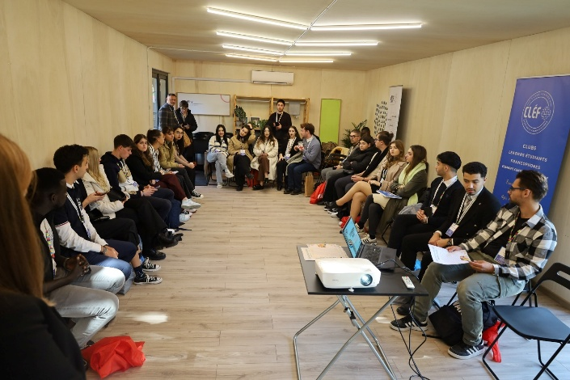
Figure 11. A regional accelerator of green transition | Figure 12. A crossroads for interdisciplinary collaboration

7. Plans for Phase 2 and beyond
- Planned growth areas
- Expansion of AI LAB X into an Applied AI Incubator
- Creation of a Digital Agriculture & Sustainability Living Lab (Hub + outdoor zones)
- Scaling-up of innovation challenges, hackathons, and XR-based educational modules
- Launch of LLL (lifelong learning) certification tracks in digital innovation, sustainability, and agri-tech
- Strengthening cross-border collaboration
- Sustainability measures
- Embedding KVC activities in ULST’s long-term strategy
- Monetization of LLL courses
- New MoUs with local and regional companies
- Development of joint research and digital transition projects

8. EIT Higher Education Initiative
IMPACT-Campus: Knowledge Valorisation Centres for Sustainable Entrepreneurship and Digital Transformation
Fourth Call for Proposals (October 2024) – Strand A
Knowledge Valorisation Centre
University of Life Sciences “King Mihai I” from Timișoara (ULST)
Prepared by: ULST KVC Team
Date: December 2025

