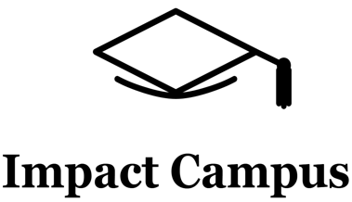
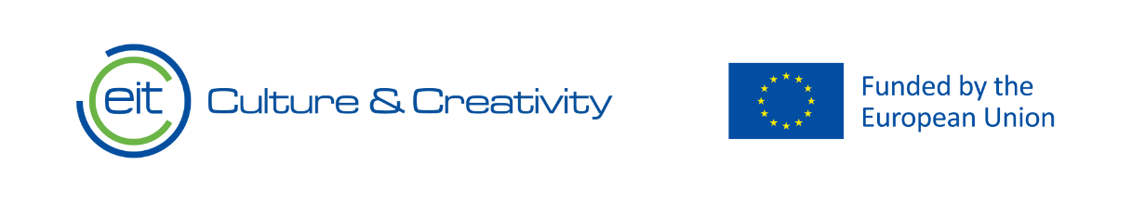

Knowledge Valorization Centre Institutional Brief
ETKİM from Türkiye, Ministry of National Education

Prepared by the ETKİM Team
EIT HEI Initiative – IMPACT-Campus: Knowledge Valorization Centers for Sustainable Entrepreneurship and Digital Transformation
Fourth Call for Proposals (October 2024), Strand A
This Knowledge Valorization Center profile is based on the conceptual framework “IMPACT-Campus: Knowledge Valorization Centers for Sustainable Entrepreneurship and Digital Transformation”.

1. Introduction and Regional Context
The Knowledge Valorization Centre at ETKİM (KVC_ETKİM), based in Ankara, Türkiye, serves as a strategic national hub for strengthening innovation and entrepreneurship within the educational technology (EdTech) sector.
The Center provides a robust platform for:
EdTech Ecosystem Building
The Center facilitates collaboration between startups, academia, industry, investors, and the Ministry of National Education to create a cohesive and dynamic national EdTech ecosystem.
Knowledge Valorization and Pilot Implementation
The Center drives the validation and adoption of educational technologies by providing structured pilot testing opportunities within the national school system, transforming innovative ideas into evidence-based solutions.
Supporting Start-ups and Scale-ups
The Center expands the EdTech entrepreneurial pipeline by offering incubation, mentorship, access to funding networks, and a clear pathway to the public education market.
Enhancing Innovation and Entrepreneurial Skills in Education
The Center provides training programs for entrepreneurs, teachers, and ministry staff on EdTech development, pedagogical integration, and innovation management.
The Center was officially established in May 2025 to formalize and expand its incubation and ecosystem-building activities. Its scope is to foster innovation capacity by connecting the grassroots startup community with the strategic goals of the national education system, in line with contemporary European practices.
Designed as a unique bridge between public policy and private innovation, the Center carries a mandate to translate EdTech knowledge into tangible impact for Turkey's education system.
Equipment and Facilities:
ETKİM provides a modern incubation environment including:
Co-working spaces and private offices for startups
Meeting rooms and event spaces
A media lab for content production
Digital tools and software for product development
Access to a national network of schools for pilot testing
Presentation and demonstration areas for demo days and investor events

2. Institutional Home, Leadership and Team
The Center is hosted by ETKİM, the Educational Technology Incubation and Innovation Center, which operates within the ecosystem of the Ministry of National Education’s Directorate General for Innovation and Educational Technologies (YEĞİTEK). It is led by Mustafa Canlı. The core team consists of 30 members whose expertise includes EdTech, pedagogy, business development, investment readiness, AI in education, and public policy.
Together, the team coordinates activities such as incubation and acceleration programs, mentor matching, the design and oversight of pilot studies in schools, policy workshops for digital transformation, and ecosystem networking events that connect startups with investors and public-sector leaders.
The internal governance structure ensures strategic alignment with the Ministry of National Education's goals while providing the autonomy needed to support agile startups. This structure allows valorization activities to be integrated into Turkey’s long-term strategy for digital transformation in education.

KVC ETKİM Team
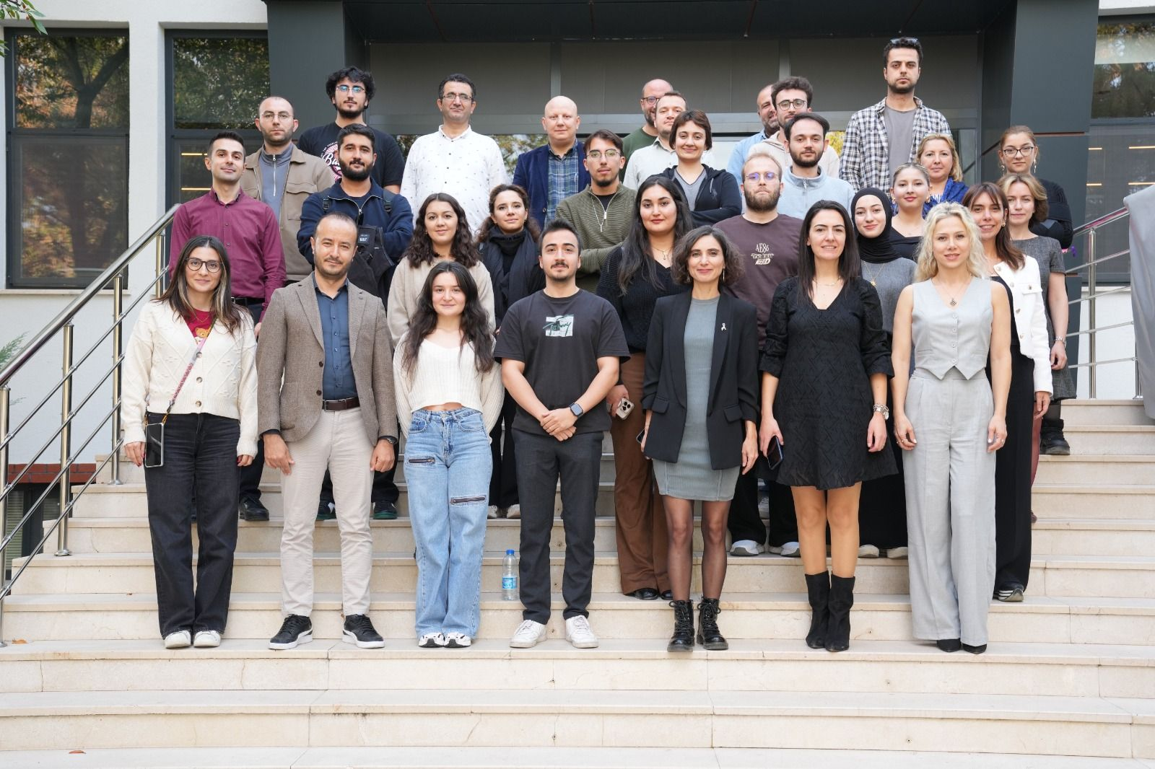

3. Stakeholder Ecosystem and Partnerships
The ecosystem around KVC_ETKİM includes EdTech startups, venture capital funds, angel investors, universities, technology companies, technoparks (such as ODTU Teknokent), national teacher associations, and international organizations.
The Center has formalized cooperation with 2 partners, including Amazon, Yıldız Technical University, These agreements underpin collaboration in domains such as startup investment, pilot study implementation, technology integration in schools, curriculum co-design, and providing feedback for national education policy.
Alongside this, informal cooperation with individual schools, teacher communities, and student entrepreneurship clubs contributes to the creation of a functional national ecosystem for EdTech innovation, aligning policy, research, and entrepreneurship to support Turkey’s educational development goals.

ETKİM_KVC and Amazon Web Services agreement to provide free credits to entrepreneurs and startups in July 2025
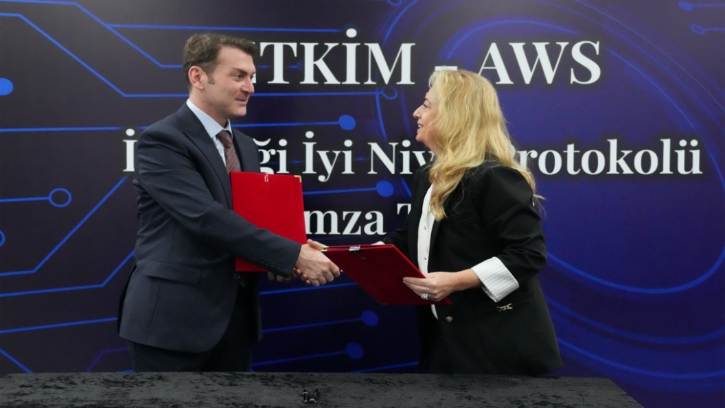

ETKİM_KVC and Yildiz Technical University agreement to provide training for entrepreneurs to become startups in June 2025
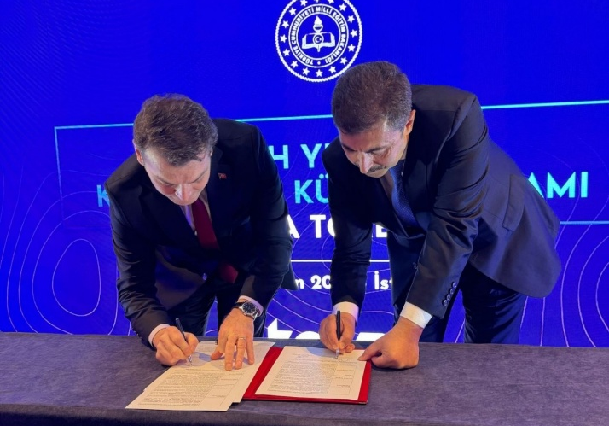

4. Contribution to IMPACT-Campus KPIs (Phase 1)

Since its establishment, KVC_ETKİM has contributed directly to the key metrics defined in the IMPACT-Campus project. To date, the Center has:
- Trained over 100 academic and 50 non-academic staff in innovation, sustainability, entrepreneurial thinking, and digital transformation in education with ODTU Teknokent
- Mentored 5 student entrepreneurs
- Supported 3 startups (ProgenX Education and Information Technologies, Teachfluence, Eding Education Platform)
- Mentored 3 non-academics
- Established 2 partnerships
These achievements align with the KPI Framework of IMPACT-Campus: competence development, entrepreneurial capacity building, startup activation, and ecosystem connectivity.

Trained over 100 Academic and 50 non-academic staff
The training activities were delivered through the macro-regional online Training Week: “Innovation, Sustainability, and Inclusion in Higher Education” held from 10–14 November 2025, where ETKİM and ODTU Teknokent experts played a leading role in several sessions. The program combined plenary sessions with dedicated tracks for academic and non-academic staff and covered themes such as:​
- Supporting Sustainable Start-ups and Initiatives – a two-part session led by the ETKİM Manager and Department Head in the Directorate General for Innovation and Educational Technologies, focusing on how higher education institutions and public bodies can systematically support impact-oriented startups and integrate them into their ecosystems.​
- Entrepreneurship and Innovation in EdTech: Experience Sharing – a practice-oriented session led by a lead teacher from the Ministry, highlighting concrete examples of EdTech initiatives, classroom-level innovation, and lessons learned from working with startups and pilots.​
- Designing Inclusive Courses with AI – training for non-academic staff and practitioners on how AI tools can support inclusive course design and accessible learning experiences, delivered by a national education expert coordinating World Bank and EU projects in the Ministry.​
- Data Literacy and Computational Thinking for Innovative Teaching – a two-part session for academic staff on integrating data skills and computational thinking into teaching practice, led by the AI in Education Policy Coordinator at the Ministry.​
- Cross-cutting sessions on sustainable campus practices, green transition competences, climate entrepreneurship, creative problem solving, and closing integration workshops, which helped participants translate the week’s content into concrete action plans in their own institutions.​
Through this combined program, KVC_ETKİM not only contributed a significant number of trained participants but also helped shape the content and methodology of the training, ensuring a strong focus on EdTech, startup collaboration, and innovation in public education systems.

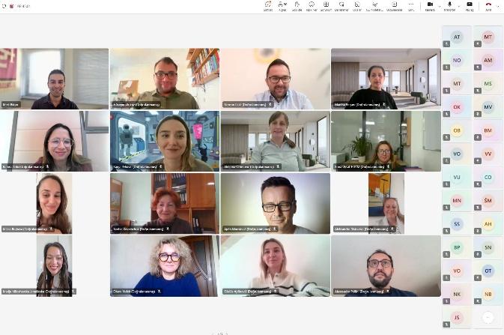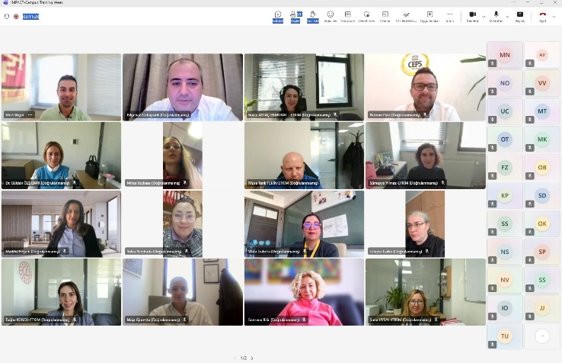
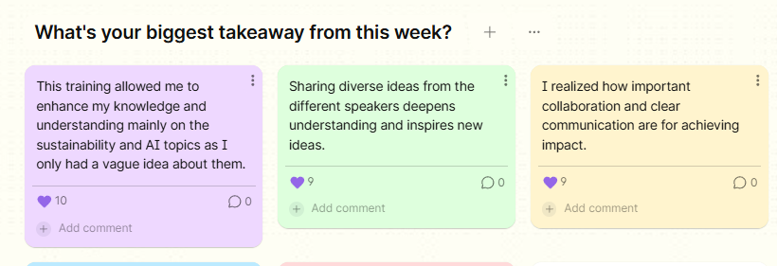

Mentored students entrepreneurs as ETKİM_KVC

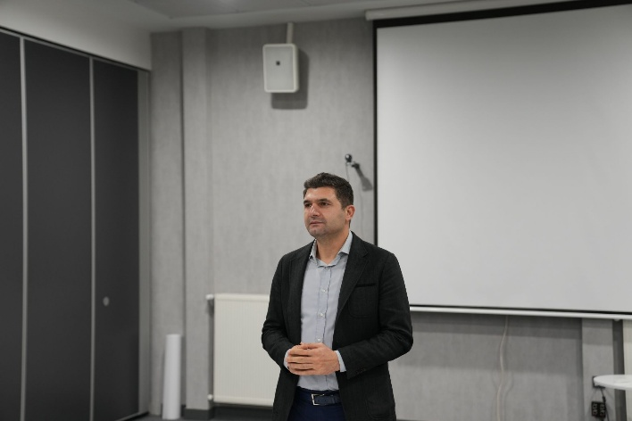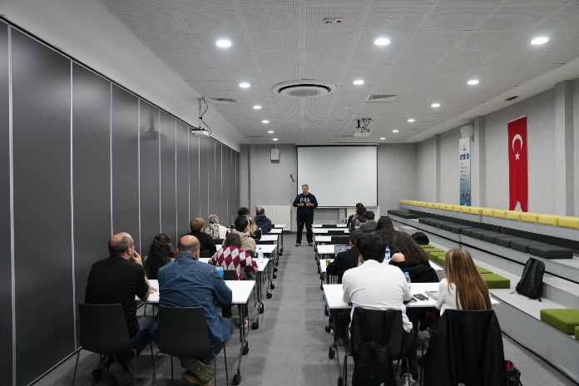

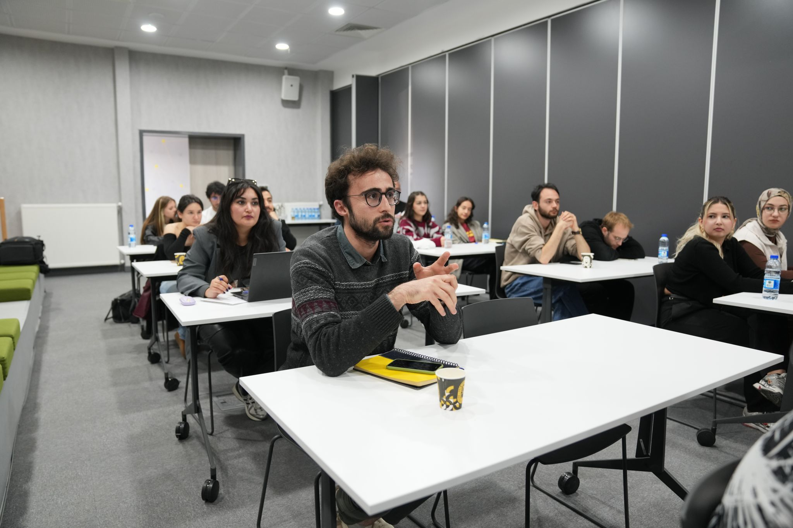

5. Institutional and Regional Changes Enabled by the KVC
The establishment of KVC_ETKİM has produced a visible transformation by creating a formal, structured pathway for EdTech innovation to reach the Turkish education system. A significant advance has been the development of a standardized pilot-testing framework, which allows startups to validate their products in real school environments and generate evidence of their pedagogical impact.
At the national level, the Center has dramatically increased the visibility of early-stage Turkish EdTech startups. Through its incubation programs and flagship events like the TETZ (Educational Technologies Summit), the KVC has showcased promising ventures to investors, policymakers, and a wide audience of educators. A clear success story is Notla, an AI-powered platform incubated at ETKİM that automates grading and feedback to reduce teacher workload. By facilitating pilot testing and providing access to the Ministry network, the KVC helped Notla refine its product and demonstrate its value, positioning it for national scaling.
This example illustrates that IMPACT-Campus KPIs reflect not just numbers, but deep structural change. The KVC is creating a transparent and merit-based system for how educational technology is discovered, validated, and integrated into public service, making ETKİM an anchor for institutional transformation and a catalyst for the entire national EdTech ecosystem.

6. Strategic Importance of the KVC
Participation in IMPACT-Campus and the operation of KVC_ETKİM represent a major strategic step for Turkey's education ecosystem. It reinforces the nation's profile as a regional EdTech hub, increases international visibility, and ensures that public investment in educational technology is evidence-based and impactful.
For Turkey, the Center acts as a long-term gateway for EdTech innovation. It provides a dedicated hub for incubating and accelerating startups, validating their solutions through rigorous pilot programs, and de-risking their entry into the national market. The Center also serves as a platform that strengthens cooperation between the public sector, private industry, and academia.
For the wider IMPACT-Campus network, the KVC contributes distinct expertise in public-sector innovation, EdTech incubation at a national scale, and building effective validation systems. It offers a strategic model for how other partners can engage with government bodies to drive systemic change and offers a gateway for European EdTech startups looking to access the Turkish market.
Our Knowledge Valorization sCenter contributes to national innovation by:
Aligning EdTech innovation with national education strategies, ensuring that new solutions address real-world classroom needs.
Enhancing startup valorization through structured pilot testing, evidence generation, and market access.
Strengthening the national EdTech ecosystem by connecting startups, investors, educators, and policymakers.
Providing tailored incubation and advisory programs that help EdTech entrepreneurs build sustainable and impactful businesses.

7. Plans for Phase 2 and Beyond

In accordance with the IMPACT-Campus framework, KVC_ETKİM commits to the following minimum Phase 2 targets:
- Double startup support: Increase the number of EdTech startups and scale-ups supported for at least 2 months from 3 to 6 or more, providing enhanced mentoring, market access support, investor matchmaking, and pilot testing services.
- Scale training programmes: Increase successful training participants by at least 30%, targeting 130+ academic staff and 65+ non-academic staff through expanded professional development courses on AI in education, EdTech pedagogy, and innovation management.
- Expand mentoring: Increase complementary mentoring activities by 30%, delivering structured mentoring to staff engaged in EdTech innovation and startup collaboration.
- Build new partnerships: Double the number of strategic partnerships from 2 to 4 or more, connecting with international EdTech accelerators, venture capital funds, European EdTech hubs, and regional innovation actors across the IMPACT-Campus network.
- Achieve intellectual property creation: Support at least 1 intellectual property rights (IPR) applications resulting from KVC activities, demonstrating the advanced innovation capacity of incubated startups.
- Foster startup creation: Facilitate the establishment of at least 2 new EdTech startups with documented financial transactions of at least €10,000 from customer sales or €200,000 raised via private investment.
Strategic Activities for Phase 2
To achieve these targets, KVC_ETKİM will implement the following strategic activities:
- International ecosystem integration: Actively engage with global EdTech accelerators, European venture capital networks, and international innovation platforms to help Turkish EdTech startups access cross-border markets and investment opportunities.
- Expanded pilot testing network: Scale the national pilot testing framework by recruiting additional schools across diverse geographical regions and socio-economic contexts, generating robust evidence of educational impact and enabling startups to demonstrate scalability.
- Cross-KVC collaboration: Leverage the IMPACT-Campus network to facilitate knowledge exchange, joint pilot programmes, and cross-border startup collaboration with partner Knowledge Valorization Centres across Europe and beyond.
- Policy integration: Work with the Ministry of National Education to translate successful pilot results into national procurement frameworks, digital transformation strategies, and teacher training curricula, ensuring long-term sustainability of validated EdTech solutions.
- Diversity and inclusion focus: Establish dedicated support mechanisms for underrepresented entrepreneurs, including women-led EdTech ventures and startups developing solutions for marginalized student populations, contributing to equity in both entrepreneurship and education outcomes.

EIT Higher Education Initiative
IMPACT-Campus: Knowledge Valorization Centers for Sustainable Entrepreneurship and Digital Transformation
Fourth Call for Proposals (October 2024) – Strand A
Knowledge Valorization Centre Institutional Brief
ETKİM (Educational Technology Incubation and Innovation Center)
Prepared by: ETKİM Team
Date: December, 2025

