


Knowledge Valorisation Centre Institutional Brief
International Balkan University - Skopje

Prepared by International Balkan University
EIT HEI Initiative – IMPACT-Campus: Knowledge Valorisation Centres for Sustainable Entrepreneurship and Digital Transformation
Fourth Call for Proposals (October 2024), Strand A
This Knowledge Valorisation Center profile is based on the conceptual framework “IMPACT-Campus: Knowledge Valorisation Centres for Sustainable Entrepreneurship and Digital Transformation”.

1. Introduction and Regional Context
The Knowledge Valorisation Center (KVC_IBU) is based at the International Balkan University in Skopje, North Macedonia. It operates in a regional environment characterised by its Western Balkans RIS status, strong performance in people and talent, and a highly active startup and digital ecosystem. The key challenge remains brain drain and fragmented support structures.
The Center was officially opened in July 2025 within the framework of the project IMPACT-Campus: Knowledge Valorisation Centres for Sustainable Entrepreneurship and Digital Transformation, funded under the EIT HEI Initiative, Fourth Call 2024, Strand A.
Designed from the outset as a bridge between higher education, industry, public authorities, and civil society, the Center carries a mandate to translate knowledge into tangible impact for the region.

KVC_IBU is located at the IBU Campus in Skopje (see Figure 1) where students have access to the latest IT technology, investment and statistical software, relevant databases, innovation center, fintech simulation center, and top of the notch library, classrooms, amphitheaters, studios, podcast room, etc.
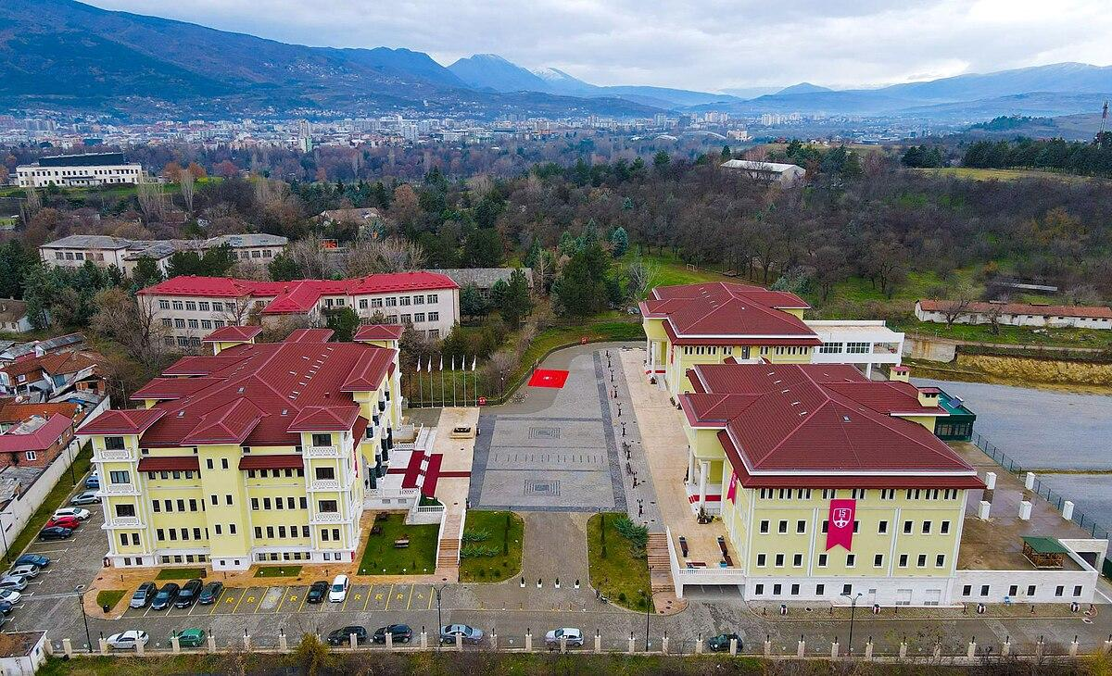
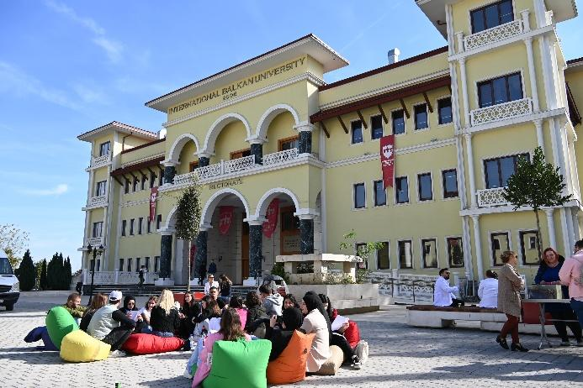
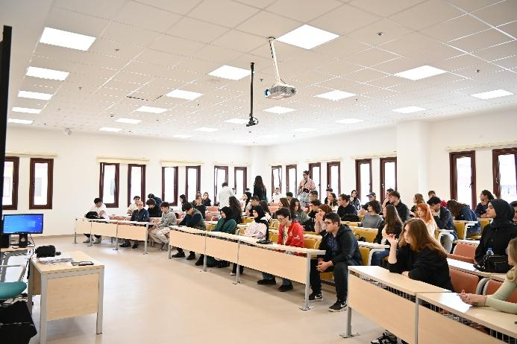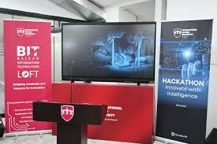
Figure 1. International Balkan University campus and premises
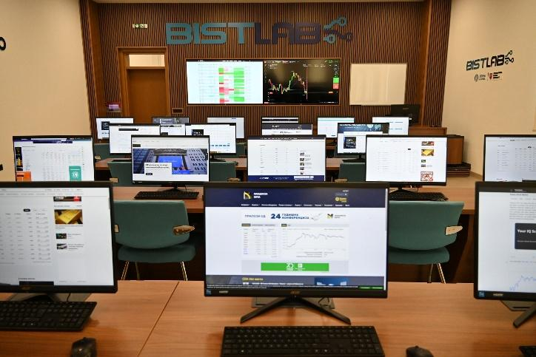
Figure 2. Balkan Economy and Finance Laboratory – BISTLAB
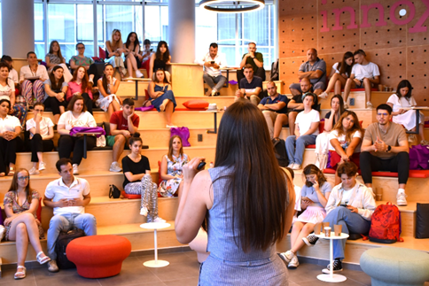
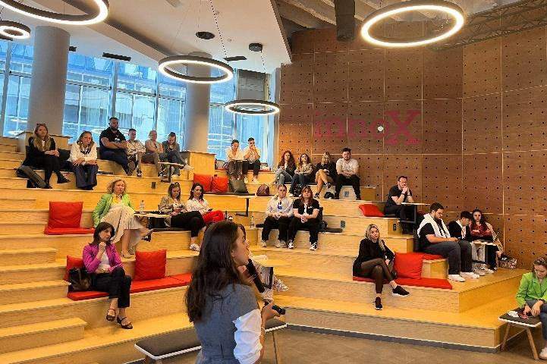
Figure 3. Innox Innovation Center

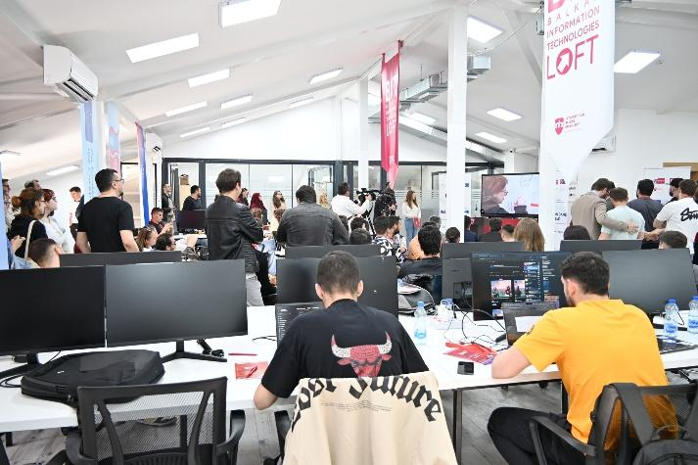
Figure 4. BIT Loft

2. Institutional Home, Leadership and Team
The Center is hosted by Faculty of Economics and Administrative Sciences and led by Assoc. Prof. Dr. Andrijana Bojadzievska Danevska. The core team currently consists of 5 members (Figure 5) whose expertise includes product development, process optimization, digital technologies, lean management, AI literacy, entrepreneurship, innovation management, and sustainable development.
Together, the team coordinates activities such as training and professional development programs, mentoring, knowledge valorization through the identification and transfer of research results to business sector, collaboration with business and public-sector partners, innovation support for start-ups and spin-offs, market simulation using BISTLAB tools, and fostering policy dialogue on innovation scoring and financing.
The internal governance structure shared leadership under the Faculty’s management, with active participation of academic staff and students, and close coordination with the Dean’s Office and the University Rectorate, the INNOX Innovation Center, the BITLOFT, the BISTLAB, (see Figures 2, 3 and 4) and the University’s Project and Research Center, allowing valorisation activities to be integrated into the long-term strategy of International Balkan University.

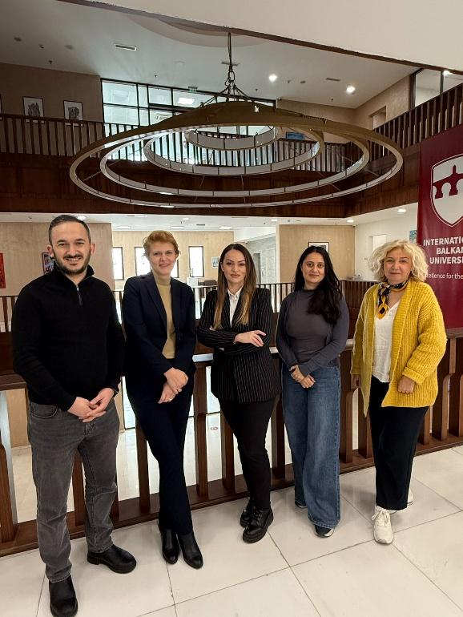
Figure 5. KVC_IBU team
10th of December 2025

3. Stakeholder Ecosystem and Partnerships
The ecosystem around KVC_IBU includes stakeholders such as SMEs, financial banking and non-banking institutions (Halkbank, NLB Tutunska Banka, Finmak), the Agency for Innovation, Scientific-Technological Development and Entrepreneurship (INOVA – Figure 6), international innovation centers (INNOPARK, Digitalpark Teknokent), the chambers of commerce, etc.

.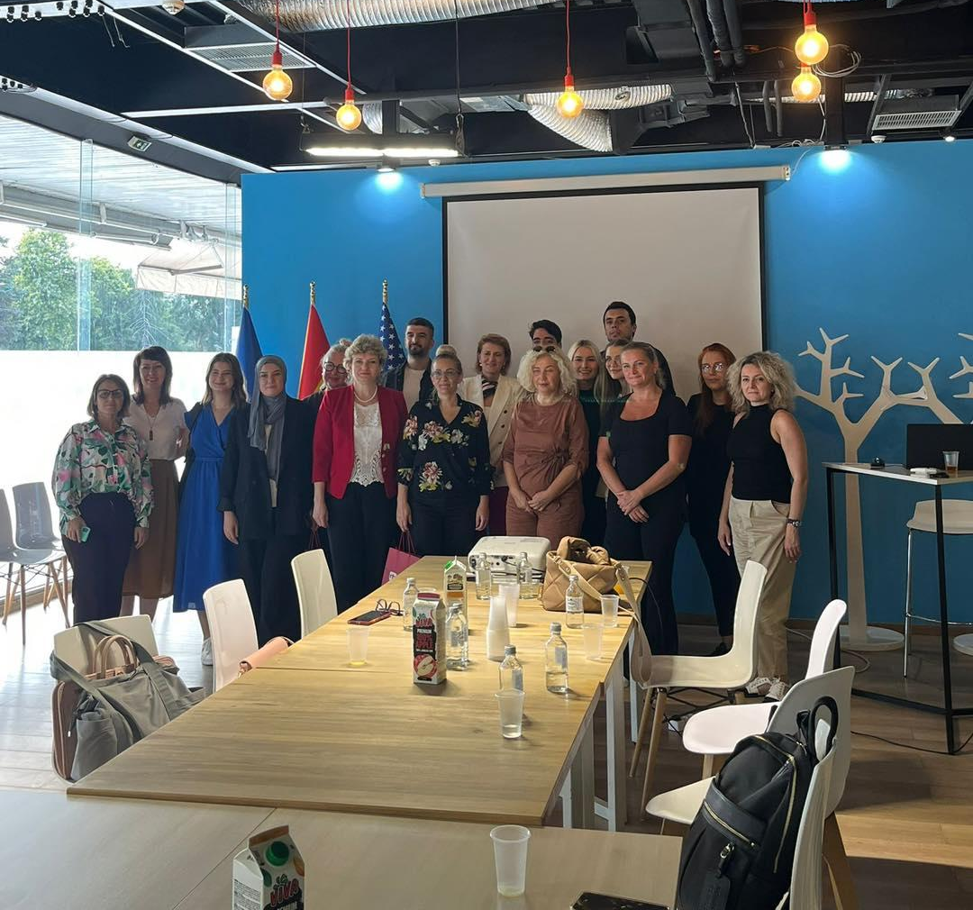 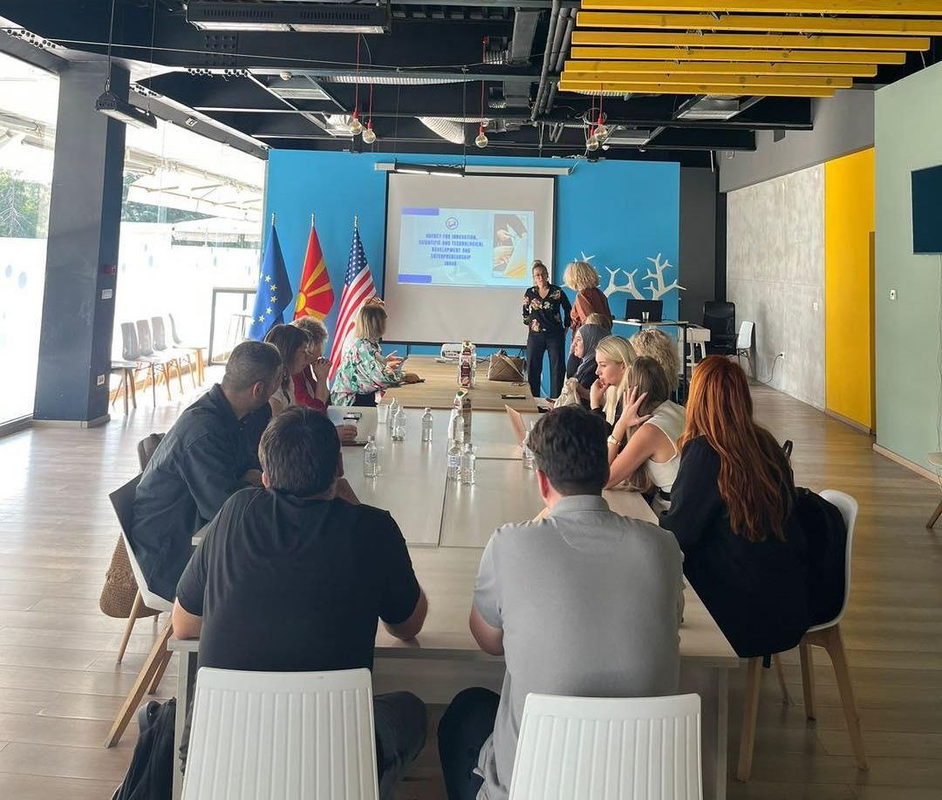
Figure 6. Visit to INOVA
25th of September 2025

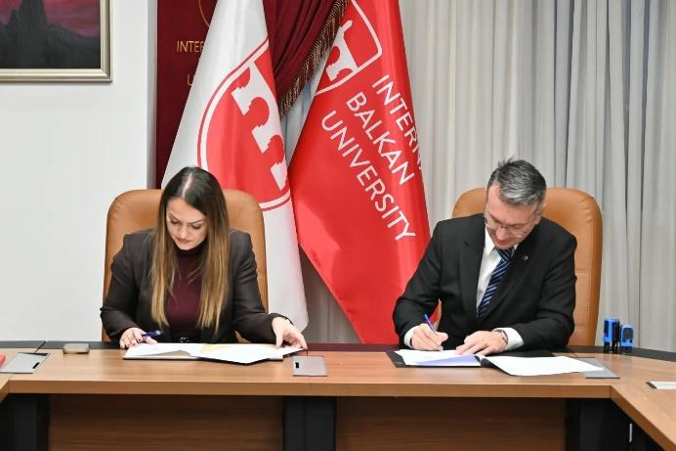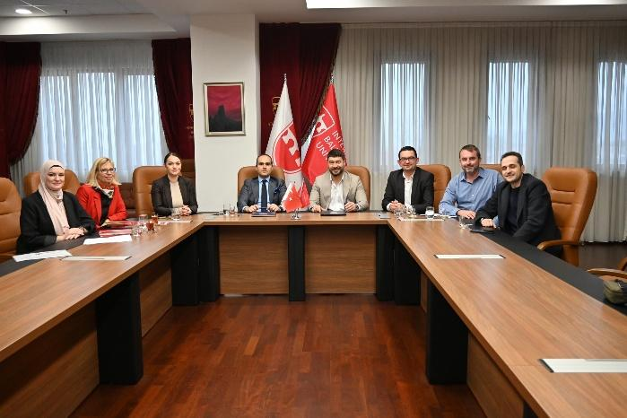
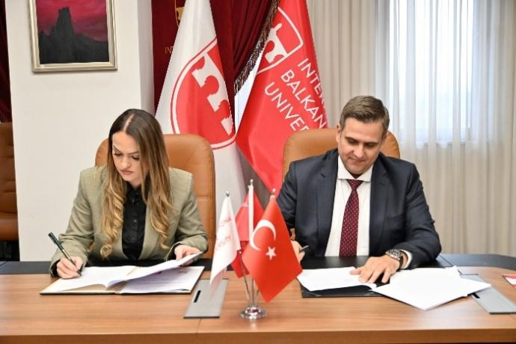
Figure 7. Signing of Memoranda of Understanding with Nordvest Consulting, WVP Fund Management AD Skopje, Economic Chamber of North Macedonia, Opfolio Investments AD Skopje (moving from top left to bottom right )
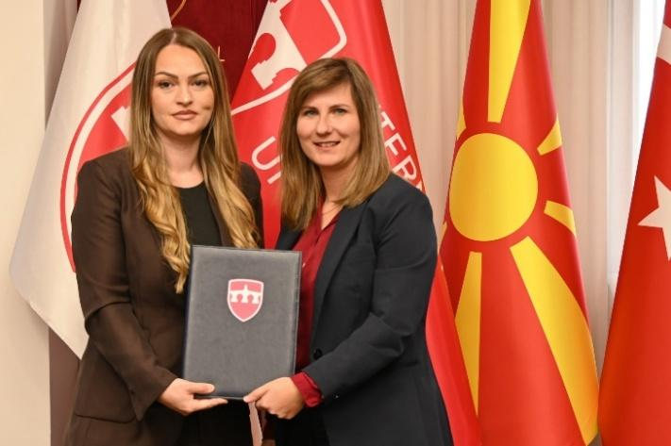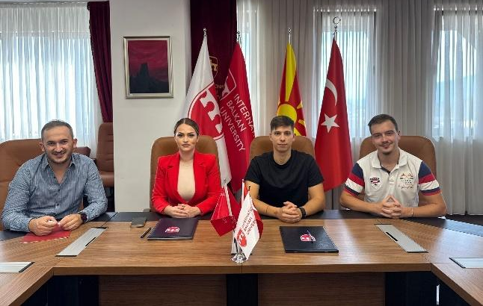
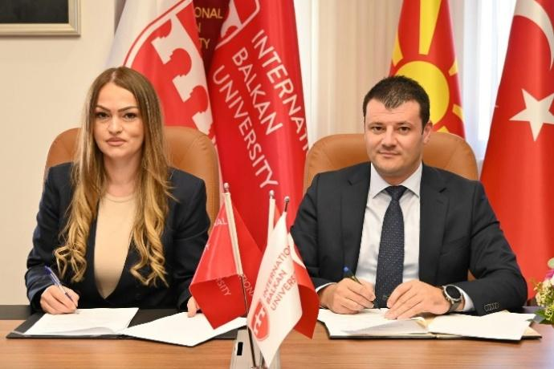Figure 8. Signing of Memoranda of Understanding with Sparkasse Bank AD Skopje, DIGIPERIA, Croatia Insurance – Life AD Skopje, Association for Regional Development – Balkan Economic Forum (moving from top left to bottom right )

The Center has formalized cooperation with six partners (Figure 7&8), including investment companies like WVP Fund Management AD Skopje and Opfolio Investments, consulting houses such as Nordvest Consulting, IT companies with focus on AI such as DIGIPERIA, banks, and economic chambers. These agreements underpin collaboration in domains such as startup incubation, testbeds for financial technology, advanced student internships, and organizing expert workshops on financial markets and innovation policy.
Alongside this, informal cooperation with the Macedonia-Türkiye Commerce Chamber (MATTO), other faculties, student clubs, and local policy actors contributes to the creation of a functional regional innovation and knowledge valorisation ecosystem.

4. Contribution to IMPACT-Campus KPIs (Phase 1)
Since its establishment, KVC_IBU has contributed directly to the key metrics defined in the IMPACT-Campus project. To date, the Center has:
- Trained 40 students
- trained 16 academic and non-academic staff
- mentored 6 students, academic and non-academic staff
- supported 4 startups or early-stage teams
- established or strengthened 6 regional partnerships
These achievements align with the KPI Framework of IMPACT-Campus: competence development, entrepreneurial capacity building, startup activation, and ecosystem connectivity.

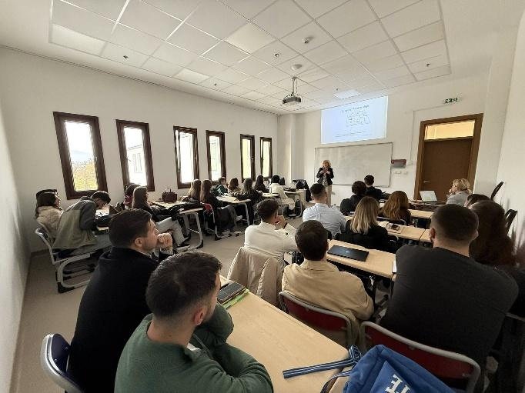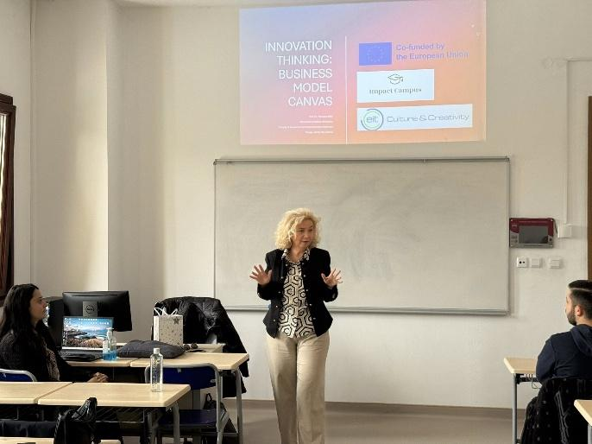
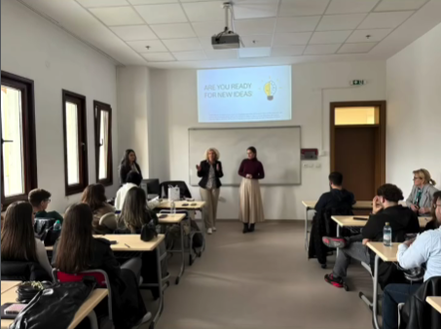
Figure 9. Innovation Thinking Business Model Canvas – In-house activity for students: Training for Business Canvas Model Training
6th of November 2025

As shown in Figure 9, the first session introduced students to innovation-thinking methodologies through a structured Business Model Canvas workshop. Participants learned how to conceptualize customer needs, value propositions, and revenue models, thereby strengthening their entrepreneurial competencies. The activity directly contributed to IMPACT-Campus KPIs on competence development and startup activation, as students worked on real business ideas and received guided support.
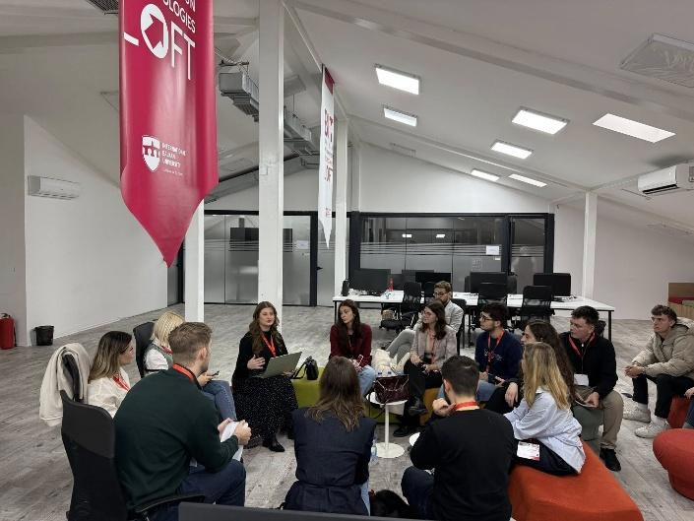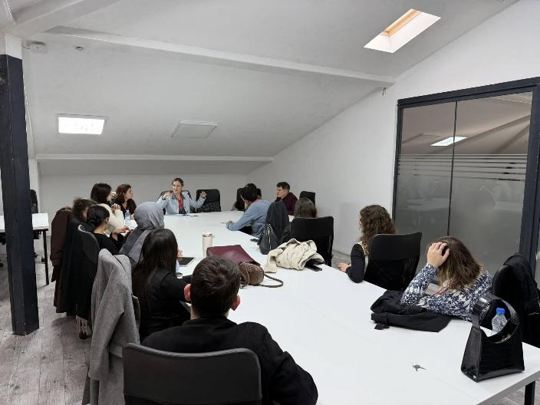
Figure 10. Sustainability in Practice
24th of November 2025

Figure 10 captures the workshop “Sustainability in Practice” organized as part of the IBU Student Congress, that engaged students in practical sustainability challenges, enabling them to connect global sustainability principles with local industry practices. Through hands-on tasks and reflective discussions, participants developed skills in environmental responsibility and sustainable business design. The session aligns with competence development and ecosystem connectivity, fostering collaboration between students, academic staff, and external partners.

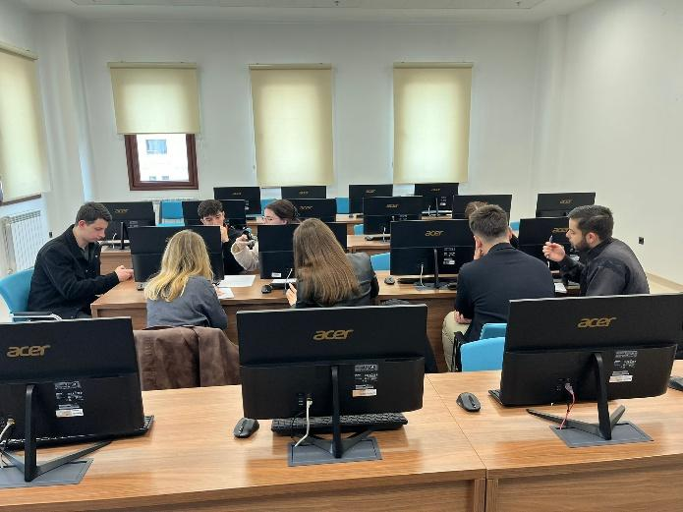
Figure 11. Green Logistics Hackathon (Economics)
25th of November 2025

The Green Logistics Hackathon (Figure 11), organized as part of the IBU Student Congress brought together interdisciplinary student teams to develop innovative solutions for sustainable logistics and supply chain optimization. Participants applied analytical, creative, and digital skills to address real-world environmental challenges faced by the industry.

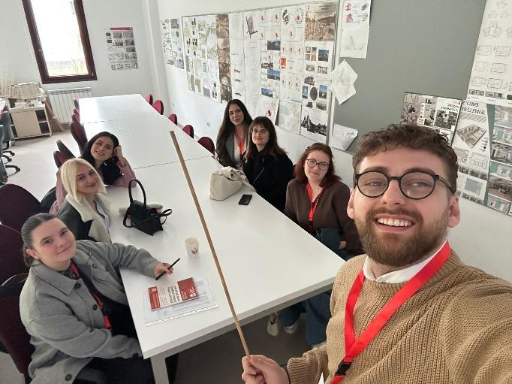
Figure 12. AI & Sustainable Fashion: Design sprint for ethical fashion (Art & Design)
25th of November 2025

The design sprint (see Figure 12), also organised as part of IBU Student Congress, challenged students to merge artificial intelligence tools with sustainable fashion principles to create ethical and innovative fashion concepts. By integrating digital creativity with sustainability values, the sprint strengthened students’ entrepreneurial mindset and design-thinking capabilities.

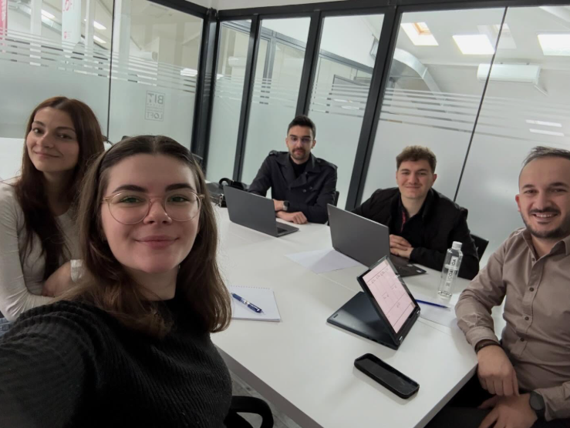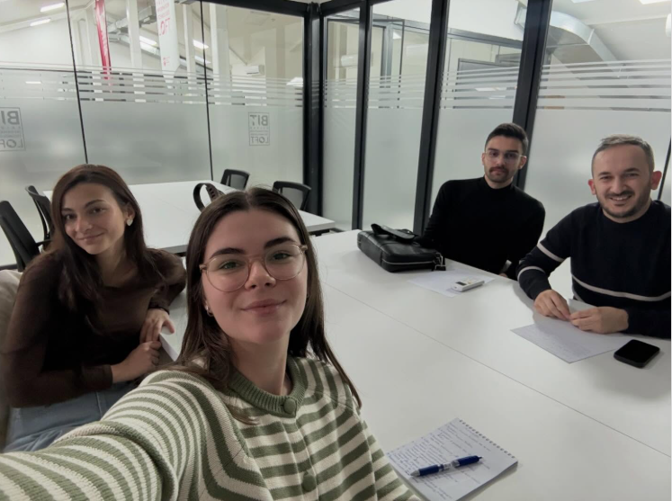
Figure 13. Mentorship sessions with students on Impact Campus
5th of December 2025

Figure 13 illustrates the one-on-one and small-group mentorship sessions that provided tailored guidance to students, academic, and non-academic staff working on entrepreneurial or innovation-driven initiatives. Mentors supported participants in refining their project ideas, improving feasibility, and preparing for early-stage validation.

5. Institutional and Regional Changes Enabled by the KVC
The establishment of KVC_IBU has already influenced the development of International Balkan University. One of the most notable achievements is the creation of a new interdisciplinary training programme in Innovation and Knowledge Valorisation, initially designed within the IMPACT-Campus framework and now being scaled for use across other IBU faculties. Built on the WP3 curriculum and training model, this programme introduces modern teaching approaches at IBU, including project-based learning, innovation challenges, digital skills development, and collaborative teamwork supported through Canvas. Furthermore, programs like the Master's in Sustainable Economics now explicitly include courses on "Economic sustainability and technological innovation" and "Social entrepreneurship for sustainable development," creating a pathway for green and digital ventures.
A clear success story from Phase 1 at IBU is the noticeable improvement in students’ engagement and innovation during their group projects and WP3 activities. Many students entered the course with limited experience in practical innovation methods, but through workshops on sustainable entrepreneurship, innovation tools, and digital communication, they quickly became more confident and proactive.
A key moment was the completion of their Business Model Canvas projects. Students not only identified social and environmental problems but also developed realistic, creative solutions—showing a deeper understanding of how ideas can generate real value. Their weekly reflections demonstrated growing awareness and responsibility toward sustainability topics.

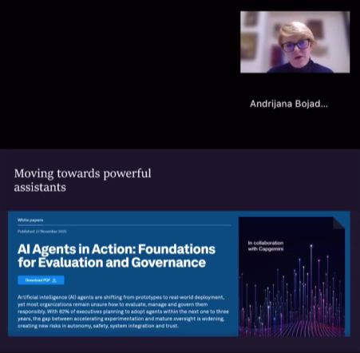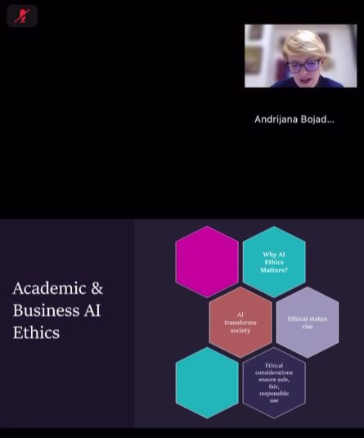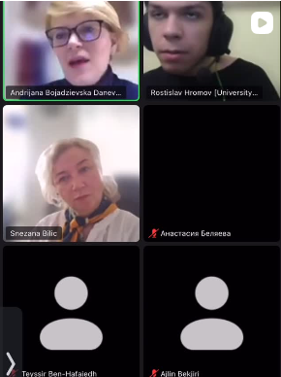
Figure 14. Impact Innovation Experience session (WP3) – Digital Transformation: AI for Business and Learning – Prof. Dr. Snezana Bilic and Assoc. Prof. Dr. Andrijana Bojadzievska Danevska

Another highlight of Phase 1 was the Impact Innovation Experience session dedicated to Digital Transformation: AI for Business and Learning, delivered by Prof. Dr. Snezana Bilic and Assoc. Prof. Dr. Andrijana Bojadzievska Danevska (Figure 14). This session exposed students to the rapidly evolving landscape of artificial intelligence and its applications in entrepreneurial practice, decision-making, and modern pedagogy. Through hands-on demonstrations and interactive discussions, participants explored AI tools for business modelling, market analysis, and digital communication, significantly enhancing their digital literacy and innovation readiness. This activity directly supports the IMPACT-Campus KPIs on competence development and entrepreneurial capacity building, while reinforcing IBU’s strategic shift toward integrating advanced technologies into teaching, research, and knowledge valorisation practices. The session also contributed to regional ecosystem connectivity, as its outcomes and learning materials were shared with partner institutions engaged in WP3 activities.
At the regional level, the Center has helped increase the visibility of early-stage student solutions developed through the “Innovation and Knowledge Valorisation” course, which reached over 350 participants across multiple partner universities. Many of these student teams showcased creative cultural-entrepreneurship ideas, green innovation prototypes, and digital transformation concepts publicly via the dedicated Instagram learning community—making young innovators from North Macedonia and neighbouring Western Balkan HEIs more visible within the macro-regional ecosystem. By fostering strong ties between the academic community and industry/policy, the KVC has visibly positioned IBU as a thought leader in the economic and digital transformation of North Macedonia.
These examples show how IMPACT-Campus KPIs correspond not only to numerical achievements but also to structural change in the production, dissemination, and valorisation of knowledge. The integration of new training programmes, cross-institutional curricula, collaborative digital practices, and community-driven innovation demonstrates how the KVC is becoming an anchor for long-term institutional and ecosystem transformation.

6. Strategic Importance of the KVC
Participation in IMPACT-Campus and the establishment of KVC_IBU are significant for International Balkan University, as they enable the institution to strengthen its entrepreneurial and technological profile in business-critical areas, aligning its education and research with the growing demand for expertise in E-Business, Fintech, and Sustainable Economics. The establishment of the Knowledge Valorisation Center in IBU represents a major strategic step for the International Balkan University. Together, they reinforce IBU’s entrepreneurial and innovation profile, increase its international visibility, and ensure stronger alignment of research, education, and training activities with the Smart Specialization Strategy (S3) priorities for sustainable and digital transformation. Through the Center, students and staff gain structured opportunities to participate in real-world innovation projects, develop advanced competencies, and collaborate with European partners.
For the region of North Macedonia, the Center serves as a dedicated hub for specialized training in economic and financial digital valorisation, and an entry point for international partners and best practices in regulatory and market-focused innovation. It provides a dedicated hub for specialized training and mentoring in new product development, digitalized process optimisation, and sustainable industrial practices. The Center also serves as a platform that strengthens cross-border cooperation among academia, industry, public institutions, and civil society, thereby enhancing the regional innovation ecosystem.
For the wider IMPACT-Campus network, KVC_IBU provides unique expertise in advanced innovation methodologies, financial advice, and growth strategies. It acts as a strategic entry point for extending entrepreneurship education, collaborative initiatives, and innovation support programs across the Western Balkan macro-region, bridging innovation gaps and promoting inclusive capacity building.

7. Plans for Phase 2 and Beyond
Looking ahead, KVC_IBU plans to build on the achievements of Phase 1 by scaling the reach of the acceleration programs, extending advisory services in compliance-tech and corporate risk management, and deepening its analytical services to support evidence-based policymaking.
Future priorities include:
• Expanding engagement with additional ecosystem actors, including financial institutions, municipal innovation and development offices, and civil society organisations working on sustainability, circular economy, and community-driven innovation. This broader involvement will reinforce the Centre’s position as a convening platform for cross-sector collaboration and enhance the regional innovation ecosystem.
• Focusing on high-impact KPIs related to the upskilling of professionals, the establishment of new business partnerships, and the measurable contribution of knowledge valorisation activities to regional innovation performance. Priority will be placed on tracking the quality and depth of collaborations, adoption of innovative practices by enterprises, and the long-term outcomes of research-to-market initiatives.
• Transferring the Center’s expertise across the wider IMPACT-Campus network, by sharing proven methodologies in product development education, Lean-based process optimisation, and effective university–industry cooperation models. These practices will be tailored to meet the needs of smaller or emerging innovation ecosystems in the Western Balkans, supporting balanced regional development and strengthening macro-regional innovation capacity.

8. Title Page Template (for each KVC)
EIT Higher Education Initiative
IMPACT-Campus: Knowledge Valorization Centres for Sustainable Entrepreneurship and Digital Transformation - Fourth Call for Proposals (October 2024) – Strand A
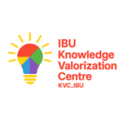
Knowledge Valorisation Centre
KVC_IBU


