


Knowledge Valorisation Centre Institutional Brief
PAR University of Applied Sciences

Prepared by PAR University of Applied Sciences
EIT HEI Initiative – IMPACT-Campus: Knowledge Valorization Centres for Sustainable Entrepreneurship and Digital Transformation
Fourth Call for Proposals (October 2024), Strand A
This Knowledge Valorisation Center profile is based on the conceptual framework “IMPACT-Campus: Knowledge Valorization Centres for Sustainable Entrepreneurship and Digital Transformation”.

1. Introduction and Regional Context

The Knowledge Valorisation Centre at PAR University of Applied Sciences (in further text: KVC_PAR) is embedded in the entrepreneurial and innovation ecosystem of the North Adriatic / Croatian RIS region, characterised by strong industrial heritage, dynamic SME base, and growing engagement in digital transformation. Despite steady progress, the region still faces key RIS challenges: fragmented SME support, underrepresentation of women in entrepreneurship and leadership roles, and uneven adoption of advanced digital skills.

KVC_PAR officially launched in June 2025 within the framework of the IMPACT-Campus project, aiming to strengthen innovation capacity, accelerate entrepreneurship, and ensure that higher education institutions contribute more directly to regional and European innovation priorities.

The Center is designed as a bridge between higher education, SMEs, public authorities, and civil society, with a mission to valorise knowledge through practical innovation support, SME acceleration, and an explicit focus on women’s entrepreneurship and digital upskilling.

The Center operates within the PAR Campus in Rijeka, in proximity to the Lifelong Learning Center, Career Center, business incubator, DIGIPARC DIH, and AI & GAMING EDIH, ensuring an integrated environment for innovation, professional development, and real-world testing of digital and managerial solutions.

The Center utilises the campus infrastructure: lecture halls, classrooms with ICT equipment, library, and offices. It also has at its disposal the available coworking spaces and business incubator spaces.

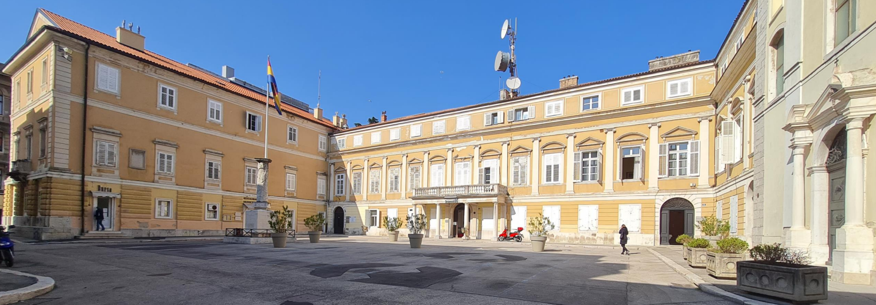

Fig.1 KVC_PAR headquarters - PAR campus building in Rijeka, Croatia
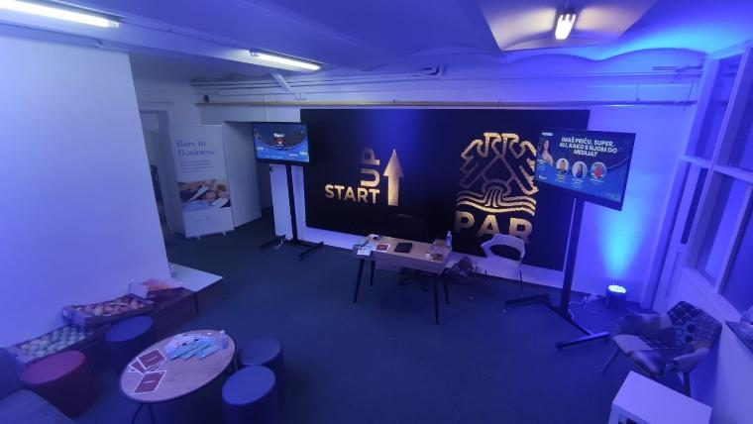
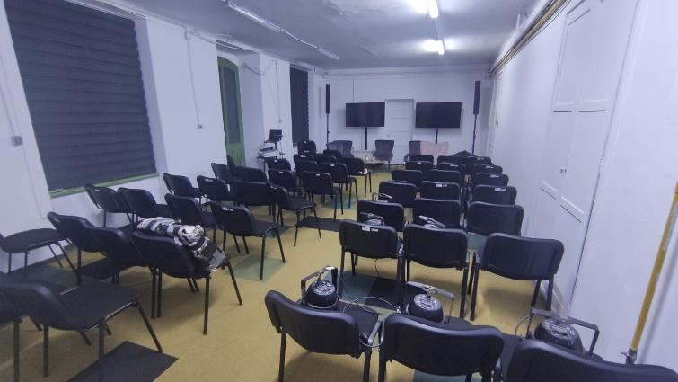

Fig. 2 – 3 KVC_PAR business incubator space and conference hall

2. Institutional Home, Leadership and Team

KVC_PAR is hosted by PAR University of Applied Sciences, under the strategic leadership of Dr. Gordana Nikolić, Dean of PAR and internationally recognised female entrepreneurship ambassador. The core team consists of 5 experts with interdisciplinary competencies across:

- women’s entrepreneurship and gender-inclusive innovation
- SME acceleration and business development
- digital transformation, AI literacy and applied technologies
- curriculum development and lifelong learning
- sustainable business and CSR
- entrepreneurial ecosystem design

Together, the team supervises activities such as:

- professional training and microcredential programs
- mentoring for entrepreneurs (special focus on women) and early-stage SMEs
- knowledge valorisation and transfer of research and best practices to SMEs
- digital skills development for business innovation
- collaborative projects with local authorities and private-sector actors
- innovation support for student-led and community-driven ventures
- development of inclusive entrepreneurship frameworks and KPIs

Governance is coordinated with PAR’s existing structures including the Lifelong Learning Center, Career Center, and the International Office, ensuring that knowledge valorisation becomes embedded in PAR’s strategic direction and aligned with its long-term development as a leading regional entrepreneurial education centre.

3. Stakeholder Ecosystem and Partnerships

The KVC_PAR ecosystem builds on a well-established network of regional, national, and international partners. These include:

Industry and SME stakeholders
- Over 80 companies collaborating with PAR through training, mentoring, and dual study placements
- Regional SMEs in tourism, mobility, ICT, creative industries, and manufacturing
- Partners of DIGIPARC DIH and AI & GAMING EDIH (AI, IoT, gamification, digitalisation specialists)
- Private- and public-sector partners
- City of Rijeka
- Primorje–Gorski Kotar County
- Croatian Chamber of Economy
- Croatian Chamber of Crafts and Trades
- Croatian Employers’ Association

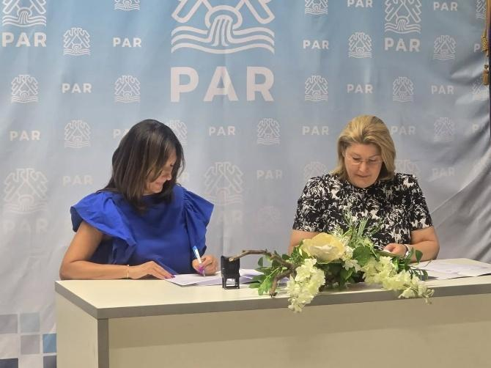
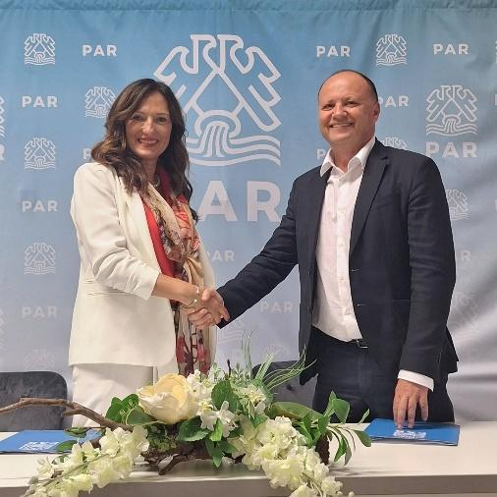

Fig.4 Signing of partnership contract with Fig.5 Signing of partnership contract with
Specialty Hospital Medico Rijeka-Pula Plodine d.d.

Women entrepreneurship networks
- Women without PARdon community (established by PAR), supporting mentorship, inspiration, and visibility for women founders
- G100 global network, in which PAR leadership plays a regional role
- KRUG association of women in business
- EntrepreneurSHEp Croatia and European women entrepreneurship communities

European networks and partners
- EU4Dual European Dual Studies University Alliance
- Networks: Businet, NICE Network, EAEC, EECOLE

These collaborations support activities in SME digitalisation, entrepreneurial acceleration, women’s empowerment, applied research valorisation, and cross-border innovation exchange. They provide a solid foundation for KVC_PAR’s ambitions to become a central node in the North Adriatic RIS ecosystem.

4. Contribution to IMPACT-Campus KPIs (Phase 1)

Since its establishment, KVC_PAR has contributed to key project metrics in line with the IMPACT-Campus KPI framework. To date, the Center has:
- trained 35 students in entrepreneurship, innovation, and digital skills
- trained 10 academic and non-academic staff in valorisation and digitalisation practices
- mentored 5 students and early-stage entrepreneurs
- established or strengthened 7 regional partnerships across industry, public sector, and women entrepreneurship networks

These actions reflect KVC_PAR’s commitment to innovation-driven capacity building, inclusive entrepreneurship, SME support, and ecosystem strengthening within the RIS region.

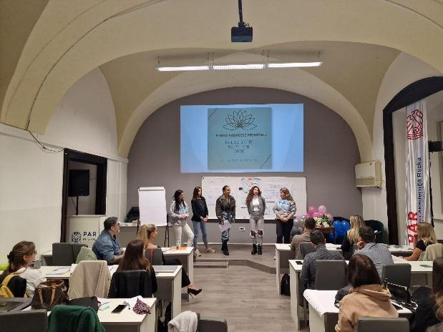
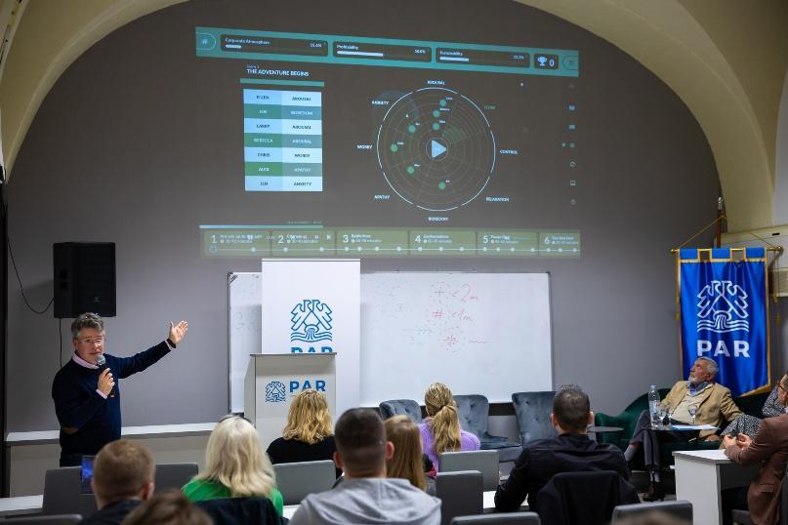

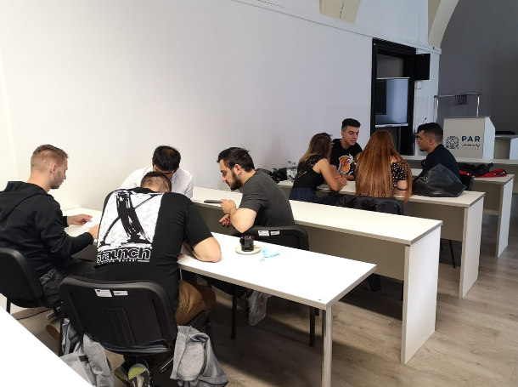
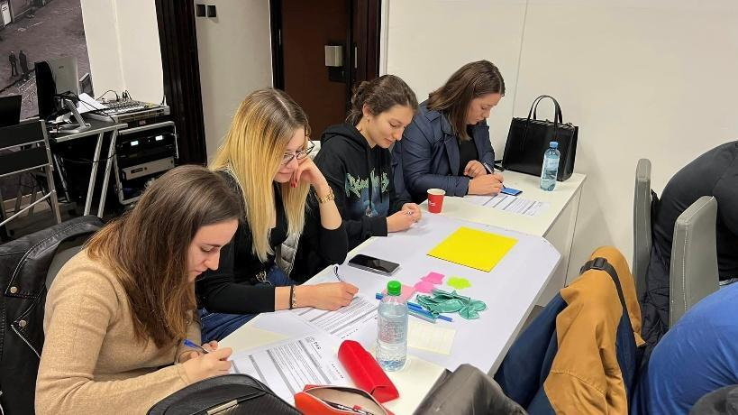

Fig. 6 – 9 Photos from lectures and trainings, pitch workshops and mentoring sessions

Activities include:
- company visits and field study
- innovation bootcamps
- AI-oriented lifelong learning courses
- SME digital upskilling workshops
- pitch development mentoring
- applied training via PAR’s dual education ecosystem
- community networking events under the “Women without PARdon” platform

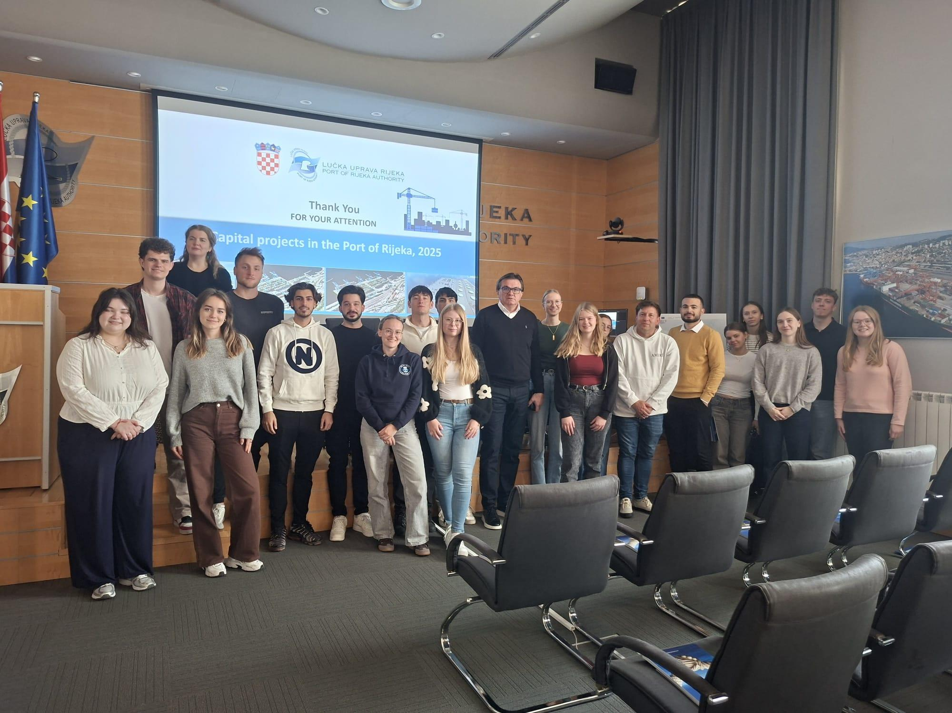
Fig. 10 Field study - Visit to Rijeka Port Authority in October 2025

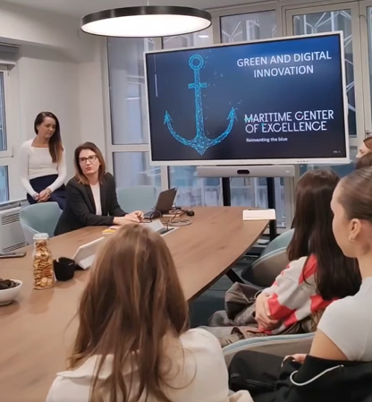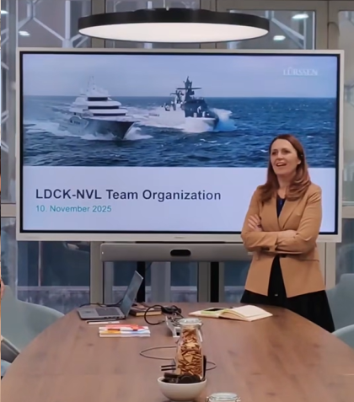
Fig. 11 Field study - Visit to Lürssen in November 2025

5. Institutional and Regional Changes Enabled by the KVC

The establishment of KVC_PAR has initiated a substantial transformation within PAR University of Applied Sciences by reinforcing knowledge valorisation, women’s entrepreneurship, and SME innovation as core institutional priorities. From the moment of its creation, the Centre began to further improve internal practices and generate new forms of collaboration across the university. One of the most visible changes is the integration of women‑focused entrepreneurship pathways into the KVC’s activities, which will include specialised programs co‑developed with regional stakeholders and trainers. These programs were designed not merely as short‑term interventions but as enduring learning opportunities that support the personal development of aspiring and early‑stage female entrepreneurs in the RIS region.

Through the KVC’s structured mentoring activities, students and external learners became more deeply engaged in real‑world entrepreneurial challenges. The conversations between SMEs and PAR faculty intensified, allowing the KVC to become a space where business owners could articulate their innovation needs and receive support in translating those needs into practical development steps. This close cooperation resulted in more effective curriculum updates and refined teaching approaches across PAR. As a result, academic staff began adopting applied methodologies, case‑based teaching, and digital innovation tools more widely in their classrooms, creating a more dynamic and practice‑oriented learning environment. A new principle of field study has been applied in 2025, with groups of students visiting companies whose representatives presented their business operations, challenges and working methods to students to expose them to real-world experience. Business partners who participated in the field study include Jadrolinija d.d., Lürssen and Rijeka Port Authority.

The KVC has contributed to a cultural shift at PAR by elevating the visibility and importance of women‑led initiatives. Activities carried out under the “Women without PARdon” platform, which had long been a flagship movement of the university, are now connected to structured innovation programs and evidence‑based support services. Many participants reported higher confidence, greater clarity in business planning, and increased access to networks that were otherwise difficult for women entrepreneurs in the RIS region to reach. This shift in access and opportunity also had a symbolic dimension: it reinforced PAR’s role as a safe, welcoming, and empowering space for those traditionally underrepresented in entrepreneurship.

At the regional level, KVC_PAR contributed to strengthening the North Adriatic innovation ecosystem by positioning inclusive entrepreneurship and SME digital transformation as central components of development. SMEs in manufacturing, tourism, mobility, and creative industries increasingly relied on the KVC for help in understanding new technologies and for guidance on how digitalisation could improve their operations. The Centre also played a role in bringing new project opportunities to the region, particularly those involving collaborations with DIHs, municipalities, and entrepreneurial networks. A compelling example is a submission of a 2025 Horizon project proposal focusing on empowering women-led initiatives, in which the university stands as an education provider in a consortium of associations of women in business across the Balkan countries.

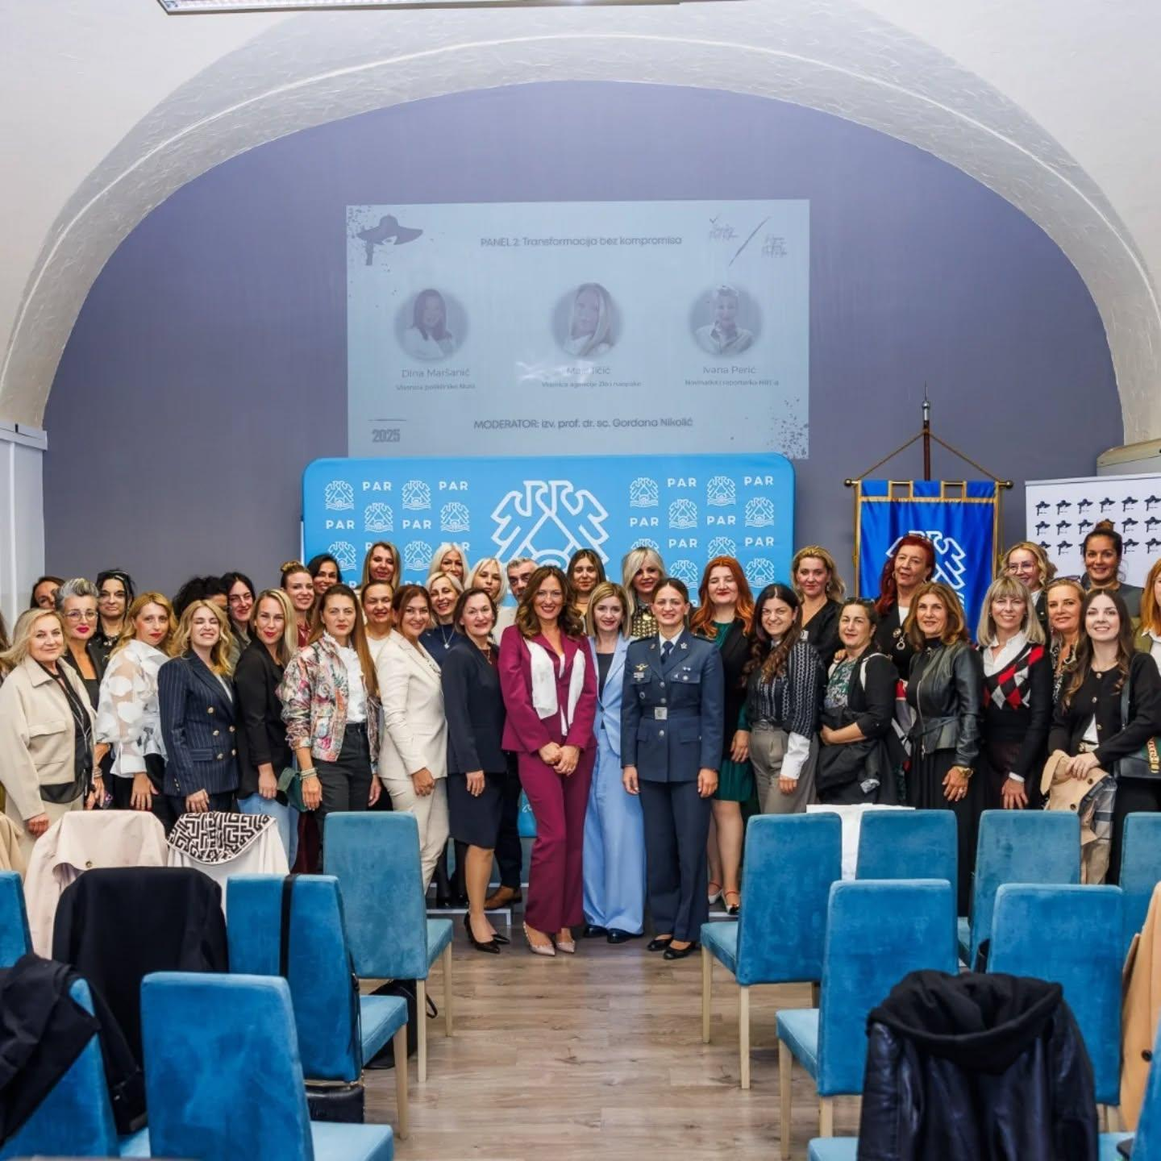
Fig. 12 Women without PARdon conference – networking and support event for women entrepreneurs

6. Strategic Importance of the KVC

The strategic importance of KVC_PAR extends far beyond the boundaries of the institution. It serves as a long‑term anchor for PAR’s ambition to become a leading entrepreneurial education centre in the North Adriatic region. The Centre embodies PAR’s long‑standing commitment to women’s empowerment, digital skills development, and community‑driven innovation, and transforms these commitments into structured, scalable, and measurable activities. KVC_PAR thus plays an essential role in ensuring that teaching, research, and external engagement are aligned with European innovation priorities, especially those highlighting inclusiveness, sustainability, and SME competitiveness.

Within the university, the KVC provides a framework through which students and staff can consistently engage with industry partners, test new ideas, and participate in innovation‑driven collaborations. This continuous engagement strengthens PAR’s institutional profile and makes its study programs more relevant to the demands of a rapidly changing labour market. The Centre also amplifies the role of PAR’s dual education model by embedding innovation challenges directly into practical work experiences, allowing SMEs to benefit from fresh perspectives while students gain valuable industry insights. These reciprocal relationships reinforce PAR’s strategic positioning as a university that bridges knowledge and practice.

At the regional level, the importance of KVC_PAR lies in its capacity to support SMEs in navigating the pressures of digital transformation. Many businesses in the Croatian RIS region lack specialised knowledge or face structural barriers when adopting new technologies. Through the KVC, SMEs gain access to digital assessments, training opportunities, and guidance offered through DIGIPARC and AI & GAMING EDIH. By helping them make informed choices and adopt sustainable practices, the Centre contributes to regional competitiveness and long‑term economic resilience. It also plays a role in reducing gender disparities in innovation by creating environments where women can participate more fully and confidently in entrepreneurial ecosystems.

From a macro‑regional perspective, KVC_PAR strengthens the IMPACT‑Campus network through its distinctive expertise in women‑focused entrepreneurship support and its strong track record of community‑based initiatives. These strengths complement the capabilities of other partner institutions and contribute a unique Adriatic perspective to the network’s shared mission. By transferring its methodologies, training formats, and inclusive KPIs to partners across Europe, KVC_PAR is positioned to influence innovation practices beyond Croatia and act as a connector between EU core innovation regions and the RIS territories.

7. Plans for Phase 2 and Beyond

Looking ahead, the development of KVC_PAR in Phase 2 is envisioned as a period of consolidation, expansion, and deeper integration of knowledge valorisation practices across the institution and the wider regional ecosystem. The experiences of Phase 1 have demonstrated not only the potential of the Centre to activate new forms of collaboration, but also the appetite among students, SMEs, and public-sector actors for more sustained and specialised support. Building on this momentum, the next phase will focus on creating long-term structures that can endure beyond the project timeline, ensuring that the Centre becomes an established and indispensable component of PAR’s innovation architecture.

One of the central ambitions for Phase 2 is the scaling of entrepreneurship and digital innovation programs, with a particular emphasis on strengthening pathways for women founders and early-stage SMEs. This does not simply involve offering more workshops or training sessions, but rather creating coherent development journeys that accompany participants from the initial stages of idea generation to the later phases of business development and market entry. The intention is to transform the KVC into a place where individuals and teams can continuously return for guidance, resources, and validation as they evolve. This approach will allow PAR to cultivate a more diverse pool of innovators and to embed inclusive entrepreneurship practices more thoroughly into the regional ecosystem.

A key aspect of KVC_PAR’s future direction lies in expanding the support available to SMEs in their digital and green transitions. Many small enterprises in the North Adriatic RIS region are aware of the importance of adopting new technologies or aligning their operations with sustainable practices, yet still struggle to access specialised knowledge or understand which investments would bring the most value. Through close collaboration with DIHs operating in the region, the KVC will serve as a gateway for SMEs to access tailored diagnostic tools, expert consultations, and experiential learning opportunities. The development of clearer communication channels, case-based demonstrations, and technical support mechanisms will help SMEs gain confidence in navigating digitalisation and adopting more future-oriented business models.

Another important area of growth involves the refinement and implementation of inclusivity indicators that will help measure the impact of entrepreneurship and innovation activities on different demographic groups. Phase 2 envisions the creation of a framework that incorporates gender-sensitive metrics and broader inclusivity KPIs which reflect PAR’s long-standing commitment to equitable access and empowerment. By systematically tracking data on participation, progression, and outcomes, the Centre will contribute to building a more transparent and accountable innovation environment in the region. These indicators will also support regional authorities in shaping policies that respond to the real needs of entrepreneurs, particularly those from underrepresented groups.

The international dimension of KVC_PAR will continue to expand as well. Having already demonstrated its ability to act as a connector between local stakeholders and European networks, the Centre aims to take a more proactive role in transferring methodologies, teaching models, and capacity-building frameworks to partners across the IMPACT-Campus consortium. This includes sharing practices related to women’s entrepreneurship programs, cross-sector collaboration, and experiential learning design. By doing so, PAR will not only contribute its expertise to the consortium but also gain access to new insights and methodologies that can help address gaps in the Adriatic RIS region. These exchanges are expected to strengthen the university’s international positioning and reinforce the broader goals of balanced innovation development across Europe.

The next phase will also place emphasis on expanding the innovation pipeline initiated during the first year. In Phase 2, the KVC intends to deepen its engagement with new ventures, identifying promising ideas, supporting early validation, and creating opportunities for regional exposure. Whether focusing on sustainable tourism initiatives, AI-supported micro-enterprises, or community-driven social businesses, the Centre will continue to nurture ideas that contribute to a more sustainable and inclusive economic landscape.

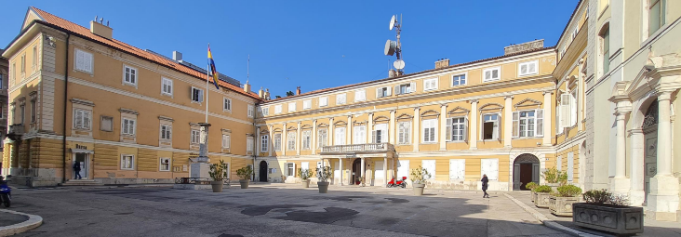

Fig. 13 Logo of PAR Fig. 14 PAR campus

Prepared by: PAR University of Applied Sciences Team
Date: December 8th, 2025

