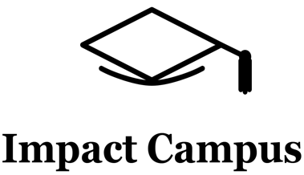
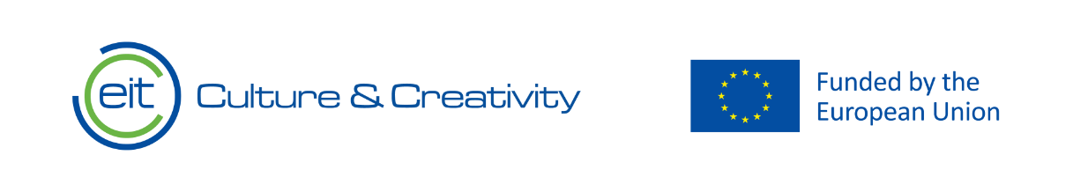

Knowledge Valorisation Centre Institutional Brief
University of Montenegro

Prepared by University of Montenegro
EIT HEI Initiative – IMPACT-Campus: Knowledge Valorization Centres for Sustainable Entrepreneurship and Digital Transformation
Fourth Call for Proposals (October 2024), Strand A
This Knowledge Valorisation Center profile is based on the conceptual framework “IMPACT-Campus: Knowledge Valorization Centres for Sustainable Entrepreneurship and Digital Transformation”.

1. Introduction and Regional Context

The KVC based at the University of Montenegro (UoM), serves as a strategic institutional hub for strengthening innovation and entrepreneurship capacities in line with European higher-education transformation agendas.

The Center provides a robust platform for:

• Knowledge Valorisation and Technology Transfer
The Center drives research-to-market activities by supporting technology maturation and collaboration with industry partners. Through mentoring schemes, and innovation-support structures, it enables UoM researchers and students to translate scientific results into high-impact solutions.
.

• Building Institutional and Regional Innovation Capacity
The Center facilitates collaboration between academia, the public sector, business community, and civil society. Its activities help reinforce Montenegro’s innovation ecosystem by embedding long-term institutional change and supporting policy and strategy development.

• Supporting Start-ups, Spin-offs, and Business Creation
The Center expands the entrepreneurial pipeline by offering mentoring, access to partner networks and exposure to market-driven innovation methodologies.
.

• Enhancing Innovation and Entrepreneurial Skills
The Center provides structured training programmes, interdisciplinary learning formats, capacity-building workshops, and competency-based education. It strengthens staff and student capabilities in innovation management, sustainable development, digital transformation, and process optimization.

• Advancing Sustainable Development
The Center supports green transition priorities, circularity, and sustainable industry practices.

The Center was officially established on 24.04.2025 with main focus on: the development and implementation of training programs and professional development in the field of innovation.

In December 2025, its scope of activities was expanded to include knowledge valorization through the identification, evaluation, and transfer of research results to industry, as well as the strengthening of innovation capacities through the development of partnerships with business entities, the public sector, and civil society, in line with contemporary European practices.

It is designed as a bridge between higher education, industry, public authorities, and civil society, the Center carries a mandate to translate knowledge into tangible impact for the region.

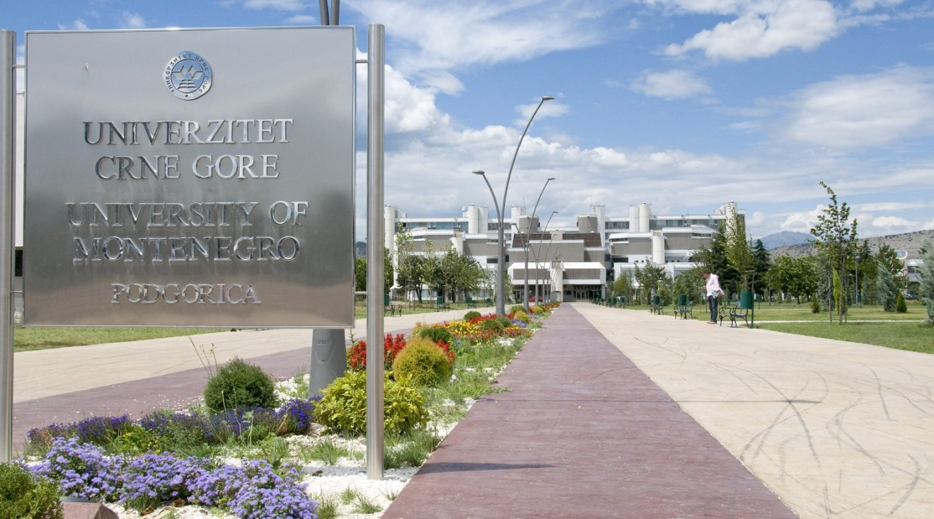
Exterior View of the KVC Location at the University of Montenegro Campus

Equipment:


MINITAB software

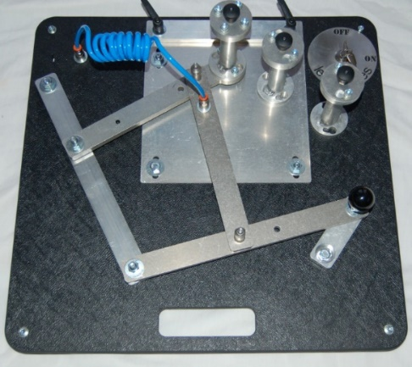
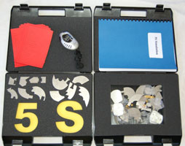


Lean games


VR glasses



AR glasses

Conference system



3D VR camera

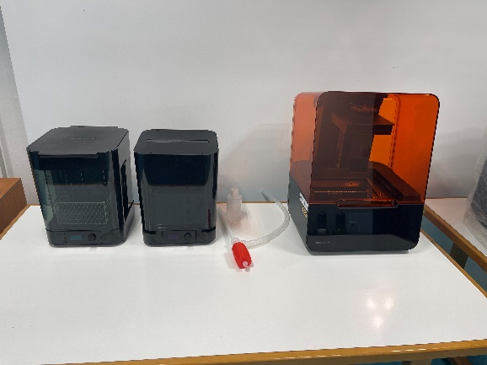

SLA 3D printer Formlabs Form 3

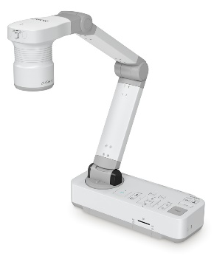
IT equipment

2. Institutional Home, Leadership and Team

The Center is hosted by the Faculty of Mechanical Engineering, University of Montenegro, and led by Prof. dr. Janko Jovanović. The core team currently consists of five members - Prof. dr. Janko Jovanović, Prof. dr Sanja Peković, Prof. dr. Jelena Šaković Jovanović, Prof. dr. Aleksandar Vujović, Prof. dr. Radoslav Tomović - whose expertise includes product development, process optimization, digital technologies, lean management, knowledge valorization, innovation management, and sustainable development.

Together, the team coordinates activities such as training and professional development programs, mentoring, knowledge valorization through the identification and transfer of research results to business sector, collaboration with business and public-sector partners, innovation support for start-ups and spin-offs, organization of living labs and simulation-based workshops (Lean games), and participation in policy dialogue on industrial innovation and reindustrialization.

The internal governance structure ensures shared leadership under the Faculty’s management, with active participation of academic staff and students, and close coordination with the Dean’s Office and the University Rectorate, allowing valorization activities to be integrated into the long-term strategy of the University of Montenegro.

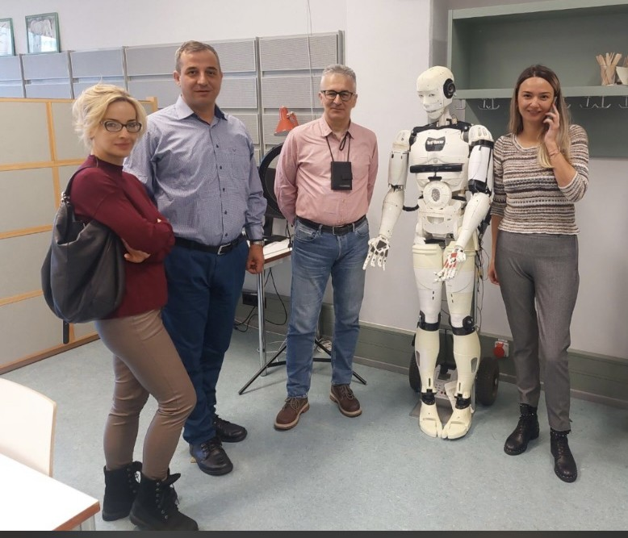
Group photo of the KVC team Momtenegro

3. Stakeholder Ecosystem and Partnerships

The ecosystem around the Center for Education in Product Development and Process Optimization includes stakeholders such as SMEs, large industrial companies, public utilities, municipalities, regional development agencies, chambers of commerce, business incubators, and non-governmental organizations active in innovation.

The Center has formalized cooperation with more than 15 partners, including the Montenegrin Electric Distribution System (CEDIS), the Chamber of Economy of Montenegro, the Innovation and Entrepreneurship Center Technopolis, the Science and Technology Park of Montenegro, and several local SMEs.
These agreements underpin collaboration in domains such as startup and spin-off support, innovation, process optimization, digital and green transition projects, student internships and thesis work, testbeds for new technologies, and applied research initiatives.

Alongside this, informal cooperation with academic staff, student innovation clubs, and local policy actors contributes to the creation of a functional regional ecosystem for innovation and knowledge valorization, aligning education, research, and industry in support of Montenegro’s sustainable development and reindustrialization goals.

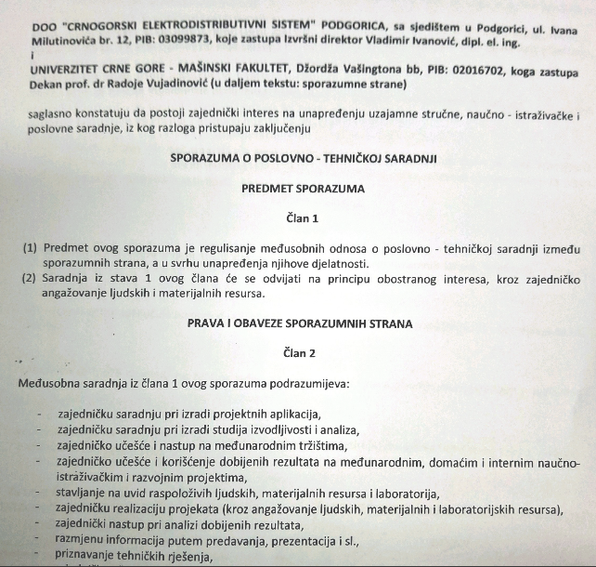

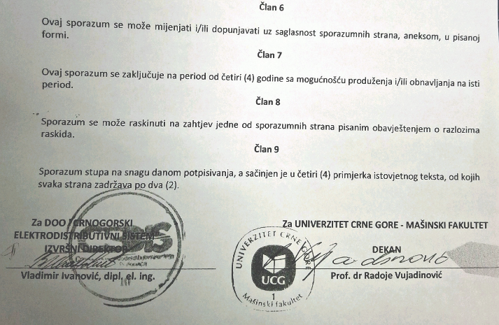

The Memorandum of cooperation

4. Contribution to IMPACT-Campus KPIs (Phase 1)

Since its establishment, Center for Education in Product Development and Process Optimization has contributed directly to the key metrics defined in the IMPACT-Campus project. To date, the Center has:
- More than trained 50 students
- trained 15 academic and non-academic staff
- mentored more than 30 students, academic and non-academic staff
- established or strengthened more than 15 partnerships

These achievements align with the KPI Framework of IMPACT-Campus: competence development, entrepreneurial capacity building, startup activation, and ecosystem connectivity.

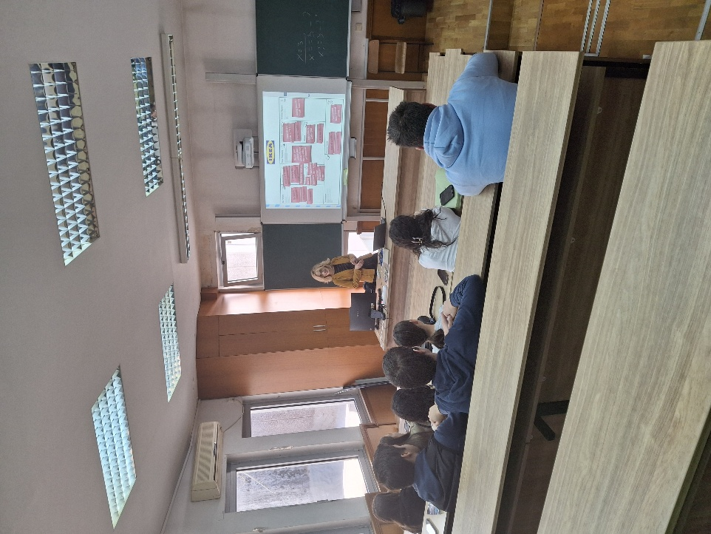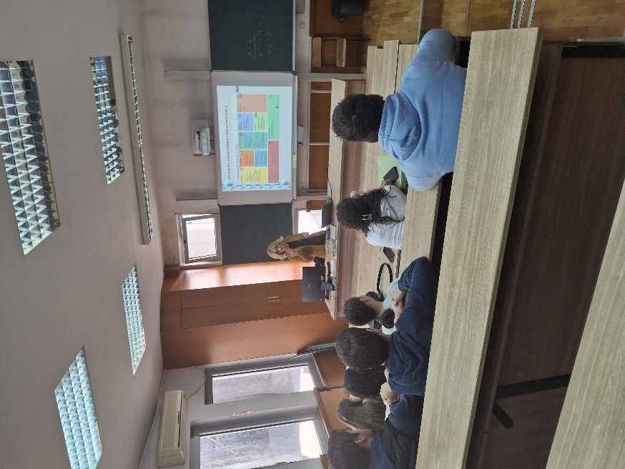
Student mentoring session

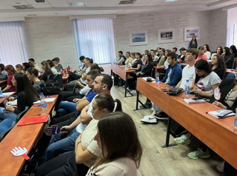
Student training session

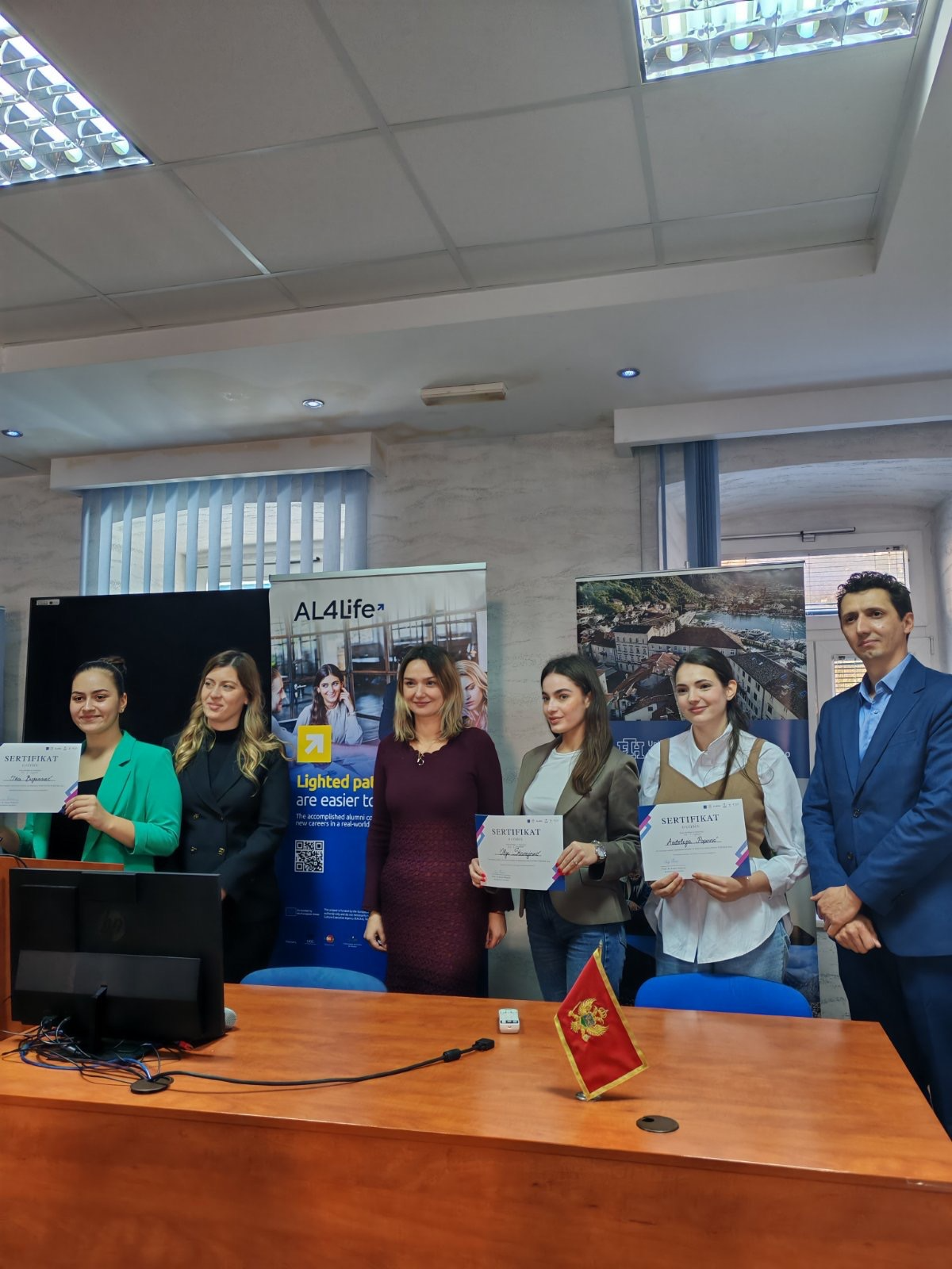
Hackathon on Inclusive Tourism – Award Announcement

5. Institutional and Regional Changes Enabled by the KVC

The establishment of the KVC has already produced visible and measurable transformation at the University of Montenegro. One of the most significant advances has been the development of a new interdisciplinary training programme on Innovation and Knowledge Valorisation, originally created within IMPACT-Campus and now being expanded for delivery to other UoM faculties. This programme—structured through the WP3 curriculum and training model —has introduced modern pedagogical methods such as project-based learning, innovation quests, digital skill building, and Canvas-based teamwork.

At the regional level, the Center has helped increase the visibility of early-stage student solutions developed through the “Innovation and Knowledge Valorisation” course, which reached over 350 participants across multiple partner universities. Many of these student teams showcased creative cultural-entrepreneurship ideas, green innovation prototypes, and digital transformation concepts publicly via the dedicated Instagram learning community—making young innovators from Montenegro and neighbouring Western Balkan HEIs more visible within the macro-regional ecosystem.

This example illustrates that IMPACT-Campus KPIs reflect more than numerical achievements: they correspond to deep structural change in how knowledge is produced, shared, and transformed into social and economic value across partners. The integration of new training programmes, cross-institutional curricula, collaborative digital practices, and community-driven innovation demonstrates how the KVC is becoming an anchor for long-term institutional and ecosystem transformation.

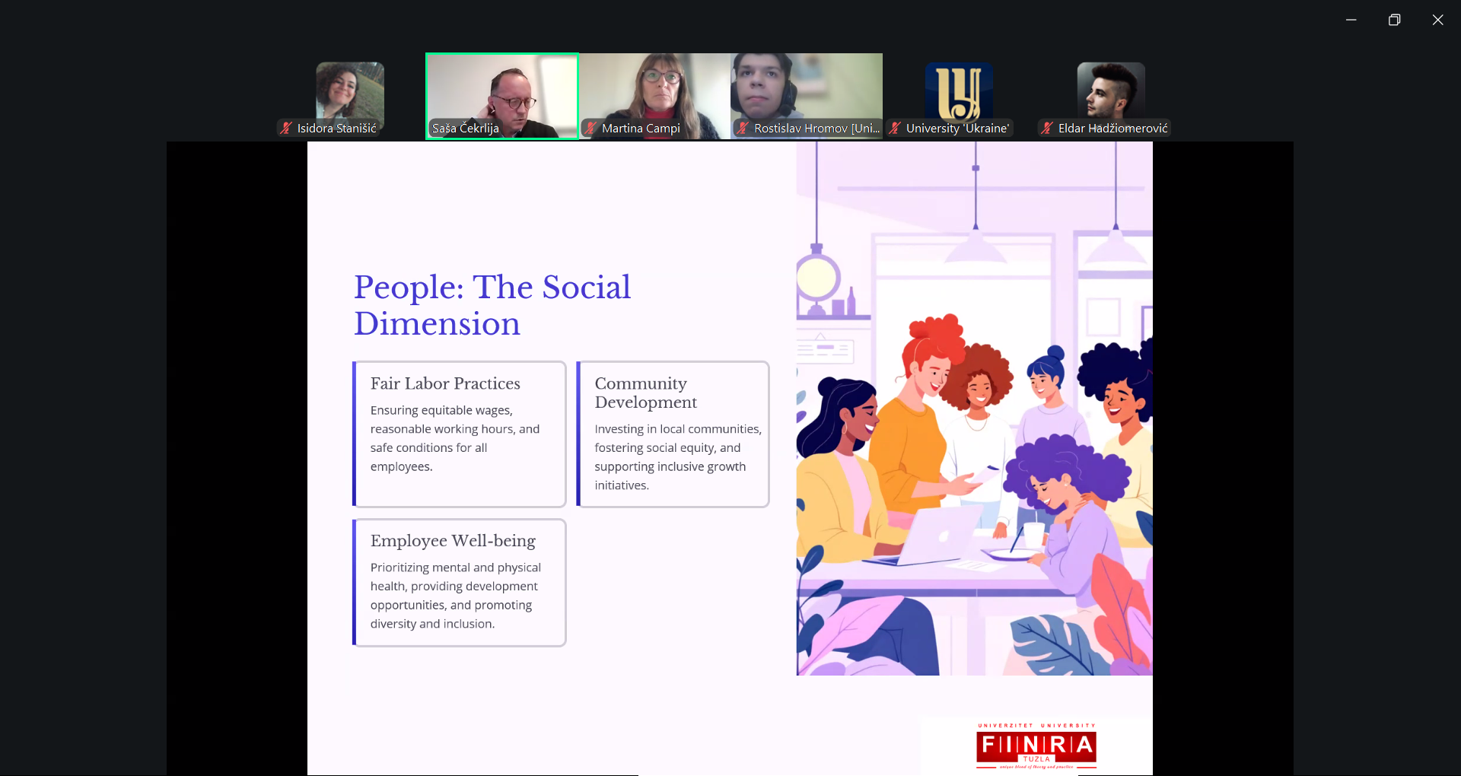

Interactive Session in the Innovation and Knowledge Valorization Programme

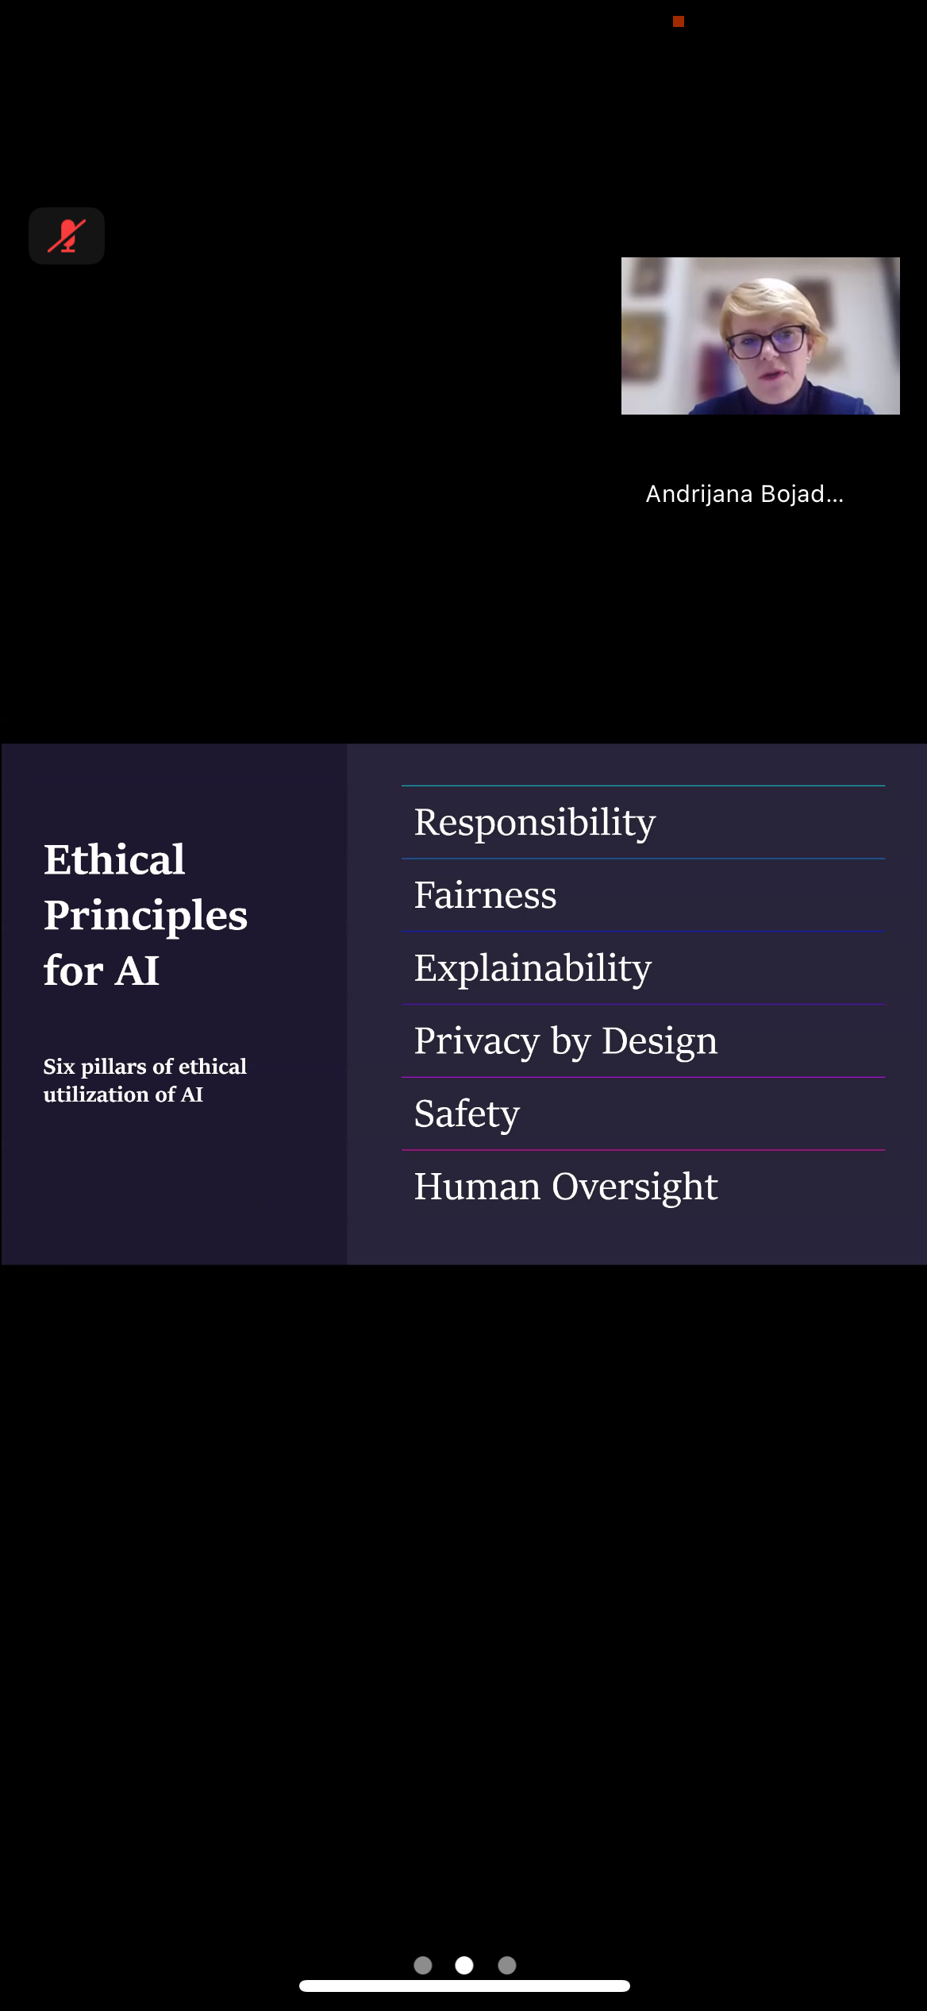

Interactive Session in the Innovation and Knowledge Valorization Programme

6. Strategic Importance of the KVC

Participation in IMPACT-Campus and the establishment of the Center for Education in Product Development and Process Optimization represent a major strategic step for the University of Montenegro. Together, they reinforce the University’s entrepreneurial and innovation profile, increase its international visibility, and ensure stronger alignment of research, education, and training activities with the Smart Specialization Strategy (S3) priorities for sustainable and digital transformation. Through the Center, students and staff gain structured opportunities to participate in real-world innovation projects, develop advanced competencies, and collaborate with European partners.

For Montenegro and the Western Balkans, the Center acts as a long-term gateway for innovation initiatives. It provides a dedicated hub for specialized training and mentoring in new product development, digitalized process optimization, and sustainable industrial practices. The Center also serves as a platform that strengthens cross-border cooperation among academia, industry, public institutions, and civil society, thereby enhancing the regional innovation ecosystem.

For the wider IMPACT-Campus network, the Center contributes a distinct sectoral expertise, particularly in advanced innovation methods, Lean management, and green industrial transition. It offers a strategic entry point for expanding entrepreneurship education, collaborative projects, and innovation support programs across the Western Balkan macro-region, helping to bridge innovation gaps and promote inclusive capacity building.

Our Knowledge Valorization Center contributes to regional innovation by:

• Developing S3-aligned green performance indicators, enabling evidence-based sustainability monitoring and supporting strategic transition pathways for enterprises and institutions.
• Enhancing research valorization, through systematic identification, assessment, and transfer of research results into economically and socially relevant applications.
• Strengthening regional cooperation networks, by engaging stakeholders across all dimensions of the quadruple helix—academia, industry, government, and civil society.
• Providing tailored training and advisory programmes to help enterprises adopt circular economy practices, improve resource efficiency, and transition toward more sustainable production and business models.

7. Plans for Phase 2 and Beyond

Looking ahead, the Center for Education in Product Development and Process Optimization plans to build on the achievements of Phase 1 by scaling up its training programmes for SMEs and industrial engineers, extending mentoring support for start-up and spin-off teams, launching new thematic tracks focused on green and digital transition, and deepening cooperation with industrial clusters, public institutions, and innovation support organizations.

Future priorities include:

• Expanding engagement with additional ecosystem actors, including financial institutions, municipal innovation and development offices, and civil society organizations working on sustainability, circular economy, and community-driven innovation. This broader involvement will reinforce the Center’s position as a convening platform for cross-sector collaboration and strengthen the regional innovation fabric.

• Focusing on high-impact KPIs related to the upskilling of professionals, the establishment of new business partnerships, and the measurable contribution of knowledge valorization activities to regional innovation performance. Priority will be placed on tracking the quality and depth of collaborations, adoption of innovative practices by enterprises, and the long-term outcomes of research-to-market initiatives.

• Transferring the Center’s expertise across the wider IMPACT-Campus network, by sharing proven methodologies in product development education, Lean-based process optimization, and effective university–industry cooperation models. These practices will be tailored to meet the needs of smaller or emerging innovation ecosystems in the Western Balkans, supporting balanced regional development and strengthening macro-regional innovation capacity.

8. Title Page Template (for each KVC)

EIT Higher Education Initiative
IMPACT-Campus: Knowledge Valorization Centres for Sustainable Entrepreneurship and Digital Transformation
Fourth Call for Proposals (October 2024) – Strand A

Center for Education in Product Development and Process Optimization
Prepared by: University of Montenegro team
Date: December, 2025

Centar za edukaciju u razvoju proizvoda i optimizaciji procesa

